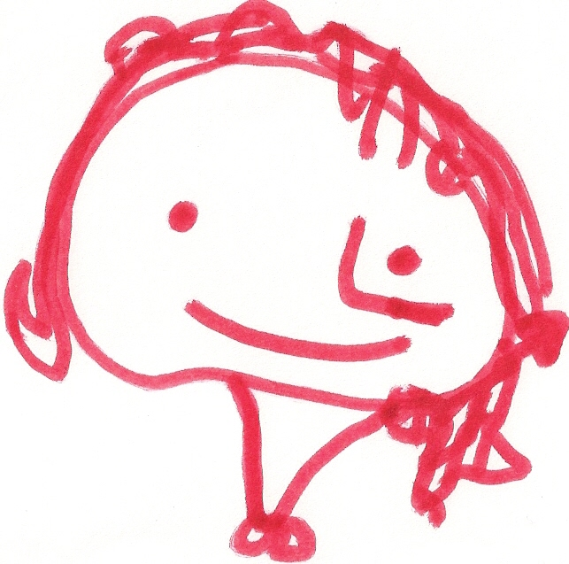
BALLYHENRY NURSERY SCHOOL
SEPTEMBER RHYMES/SONGS

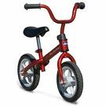
I ride my little bicycle, Big red combine harvester, Teddy bear, Teddy bear, turn around!

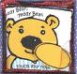
I ride it to the shop, Big red combine harvester, Teddy bear, Teddy bear, touch the ground!
And when I see the big red light Big red combine harvester, Teddy bear, Teddy bear, show your shoe!
I know that I must STOP! Chug, Chug, Chug, Chug, Teddy bear, Teddy bear, that will do!
Chugging Away
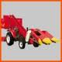
I Wiggle my fingers, Teddy bear, Teddy bear, climb upstairs!
I wiggle my toes, Teddy bear, Teddy bear, say your prayers!
I wiggle my shoulders, Teddy bear, Teddy bear, turn off the light!
I wiggle my nose, Teddy bear, Teddy bear, say “Good night”!
Now, no more wiggles
Are left in me, 5 little monkeys jumping on the bed
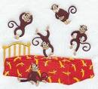
So I will be still, 1 fell off and bumped his head Jack in the box,
As still as can be. Mummy phoned the doctor As still as a mouse,
And the doctor said…. Deep down inside
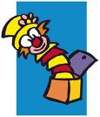
“No more monkeys jumping on the bed!” Your little dark house.
2 little eyes to look around, 4 little monkeys jumping on the bed …. Etc. Jack in the box
2 little ears to hear each sound, Ever so still
1 little nose, to smell what’s sweet, Will you come out?
And 1 little mouth, which likes to eat! Roly Poly, Roly, Poly YES, I will!
Up, Up, Up
Roly, Poly, Roly, Poly Jack-in-the-box,
Down, down, down As still as a mouse,
Hello, hello, it’s good to see you, Roly, Poly, Roly, Poly Curled up inside,
Hello, hello, it’s good to see you, Out, Out, Out Your little dark house,
I must say, you’ve made my day Roly, Poly, Roly, Poly Nice and quiet
Hello, hello, hello! (Repeat) In, In, In Nice and still,
Will you listen to my story?
Goodbye, goodbye, it’s time to go now Yes, I will (whispered)
Goodbye, goodbye, it’s time to go now Jelly on a plate, Jelly on a plate,
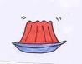
I must say, you’ve made my day, Wibble, wobble, wibble, wobble
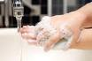
Goodbye, goodbye, goodbye! (Repeat) Jelly on a plate Wash your dirty hands,

Sausages in the pan, sausages in the pan, Wash your dirty hands,
Sizzle, sozzle, sizzle sozzle, Rub and scrubs, rub and scrub,
Sausages in the pan And wash your dirty hands

