Nursery News March/April 2025

# Monthly Topic

Our themes until Easter will be babies and baby animals, including frogs and ducks and of course, Easter and Spring.

Please send a picture of your child as a baby via Seesaw and send in a baby item they could tell their friends about.

World Book Day is on Thursday 6th March and we will be sending home £1 book tokens. Please remember to read with your child every day and also allow them to see you reading.

Nursery will be closed on Monday 17th March for the St Patrick's Day Bank Holiday.

We will be having our Happy Healthy Kids evening on Thursday 3rd April. This event will run from 6:30pm - 7:30pm. More details will follow.

Please send in a box of tissues. With all the colds that have been going around our supply has depleted.

School closes for the Easter Break on Monday 14th April at 11:30am. No dinners will be served.

There will be an Easter party on that day and nursery will provide the treats.

We will reopen on Monday 28th April.



# We remind parents that if your child has a high temperature or has had diarrhea/vomiting, infectious diseases he/she must be kept at home for 48 hours to minimize the spread of infection within the nursery.  Your child will be sent home if they are unwell.



# MENU IS SUBJECT TO CHANGE



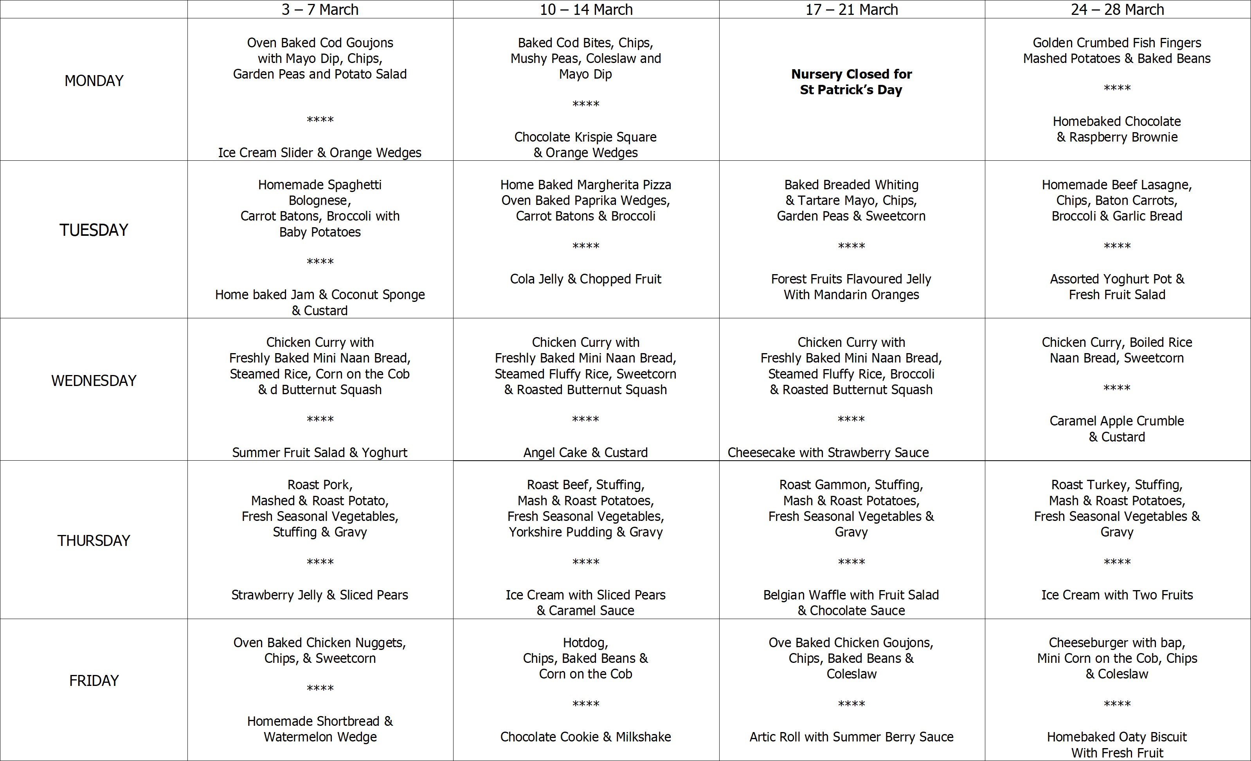



Safeguarding Team

* Mrs Pollock Designated Teacher
* Miss Cowan Deputy Designated Teacher
* Mrs Waugh Chair of Governors
* Mrs Magee Governor for Child Protection



* Thursday 6th March World Book Day. Mrs Darragh will be teaching Mrs Pollock's class as she is on a course.
* Friday 7th March Mrs Pollock's class trip to W5.
* Friday 14th March Miss Cowan's class trip to W5.
* Monday 17th March Nursery Closed for St Patrick's Day.
* Thursday 3rd April Happy Healthy Kids Evening 6:30 - 7:30pm more details to follow.
* Monday 7th April Three Plus Health Visitor Reviews ... more details to follow.
* Wednesday 9th April Three Plus Health Visitor Reviews ... more details to follow.
* Thursday 10th April Visit from Puppets. £1 donation to be paid via Eduspot.
* Monday 14th April Nursery closes at 11:30am for the Easter break. We will be having our Easter party.
* Tuesday 15th April Staff Development Day. Nursery is closed for children.
* Wednesday 16th April - Friday 25th April - School Closed for Easter Holidays.
* Monday 28th April School reopens for Term 3.

# Happy Healthy Kids Go Fly a Kite

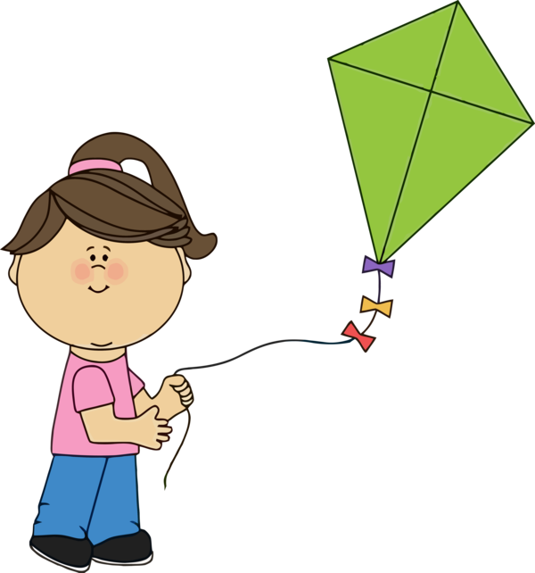

As part of our 'Happy Healthy Kids' theme we would encourage you and your child to be active outdoors. We will send home paper plates for you all to make a kite.

1. Cut out the centre of the plate
2. Allow your child to decorate the plate by drawing or painting on it
3. Sellotape lengths of wrapping ribbon, crepe paper or wool to one end
4. Attach a string handle through a hole
5. Take kite outside and run along to fly the kite
6. Please bring your kite to school to show your friends



Sing the rhyme :

Hey Mr Wind stop whistling

Stop whistling around my toes

Did you know your whistling

Is making my toes all cold?