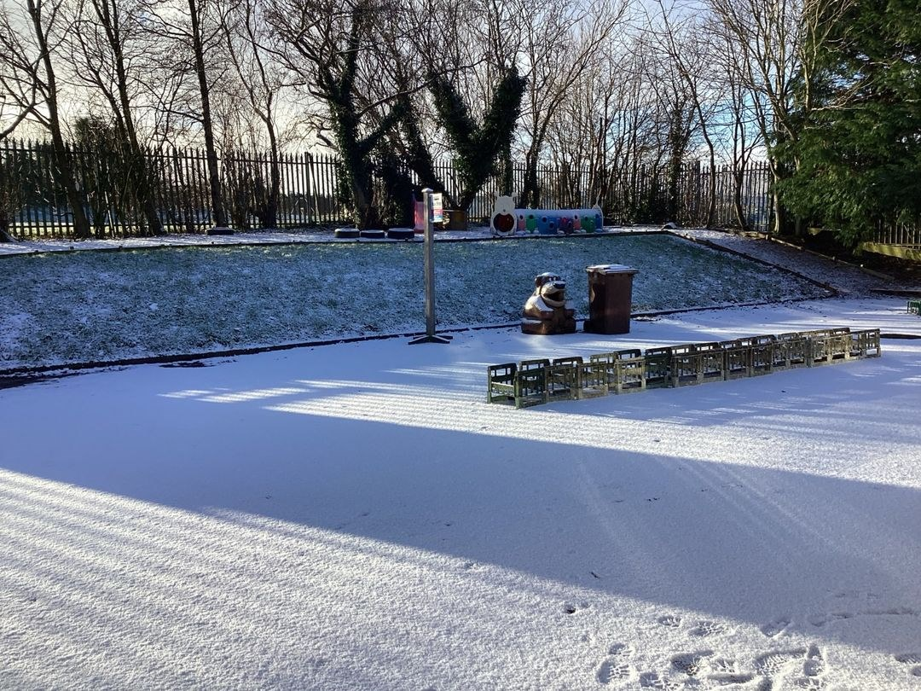

Nursery News February 2025

Our Monthly Topic will be People Who Help Us

We will be thinking about people who care for us, help to keep us safe and those who care for our environment. If you have an interesting job and are willing to come into nursery, please speak to us.

Our colours will be pink and purple and we will be focusing on the heart shape.

Adventure Ted Sleepover, please sign up for this in your child's cloakroom.

You should have by now applied for your child's Primary One or Nursery School place for September 2025.

Parent Teacher interviews for Mrs Pollock's class will be held week commencing Monday 3rd February. Please contact Michelle if you need to confirm you time slot.

Please remember to check our website [www.ballyhenrynurseryschool.co.uk](https://www.ballyhenrynurseryschool.co.uk) for information.

If we experience severe weather and need to close classes, a Seesaw message will be posted as soon as possible.

# Class Trips to W5

We will be having our class trips to W5 in March.

Mrs Pollock's class will be going on Friday 7th March.

Miss Cowan's Class will be going on Friday 14th March.

All pupils must be accompanied by an adult.

Families make their own way to W5. If your child is unable to attend, they can still come to nursery and play with their friends in the remaining classroom. Permission slips are in your child's pigeon hole today.

Please ensure your permission slip is signed and returned by Friday 21st February., to enable us to confirm numbers with W5.



# We remind parents that if your child has a high temperature or has had diarrhea/vomiting, infectious diseases he/she must be kept at home for 48 hours to minimize the spread of infection within the nursery.  Your child will be sent home if they are unwell.





# February 2025

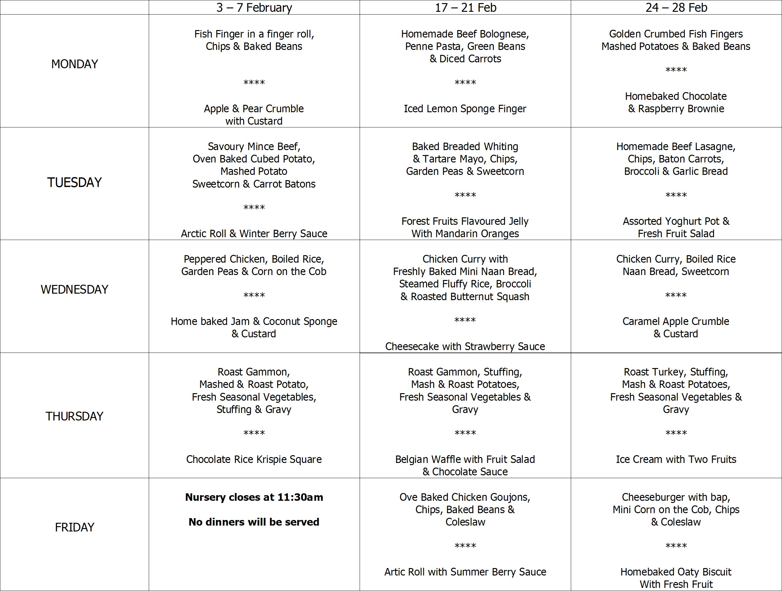



Safeguarding Team

* Mrs Pollock Designated Teacher
* Miss Cowan Deputy Designated Teacher
* Mrs Ball Chair of Governors
* Mrs Magee Governor for Child Protection



* Week Commencing Monday 3rd February - Parent Teacher Interviews for Mrs Pollock's Class
* Friday 7th February - nursery closes at 11:30am for the Half Term Break.
* Monday 10th February - School Development Day - Nursery closed to pupils.
* Tuesday 11th February - Friday 14th February School closed for half term holidays.
* Monday 17th February Nursery resumes.
* Thursday 20th February - Visit from Musical Monkeys for music and dance. £1 donation can be paid via Eduspot.
* Monday 24th February - visit from PSNI for our People Who Help Us Topic.

# Numbers Are All Around Us

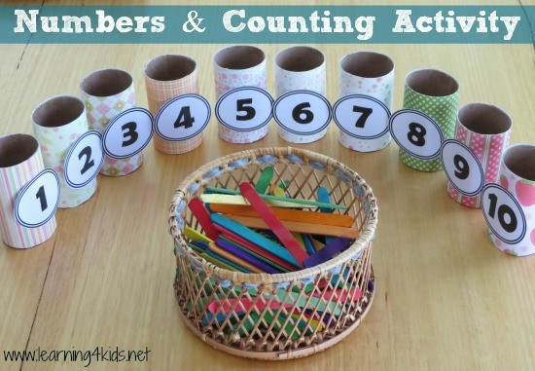

Make your child aware of numbers by talking about their age or their siblings ages and what age they will be on their next birthday.

Look for numbers in the environment with your child, eg., mobile phones, television controls, number plates, house numbers or numbers on clocks.

Use opportunities to rote count with your child through daily activities. As you go up the stairs to bed, count them, sing number rhymes together in the car or walking to nursery eg., five currant buns or 1, 2, 3, 4, 5 Once I Caught a Fish Alive, Count toes when getting ready for bed or fingers when putting on gloves. Put magnetic numbers on your fridge and mix them up. Look at the numbers on your car number plates or front door.

Remember, take advantage of fun learning experiences.