Nursery News January 2025

Happy New Year!

Welcome back to everyone for another busy term.

Thank you for all the lovely cards and gifts.

Applications for Primary One and Nursery will go live on Friday 10th January at 12 noon. Please visit [www.eani.org.uk/admissions](https://www.eani.org.uk/admissions) to apply for your Nursery or Primary School place.

Monthly Topic will be Winter and Space

We will discussing daily weather conditions, appropriate clothing, snowmen, life in Polar Lands and caring for the birds in Winter. In our creative work we will be focusing on 'cold' colours. The children will be talking about Space and we will be encouraging them to become more curious about planets.

Please return Story Sacks on a Wednesday morning and a new one will be issued on a Wednesday afternoon. A new story sack will not be issued until your previous one is returned.

Parent Play and Stay Sessions

We would to extend an invitation for our Play and Stay Sessions ... one adult per child can stay and play with their child in the classroom for 30 mins. Sign up sheet is in your child's classroom.

Parent Interviews

Parent Interviews will take place in January/February 2025. More details to follow.

If we experience severe weather conditions and need to close nursery, we will advise you via Seesaw as soon as possible.



# We remind parents that if your child has a high temperature or has had diarrhea/vomiting, infectious diseases he/she must be kept at home for 48 hours to minimize the spread of infection within the nursery.  Your child will be sent home if they are unwell.

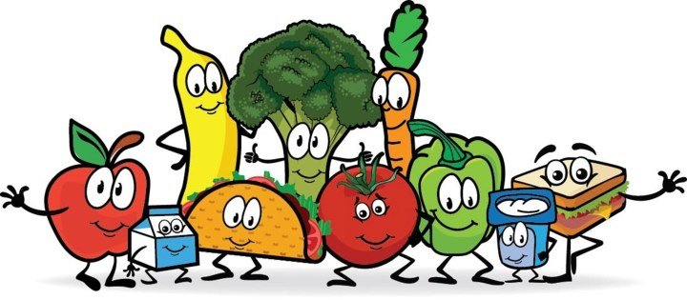

School Dinners

Dinners must be paid a week in advance or your child can not have dinners in school - no exceptions, you will need to make arrangements for your child to be collected from nursery at 12 noon.



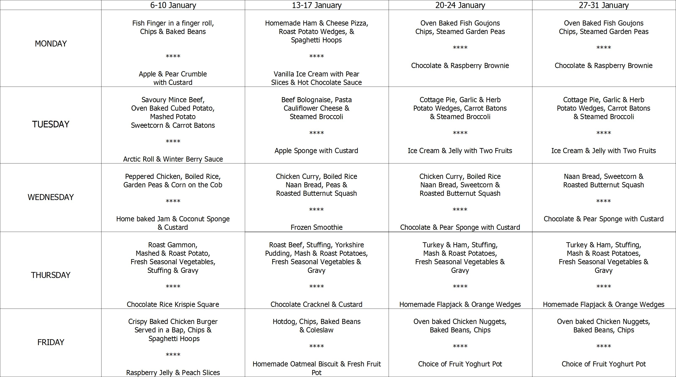

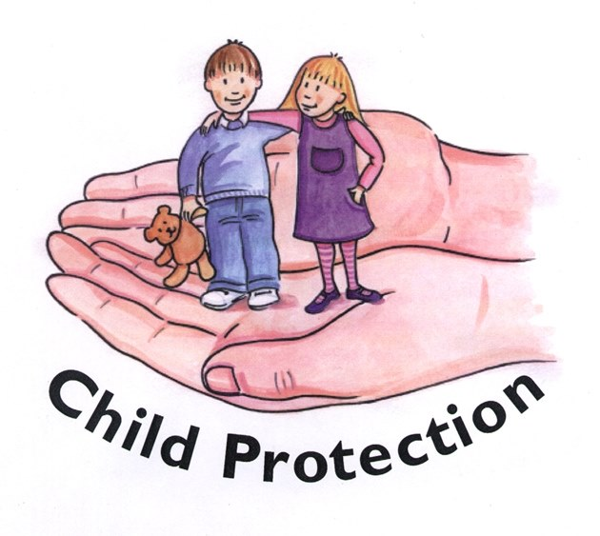

Safeguarding Team

* Mrs Pollock Designated Teacher
* Miss Cowan Deputy Designated Teacher
* Mrs Ball Chair of Governors
* Mrs Magee Governor for Child Protection



Friday 3rd January - School returns after the Christmas break. We close at 12 noon - no dinners will be served.

Friday 10th January - Online Portal for Nursery and Primary School goes live at 12 noon.

Tuesday 14th January - Visit from Mini Groovers for music and dance! £1 donation via Eduspot please.

Week Beginning 20th January - Stay and Play sessions. Sign up in your child's classroom.

Friday 24th January - Online Portal for Nursery and Primary School closes at 12 noon.

Friday 7th February - Nursery closes at 11:30am for the half term break. No Dinners will be served.

Monday 10th February - School Development Day. School closed to pupils.

Tuesday 11th - Friday 14th February - Half Term Break

Monday 17th February - School returns.

# Home School Links

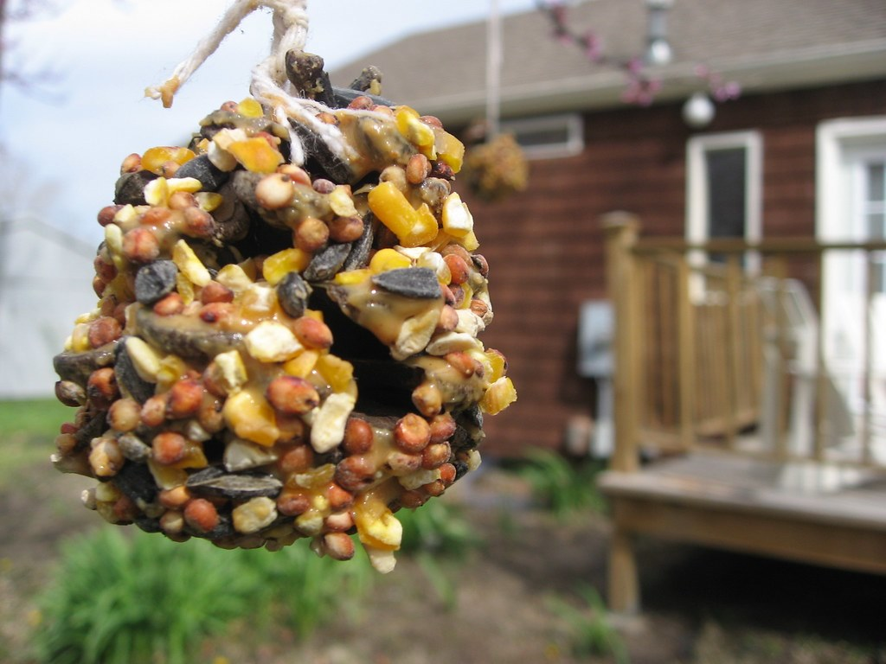

In nursery we will be discussing the weather in Winter and its impact on people and animals. In school we will be making bird cake to feed the birds. We will be watching to see the different types of birds who visit our nursery garden.

At home, your child could make an apple birdfeeder.

You will need :

* 1 apple
* Bird seed
* 3 sticks
* String

Instructions

1. Remove the core from your apple
2. Push the bird seed into the top half of the apple
3. Push two sticks into either side of the apple, near the bottom, for the birds to sit on
4. Tie string around the last stick and thread the string through the apple core
5. The apple should sit on the stick and you can tie the apple to a tree in the garden