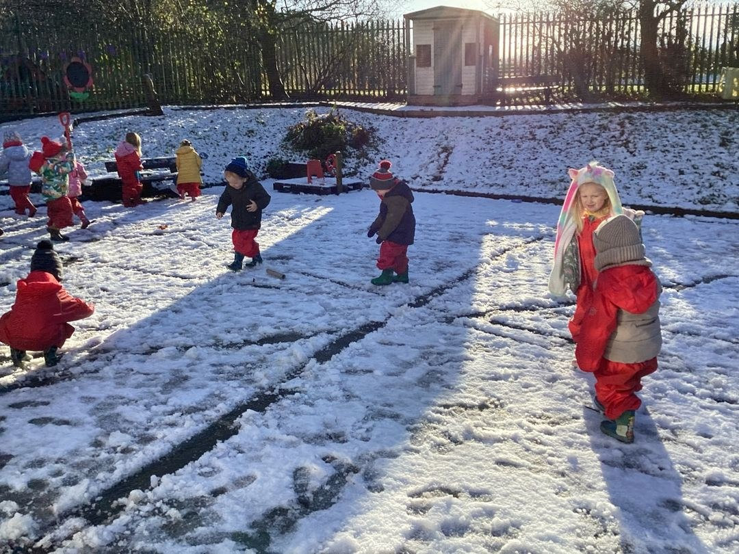

Nursery News December 2024

The children are already excited about Christmas!

Our nativity ‘Toby's Drum’ will be held on Friday 13th December at 9:30am in Ballyhenry Primary School Assembly Hall.  Children will get dropped to nursery as usual and then parents can make their way over to get a seat for our big performance!  We would ask that children come dressed as an Angel, King, Shepherd, Star, Animal or a Christmas Jumper but stress that no props are required.  All children go home after the nativity.

As we have a large number of staff and in these difficult days, rather than buying Christmas presents, we will be having a donation basket at our nativity as our goal this year is to purchase a brand new interactive whiteboard .... we are so close!

We will have a Christmas party on Friday 20th December and children can wear their own clothes.  Nursery will provide treats and school will close at 11:30am …. no dinners will be served.

We wish every family a happy and healthy Christmas.



# We remind parents that if your child has a high temperature or has had diarrhoea/vomiting, infectious diseases he/she must be kept at home for 48 hours to minimize the spread of infection within the nursery.  Your child will be sent home if they are unwell.



School Dinners

We remind parents that dinners must be paid a week in advance or your child can not have dinners in school - no exceptions, you will need to make arrangements for your child to be collected from nursery at 12 noon.

# MENU IS SUBJECT TO CHANGE



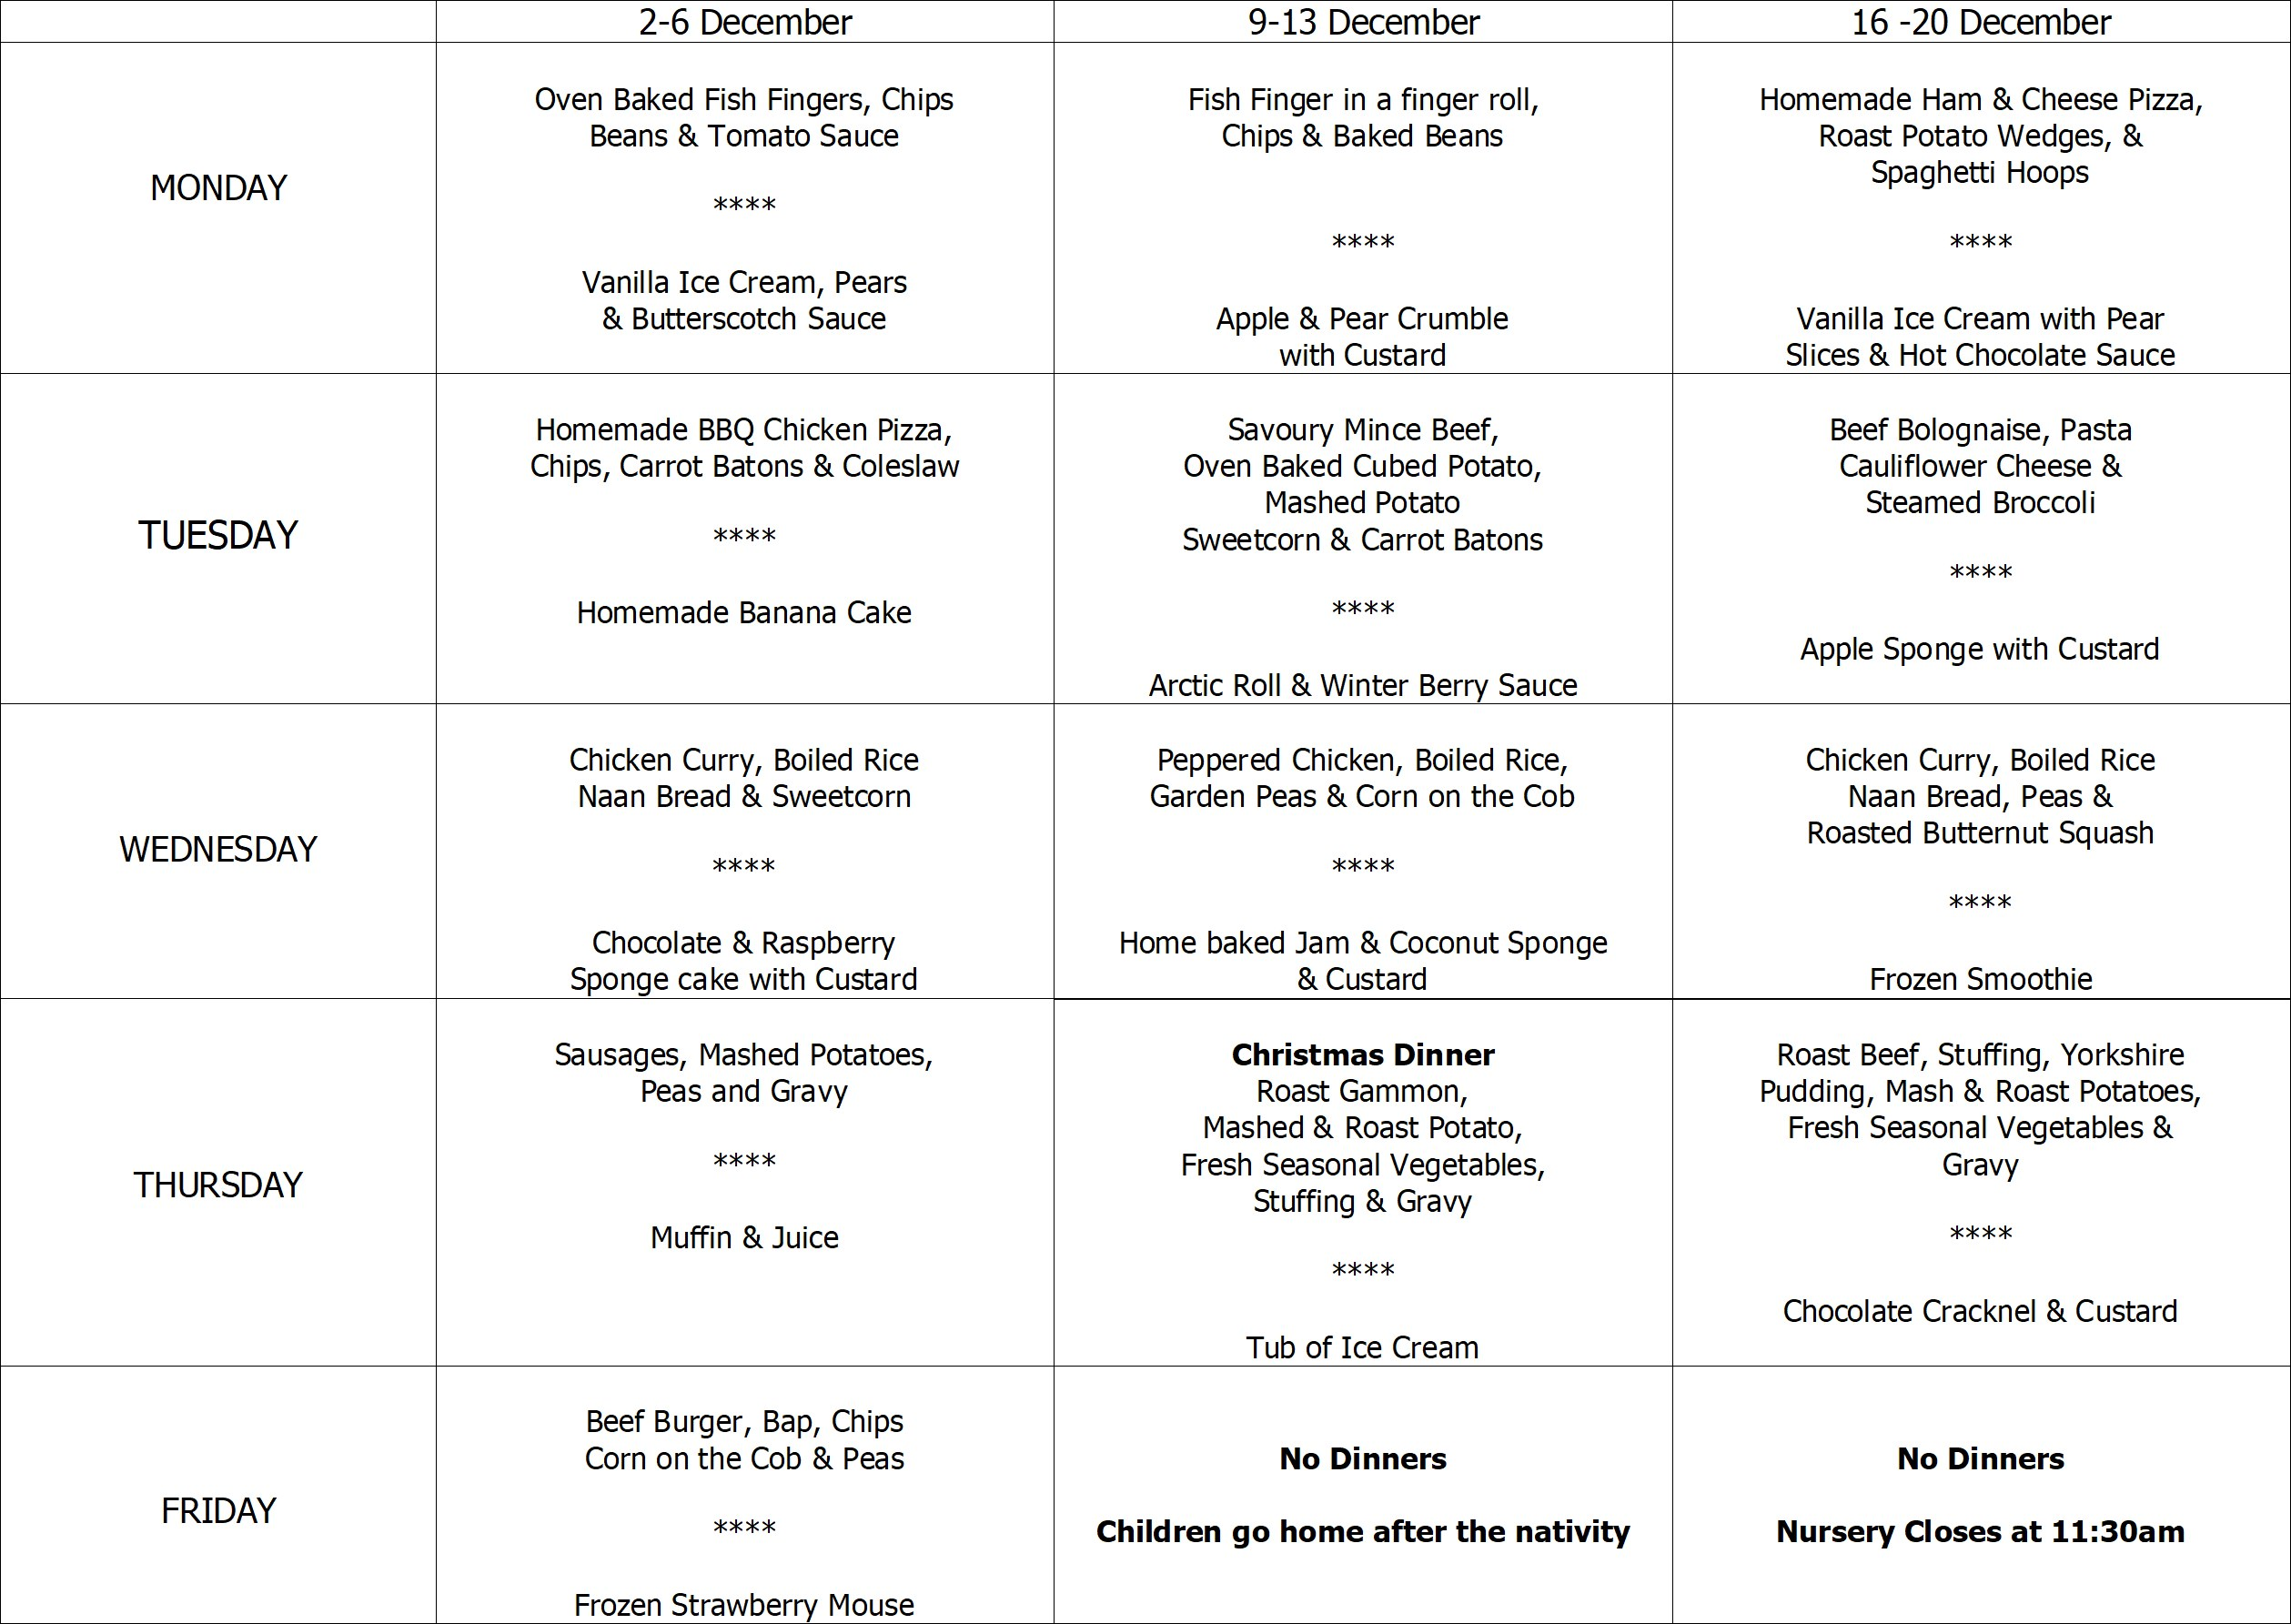



Safeguarding Team

* Mrs Pollock Designated Teacher
* Miss Cowan Deputy Designated Teacher
* Mrs Ball Chair of Governors
* Mrs Magee Governor for Child Protection



* Tuesday 3rd December - Mrs Darragh will be teaching Mrs Pollock's class.
* Tuesday 3rd December - We will be visiting Ballyhenry Primary School's Winter Wonderland. We will visit Santa and enjoy some hot chocolate!
* Thursday 5th December - Open Afternoon for the September 2025 school year. Children to be collected by 1pm to facilitate the staff in setting out the classrooms.
* Monday 9th December - We will be walking over to Ballyhenry Primary School to practise for our nativity.
* Thursday 12th December - Our Christmas dinner! Children can come to nursery wearing a Christmas Jumper.
* Friday 13th December - Christmas Nativity at 9:30am. More details to follow. To facilitate childminding arrangements, the children go home after the nativity at 10am.
* Monday 16th December - We will be visiting Ballyhenry Primary School to watch their school nativity.
* Tuesday 17th December - Mrs Darragh will be teaching Mrs Pollock's class.
* Wednesday 18th December - We will be getting a visit from the Puppet Show. £1 donation to be paid via Eduspot or cash into the office.
* Friday 20th December - Nursery will close at 11:30am for the Christmas holidays. No dinners will be served. We would like to remind parents to inform day care facilities of our early closure.
* Friday 3rd January - Nursery returns after the holidays. Please note, children will be going home at 12 noon .. no dinners will be served.
* Friday 10th January - the EA Online Portal will open at 12 noon for Pre-School and Primary One Applications.

# Home School Links

In nursery we are trying to develop the children’s fine motor skills through various activities, such as painting, manipulating dough, using scissors or tweezers.  This will help with their pre-writing skills also.

At home, use the various toy or Christmas gift catalogues to encourage your child to cut out pictures of items that they would like for Christmas or to choose for friends or family members.  Encourage your child to give a reason for choosing a particular item for different people.  Remember to use left handed scissors if your child is left handed!