Nursery News October 2024

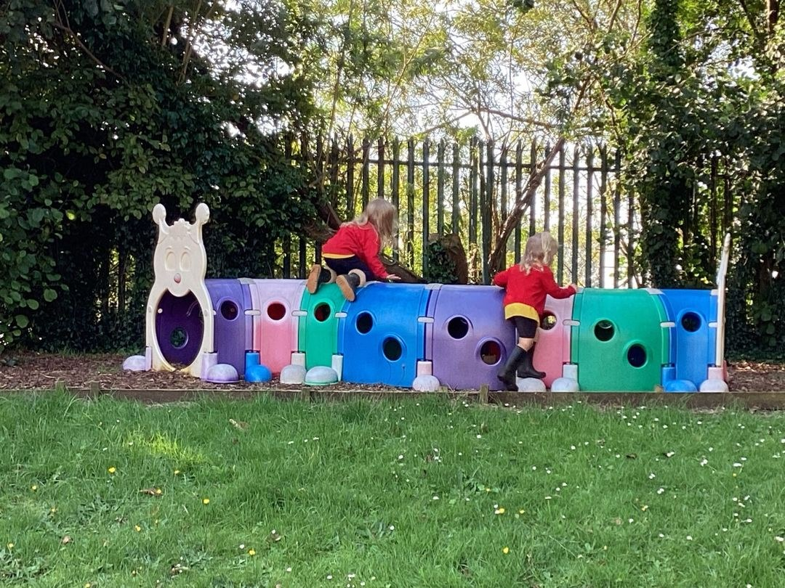

# Monthly Topic

All children have settled into nursery and are having fun!

If you have any concerns, please speak to Mrs Pollock or Miss Cowan.

Our Monthly Topic will be Autumn.

As Autumn approaches in school, we are looking at leaves, chestnuts, acorns etc.. We will be exploring the colours of Autumn, doing lots of creative work with leaves and natural materials and of course, pumpkins. Keep a look out when you are out walking for signs of Autumn.

It is important that every child comes to school wearing a warm coat. A pair of wellies should be left in nursery. Please ensure these are named. At home, please practice putting shoes on independently and send your child to nursery wearing footwear with velcrose fastenings. No jewellery should be worn.

At home time ring the classroom doorbell and come in when the buzzer sounds. Children can be collected between 1:15pm - 1:30pm to help ease traffic congestion.



# We remind parents that if your child has a high temperature or has had diarrhea/vomiting, infectious diseases he/she must be kept at home for 48 hours to minimize the spread of infection within the nursery.  Your child will be sent home if they are unwell.

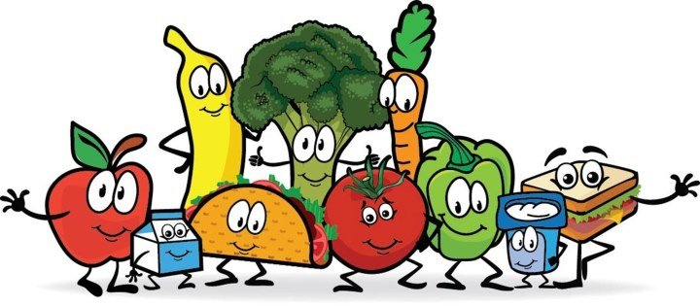

School Dinners

Dinners will commence in October. You will already have received your child's group setting. Once your child stays for dinners, school will end at 1:30pm. All other children go home at noon. We remind parents that dinners must be paid a week in advance or your child can not have dinners in school - no exceptions, you will need to make arrangements for your child to be collected from nursery at 12 noon.

Group 1 - Monday 30th September

Group 2 - Monday 7th October

Group 3 - Monday 14th October

# MENU IS SUBJECT TO CHANGE

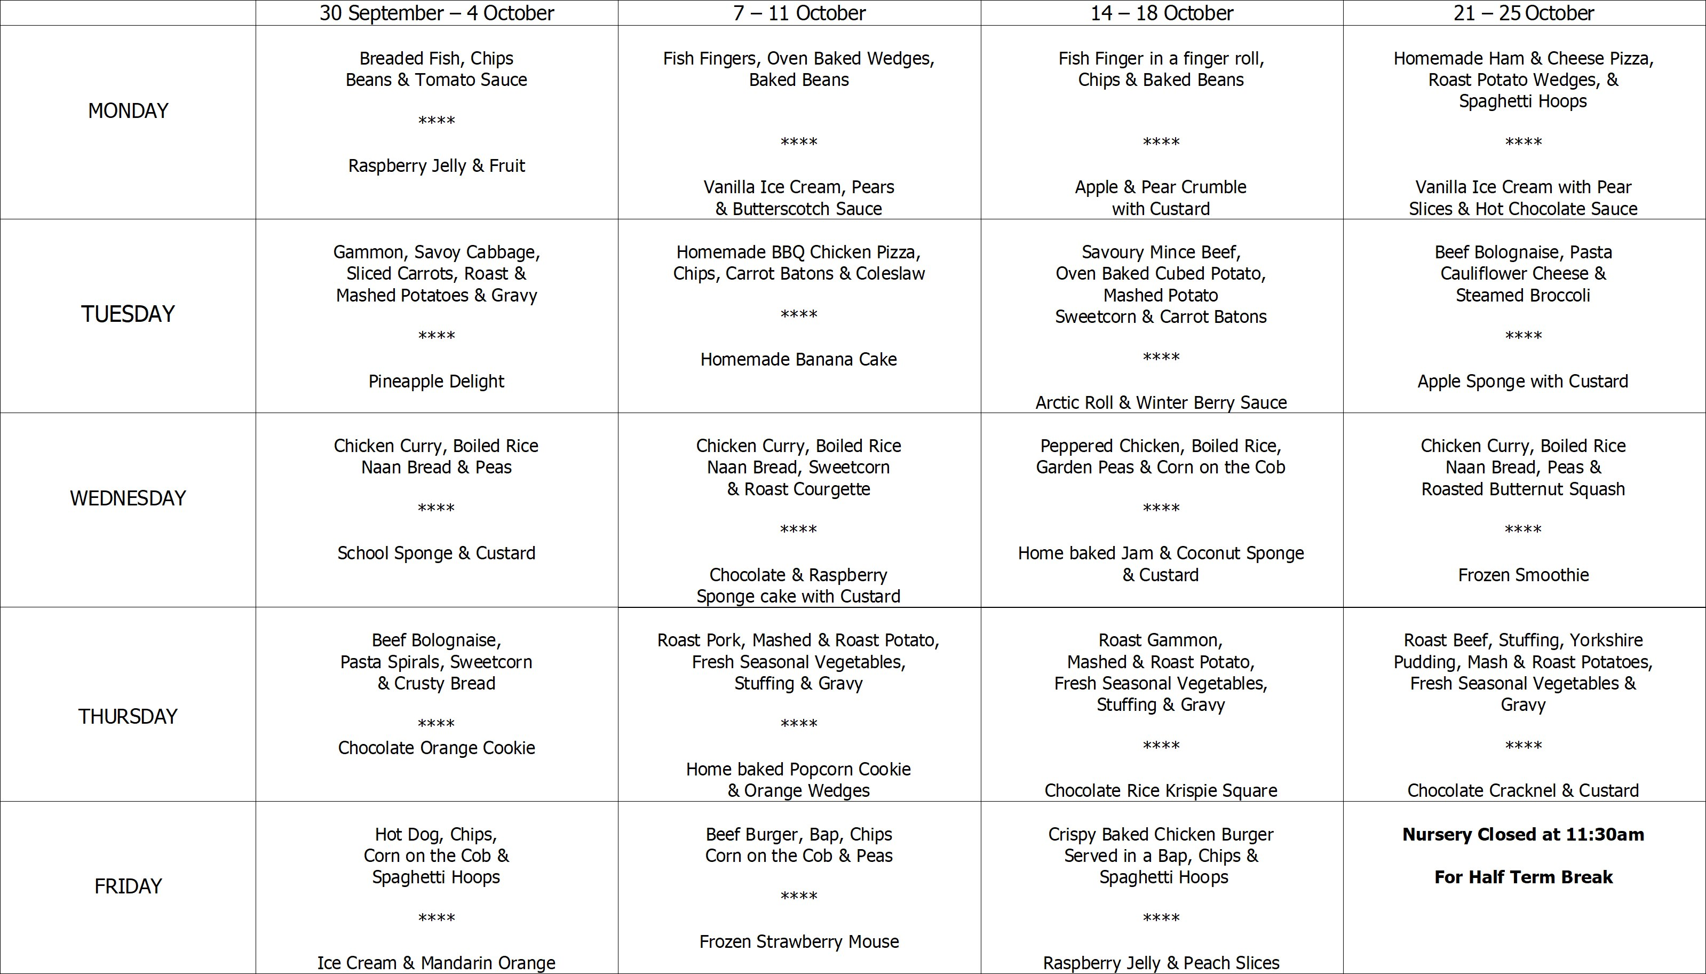

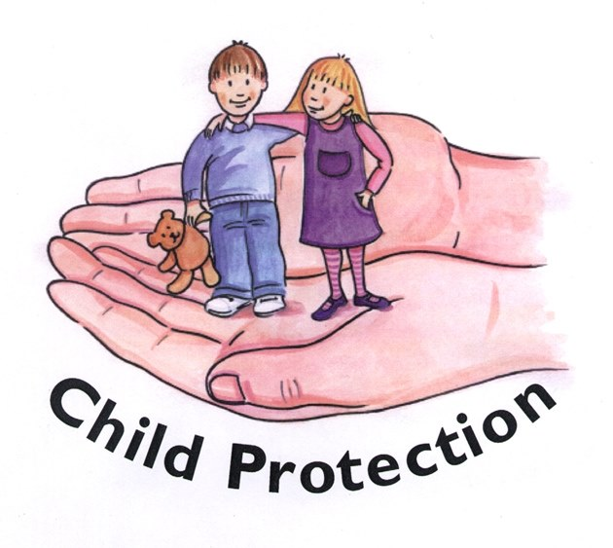

You will have received a copy of our Child Protection Policy. Information is also on display in the foyer, should you have any Child Protection concerns.

Safeguarding Team

* Mrs Pollock Designated Teacher
* Miss Cowan Deputy Designated Teacher
* Mrs Ball Chair of Governors
* Mrs Magee Governor for Child Protection



* Week commencing Monday 30th September Group 1 stay for dinner
* Week commencing Monday 7th October Group 2 stay for dinner
* Week commencing Monday 14th October Group 3 stay for dinner
* Monday 14th October We will be having a visit from Mini Groovers who will be doing dance and music with the children. £1 donation to be paid via Eduspot.
* Tuesday 15th October School Photographer will visit school for individual photographs. Please wear school poloshirt and jumper.
* Wednesday 16th, Thursday 17th, Monday 21st and Tuesday 22nd October - Miss Cowan will be holding her Parent/Teacher Consultation meetings. Please sign up in your child's classroom cloakroom for a telephone call or face to face meeting to discuss how your child has settled into nursery.
* Week Beginning Monday 21st October - Mrs Pollock will be holding her Parent/Teacher Consultation meetings. Please sign up in your child's classroom cloakroom for a telephone call or face to face meeting to discuss how your child has settled into nursery.
* Tuesday 22nd October We will be having a visit from Blytheswood to collect our shoe boxes and explain to the children how these will be used. Please ensure your shoe box is returned by Friday 18th October . These can be left into the office.
* Friday 25th October Pumpkin Party - children can wear costume or party clothes. Please do not send any props to school. School ends at 11:30am. No dinners will be served that day. School will provide party treats.
* Monday 28th October - School Development Day. Nursery will be closed to children.
* Tuesday 29th October - Friday 1 November half term holidays. School will be closed.

# Home School Links

In nursery we are thinking about Autumn.  Go for a walk and see if you can find and collect these leaves.

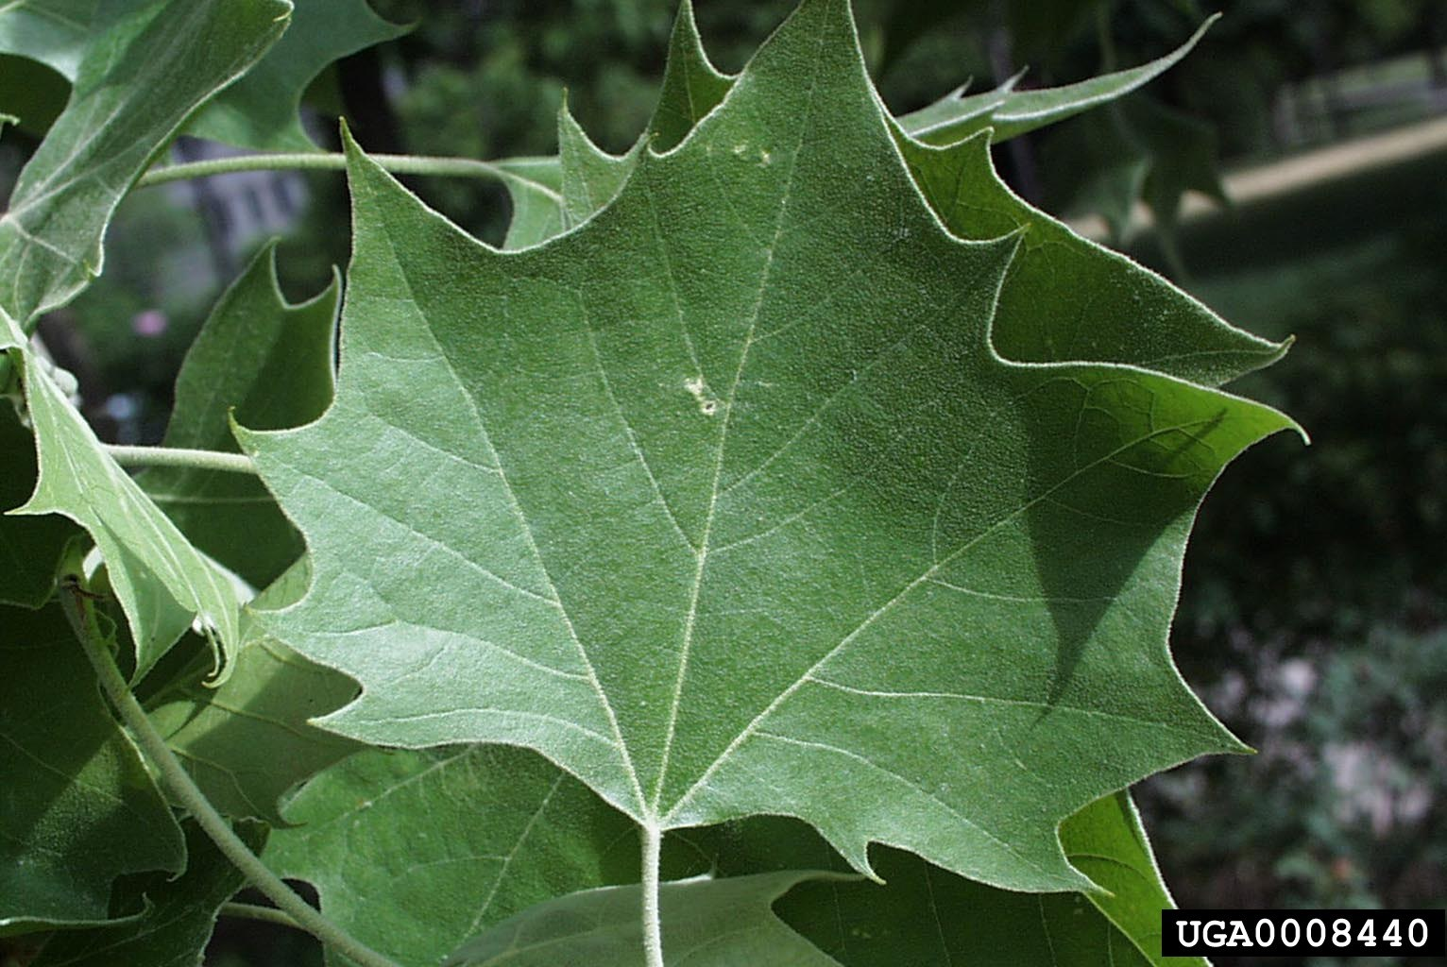

1 - Sycamore Leaf

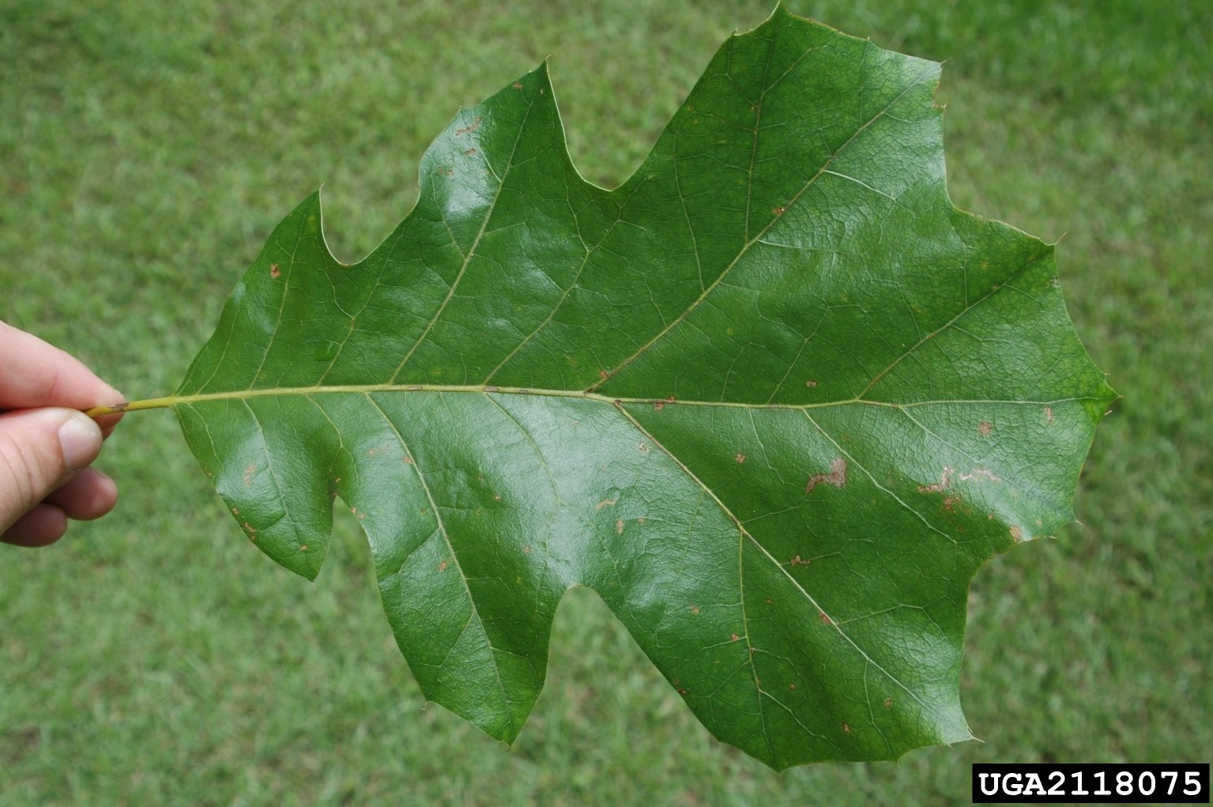

2 - Oak Leaf

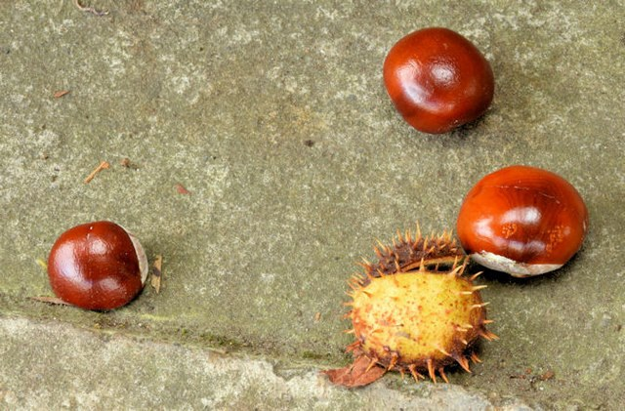

3 - Horse Chestnut

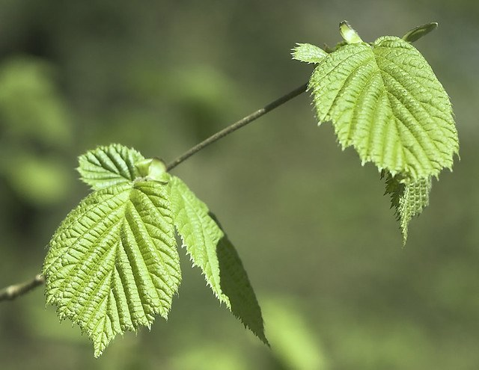

4 - Beech Leaf

As the weather is getting colder in Autumn, you may wish to make vegetable soup with your child.  Encourage your child to be involved in choosing, naming, washing and chopping the vegetables to make soup.

[Soup](https://www.bbcgoodfood.com/recipes/collection/vegetable-soup-recipes)