B A L L Y H E N R Y N U R S E R Y S C H O O L

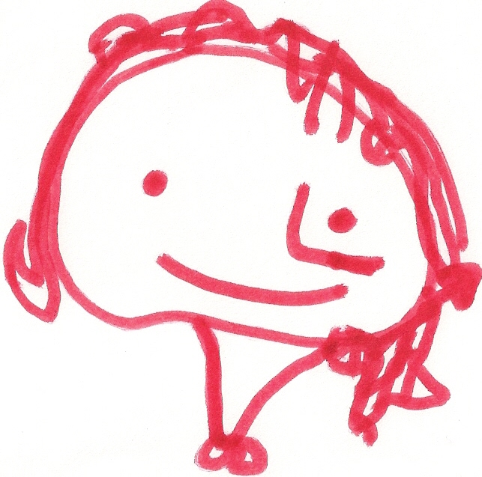
SCHOOL CLOSURES 2024 / 2025
All dates are inclusive

AUTUMN TERM Thursday 29th August – Friday 20th December 2024

School Development Day 1 : Friday 27th September 2024

School Development Day 2 : Monday 28th October 2024

Half Term Break Tuesday 29th October – Friday 1st November 2024
School closes for half term on Friday 25th October ’24 at 11.30 am

Christmas Holiday Monday 23rd December 2024 to Thursday 2nd January 2025
School closes for Christmas holiday – Friday 20th December ’24 at 11.30am.

SPRING TERM Friday 3rd January – Monday 14th April 2025

School Development Day 3 : Monday 10th February 2025

Half Term Break Tuesday 11th – Friday 14th February 2025
School closes for half term on Friday 7th February ’25 at 11:30am

St Patrick’s Day Monday 17th March 2025

School Development Day 4 : Tuesday 15th April 2025

Easter Holiday Wednesday 16th April – Friday 25th April 2025
School closes for Easter holiday Monday 14th April ‘25 at 11.30am.

SUMMER TERM Monday 28th April – Monday 30th June 2025

May Bank Holiday Monday 5th May 2025

School Development Day 5 : Friday 23rd May 2025

May Bank Holiday Monday 26th May 2025

School closes for Summer holiday - Monday 30th June ’25 at 11.30am.

