

Nursery News June 2024



Monthly Topic

This month our topic will be :

Holidays and Starting School

Everyone is looking forward to sunny days, holidays and Primary One!

We will be mounting a display in the foyer of the schools showing which school the children will be transferring to in September. We will upload a copy of this to Seesaw so you can discuss with your child at home.

Transition Reports

Transition Reports and Parental Questionnaires will be issued later this month. A copy of your child's report will be forwarded to their Primary School. We would appreciate if you could sign your child's report and complete the questionnaire as soon as possible, as we value your opinions.

Reminders

For ease of administration, can all outstanding snack money be paid by Friday 7th June.

If you are going on holidays and your child will be leaving before 28th June, please let us know.

Thank You

Wishing you all the best for the next school year. Do keep in touch to let us know how you are enjoying Primary One.



# We remind parents that if your child has a high temperature or has had diarrhea/vomiting, infectious diseases he/she must be kept at home for 48 hours to minimize the spread of infection within the nursery.  Your child will be sent home if they are unwell.



# MENU IS SUBJECT TO CHANGE



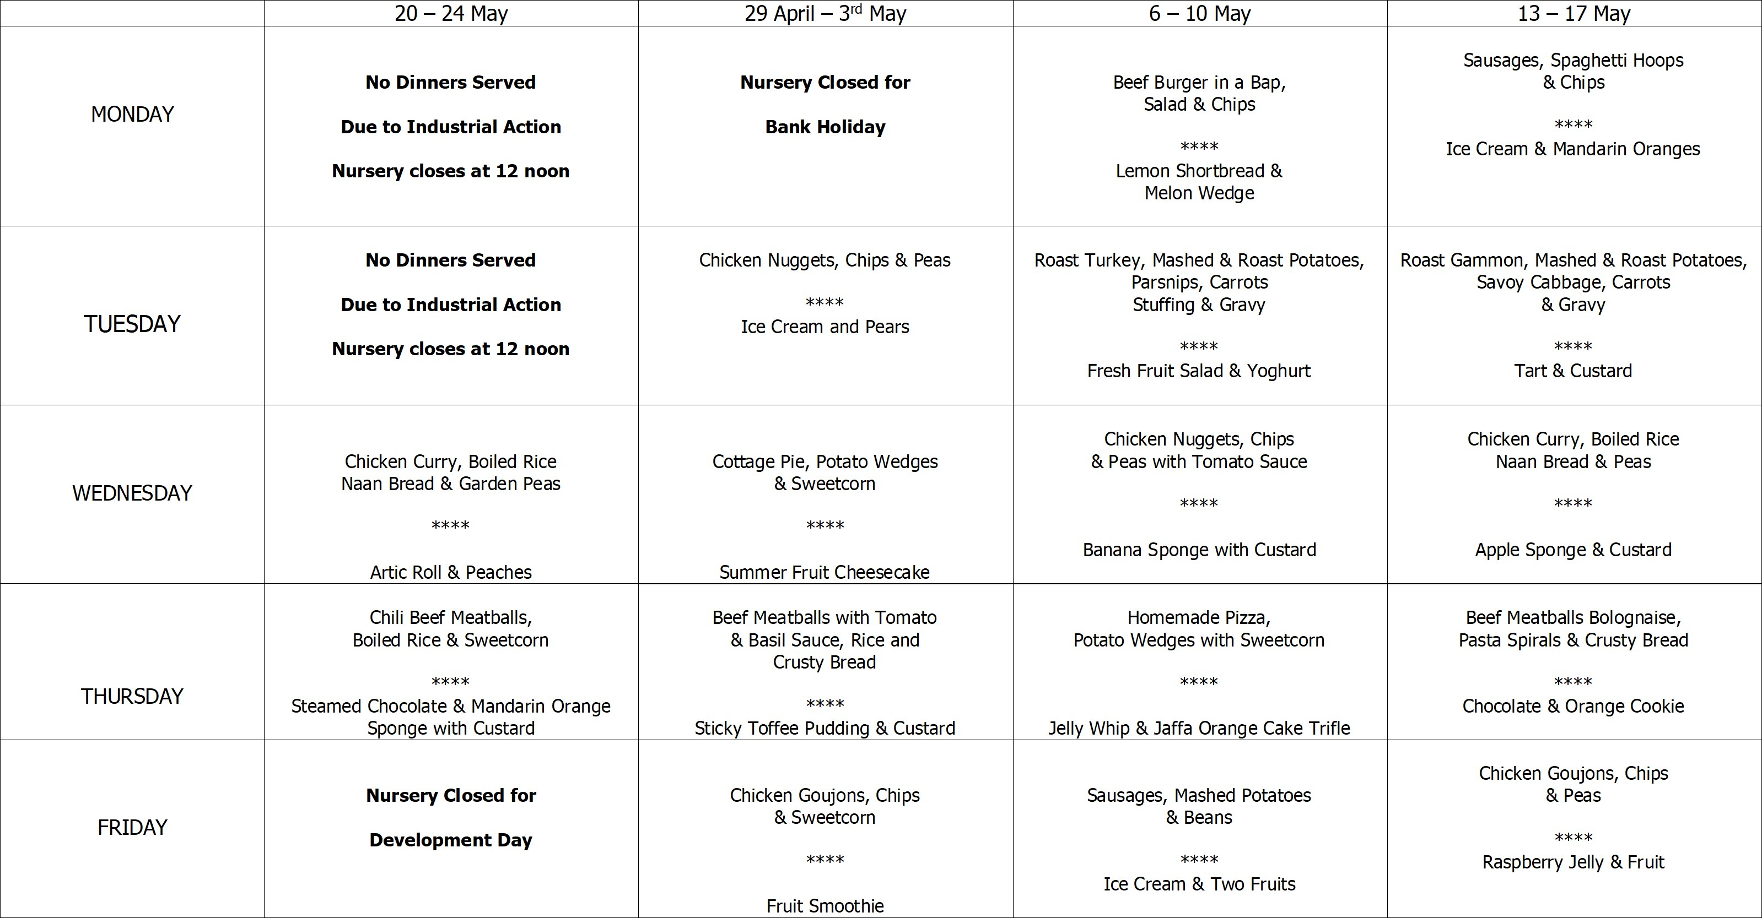



Safeguarding Team

* Mrs Pollock Designated Teacher
* Miss Cowan Deputy Designated Teacher
* Mrs Ball Chair of Governors
* Mrs Magee Governor for Child Protection



* Monday 3rd, Tuesday 4th June, Wednesday 5th & Thursday 6th June - All children to be collected by 1pm to facilitate Play Day Sessions for the children starting in September 2024.
* Friday 7th June - All outstanding snack money to be paid.
* Wednesday 12th June - We will be having a visit from Joe the Drummer. A £3 donation to be paid via Eduspot.
* Friday 16th June - Please return school reports.
* Tuesday 18th June - We will be having a visit from Blackberry Farm. £4 donation to be paid via Eduspot.
* Friday 28th June - Last day of term. Nursery will close at 11:30am.

# Getting Ready For Primary One

Many children will be excited about starting Primary One and others may be anxious.

Over the holiday period, talk with your child about going to Primary One.

To make transition easier, you could try the following things :

* Drive or walk past their new school.
* Talk to them about their teacher and other children from nursery who may be in their class.
* Practise and encourage putting on and zipping up coats.
* Encourage them to put on and take off their jumpers and shoes.
* If you buy a school bag or lunch box, allow the children to practice opening and closing them.
* Read lots of stories together.

