

At Ballyhenry Nursery School we believe that children benefit most when teachers and parents work together and both are involved in the child’s learning. We hope to strengthen this relationship by providing you with ideas on how to extend and develop learning with your child. You may wish to visit the Department of Education’s website for ideas… [www.nidirect.gov.uk/educationworks](http://www.nidirect.gov.uk/educationworks).

Each day we are encouraging children to wash their hands carefully. Discuss the pictures below with your child and talk about times when he/she should wash their hands

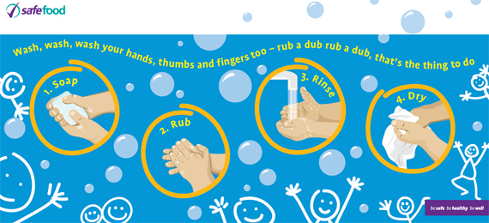

Children love to work with the play dough and it develops their fine motor skills**.**

**Basic Dough**

2 cups of plain flour

1 cup of salt

1 tbsp cooking oil

Add water gradually to dough consistency. This dough can also be used for modelling and then place in a very low oven to dry for at least twelve hours. This dough is firm, pliable and smooth. May need a little flour to stop it sticking.

**Microwave Dough**

1 cup of plain flour

½ cup of salt

2 tsp cream of tartar

1 tbsp oil

1 cup water

Food colouring (add to water)

Put all ingredients into a bowl suitable for the microwave. Cook at full power for one minute. Remove from microwave and stir well. Put back into oven and cook for a further 1-1.5 minutes. Remove from oven and scrape out with a wooden spoon and leave to cool. Knead well, adding food colouring at this point. Store in a polythene bag to remain soft.

**Basic Dough**

2 cups of plain flour

1 cup of salt

1 tbsp cooking oil

# Welcome to Nursery

**Home School Links**