* **Monday 1st May –** Bank Holiday – Nursery will be closed.
* **Friday 5th May –** Wee Critters visiting nursery. £1 donation via Eduspot please.
* **Monday 8th May -** Coronation Bank Holiday. Nursery will be closed.
* **Thursday 11th May –** Mrs Pollock’s Class Trike Ride at 12:45pm.
* **Friday 12th May –** Miss Cowan’s Class Trike Ride at 12:45pm.
* **Thursday 18th May –** Election Day – nursery closes at 12 noon . No dinners will be served.
* **Monday 22nd & Tuesday 23rd May –** Mrs Pollock will be doing September 2023 intake interviews. Mrs Thompson & Miss Rea will be teaching the class alongside Miss Eves.
* **Thursday 25th May –** Blackberry Farm Visit. £1 donation via Eduspot please.
* **Thursday 25th May –** Trike Ride Donations to be returned.
* **Friday 26th May –** School Development Day – Nursery will be closed.
* **Monday 29th May –** Bank Holiday – Nursery Closed.

# Important Items to Note

* As the weather hopefully starts to change and we get to enjoy some sunshine we would ask if you could please ensure your child has some screen protection on coming to school. If you do not wish staff to reapply sun cream later in the day please inform us via Seesaw
* Sunhats are available to buy at £3 on the school money app.
* School reports will be issued in June.

This month our topic will be ***MINIBEASTS***.

We will be observing caterpillars change into butterflies. We will also focus on Jungle animals.

We will be using ‘lots’ of colours in our art and creative activities.

We hope to celebrate the King’s Coronation in nursery with fun activities,

# Sponsored Trike Ride

Our annual Trike Ride will be held on Thursday 11th May (Mrs Pollock’s Class) and Friday 12th May (Miss Cowan’s Class) weather permitting at 12:45pm. Please come and spectate.

This is our main fundraising event in the nursery year. We would ask if all money could be put in an envelope and marked with your child’s name, this can then be handed to either Mrs Pollock or Miss Cowan at the start of the day or dropped into Michelle in the office. As you are all aware from the Press, budgets have been dramatically reduced so this fundraiser will be used to purchase resources for the school.

If your child will be finishing nursery early (before 30th June), please advise Mrs Pollock or Miss Cowan in advance.

As we start approaching the end of term, we would ask that all outstanding snack money be paid by Tuesday 20th  June to allow for end of year banking.

# DATES FOR YOUR DIARY

# Reminders

# Monthly Topic

May 2023

Nursery News & Home School Link

Ballyhenry Nursery School

Glenvarna Court Newtownabbey, BT36 5JD

Tel : 028 90 833 884

Principal : Mrs L Pollock B.A Hons

Email: info@ballyhenryns.glengormley.ni.sch.uk

Web : www.ballyhenrynurseryschool.co.uk

Ballyhenry Nursery

banner with apples and crayons

Go into your garden or park and look for bugs.

Take an old yoghurt pot to put them in.

Can you find any of the following :

**Home School Links**

## Woodlouse

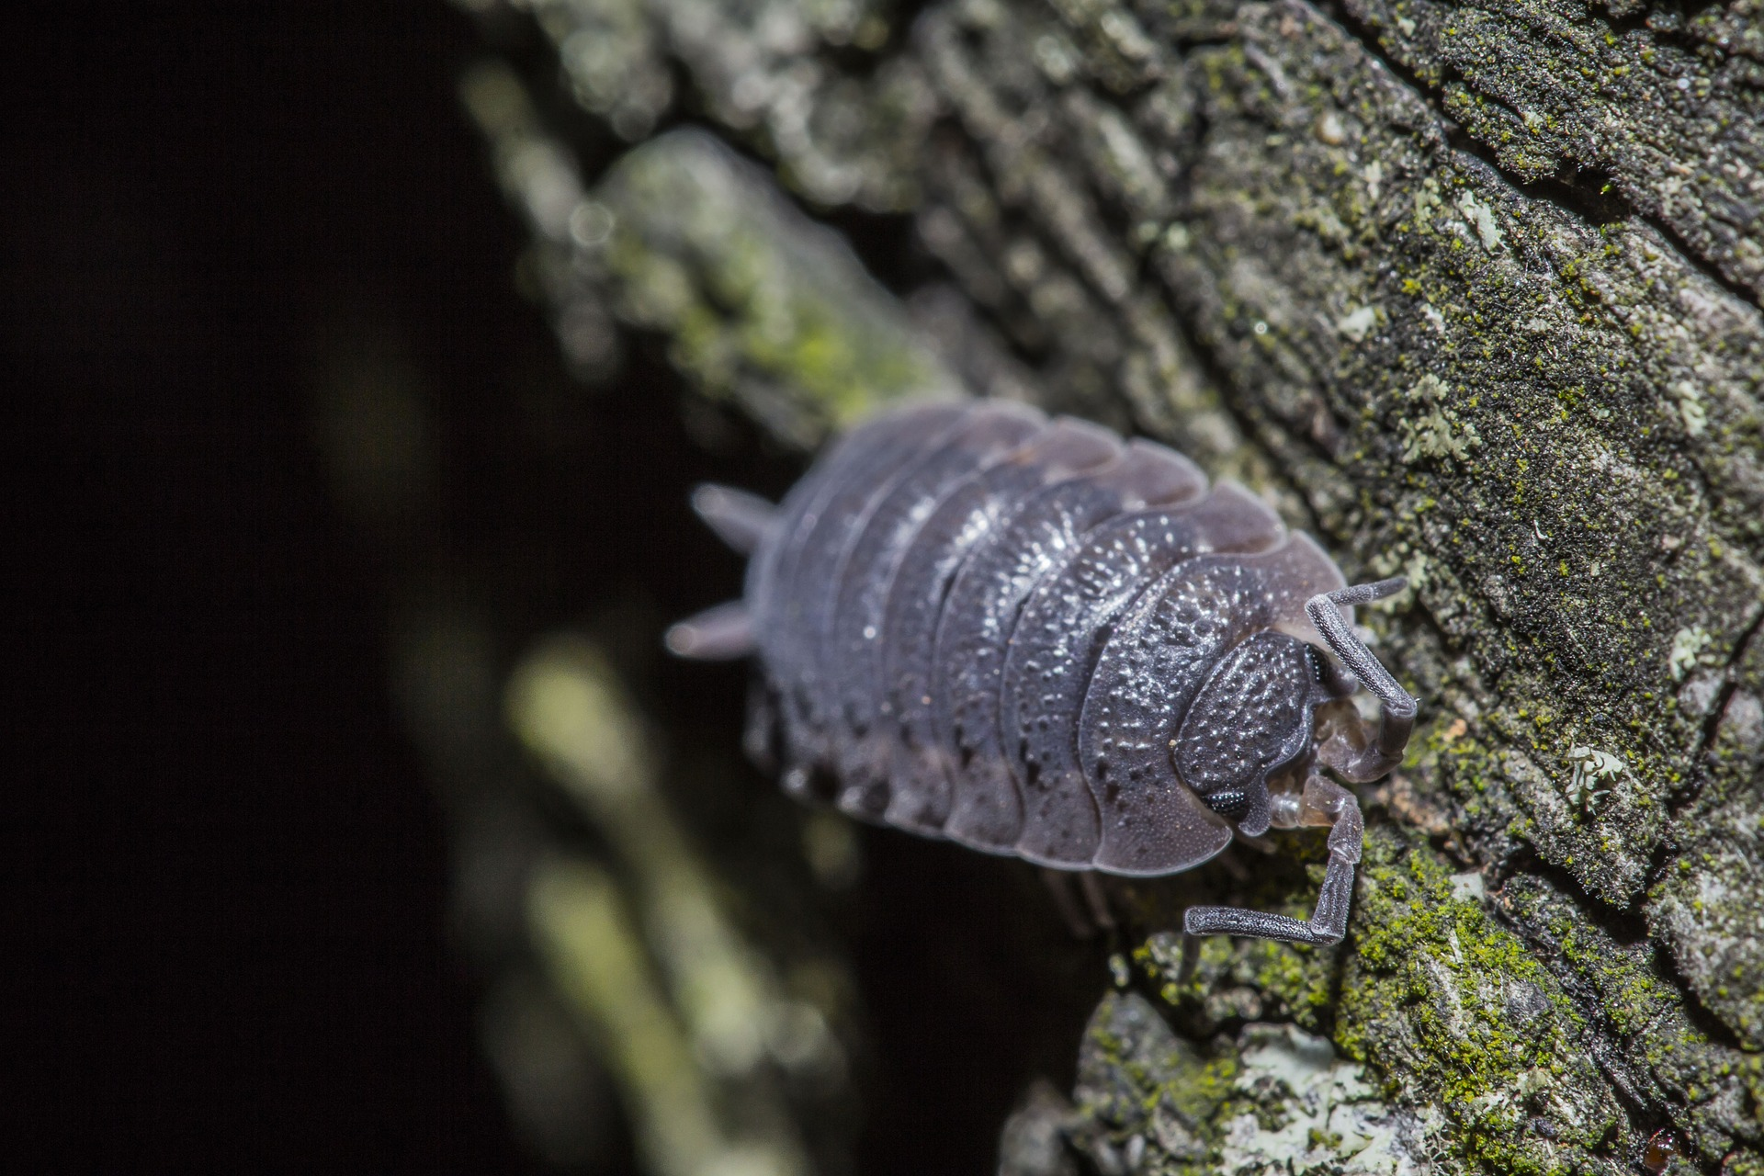

## Millipede

## Ladybird

## Spider

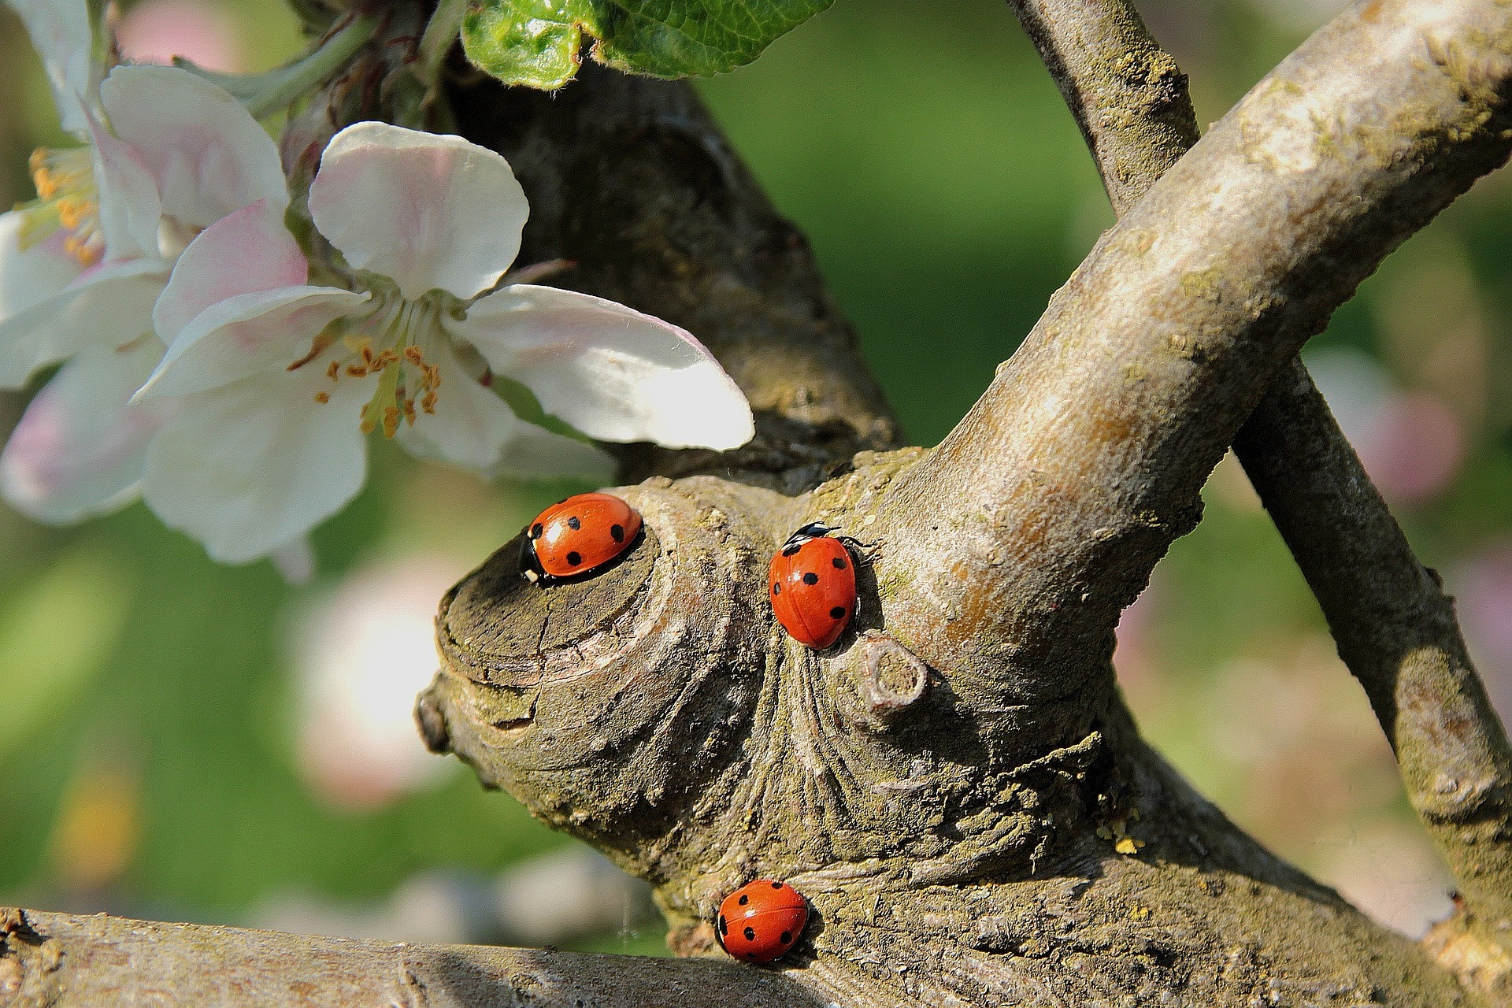

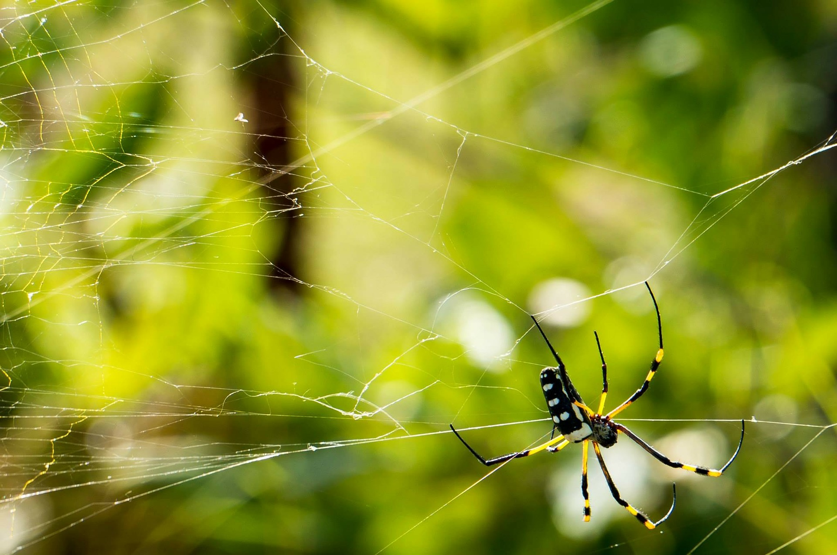

## Snail

## Worm

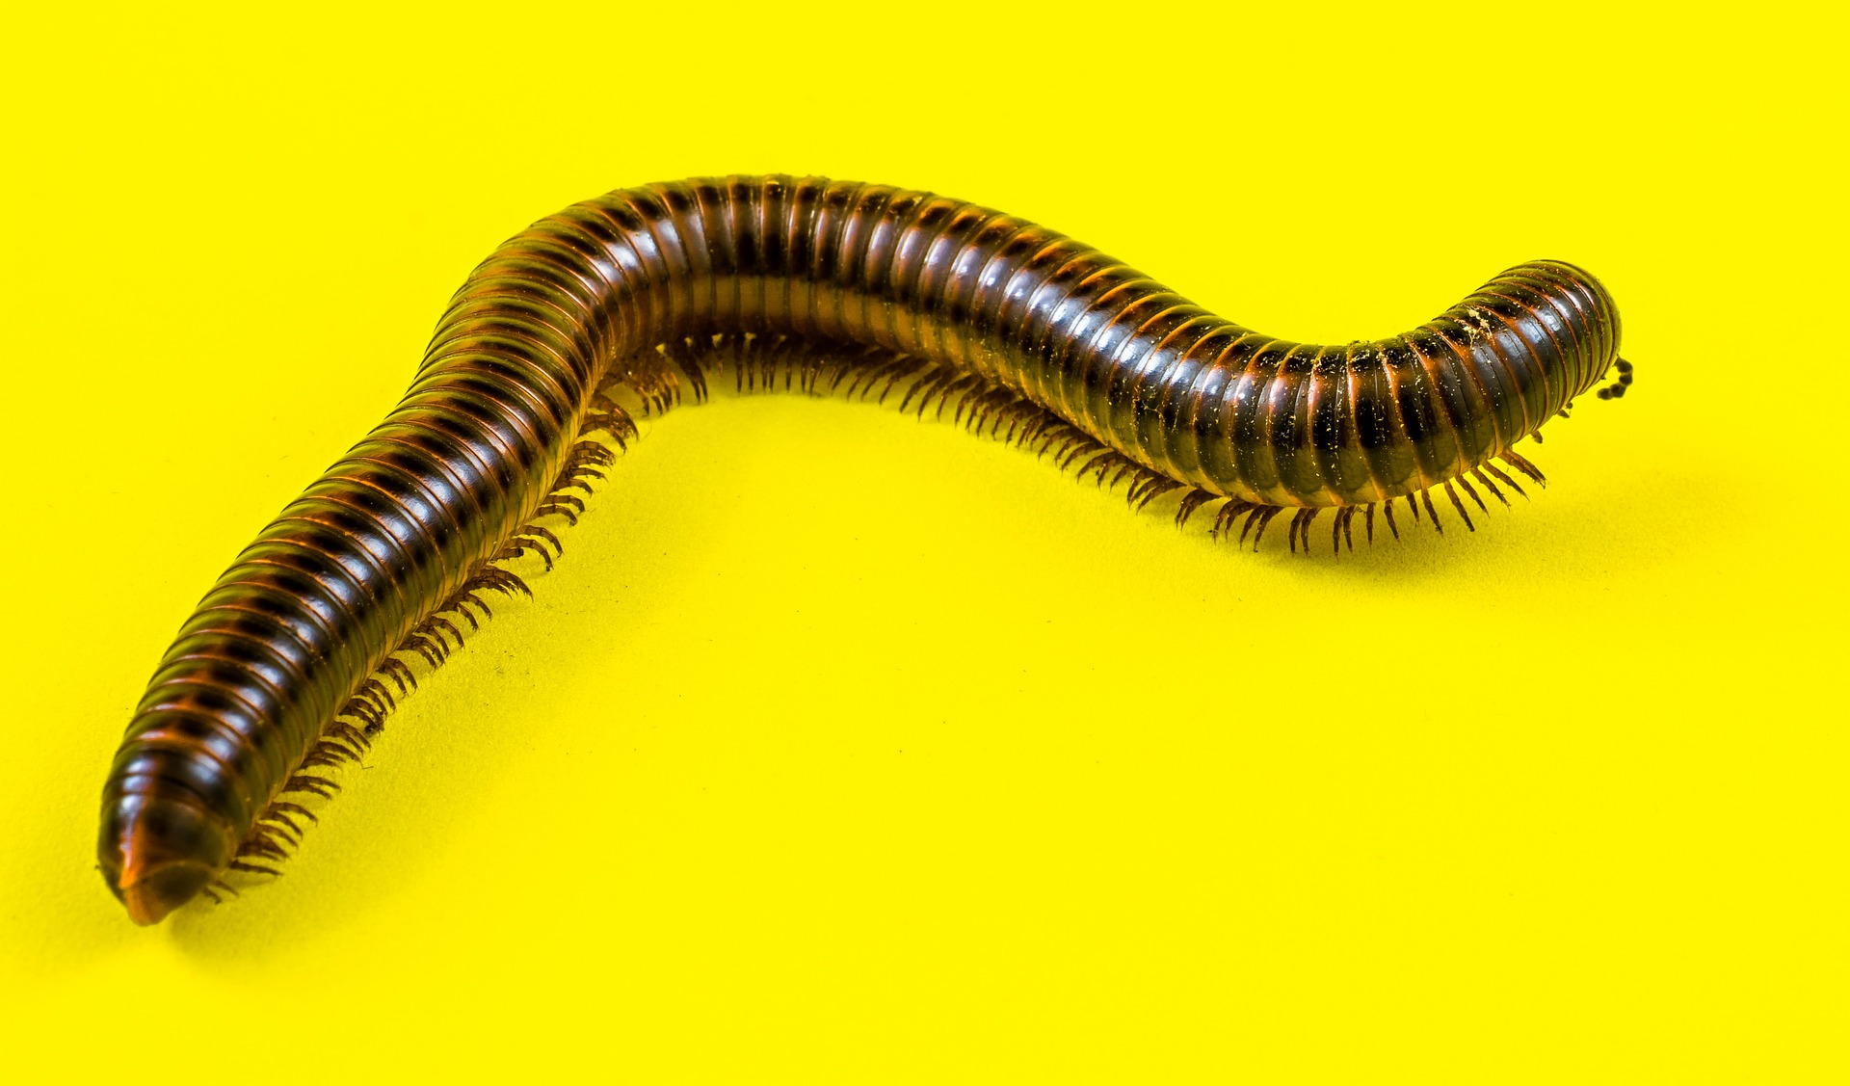

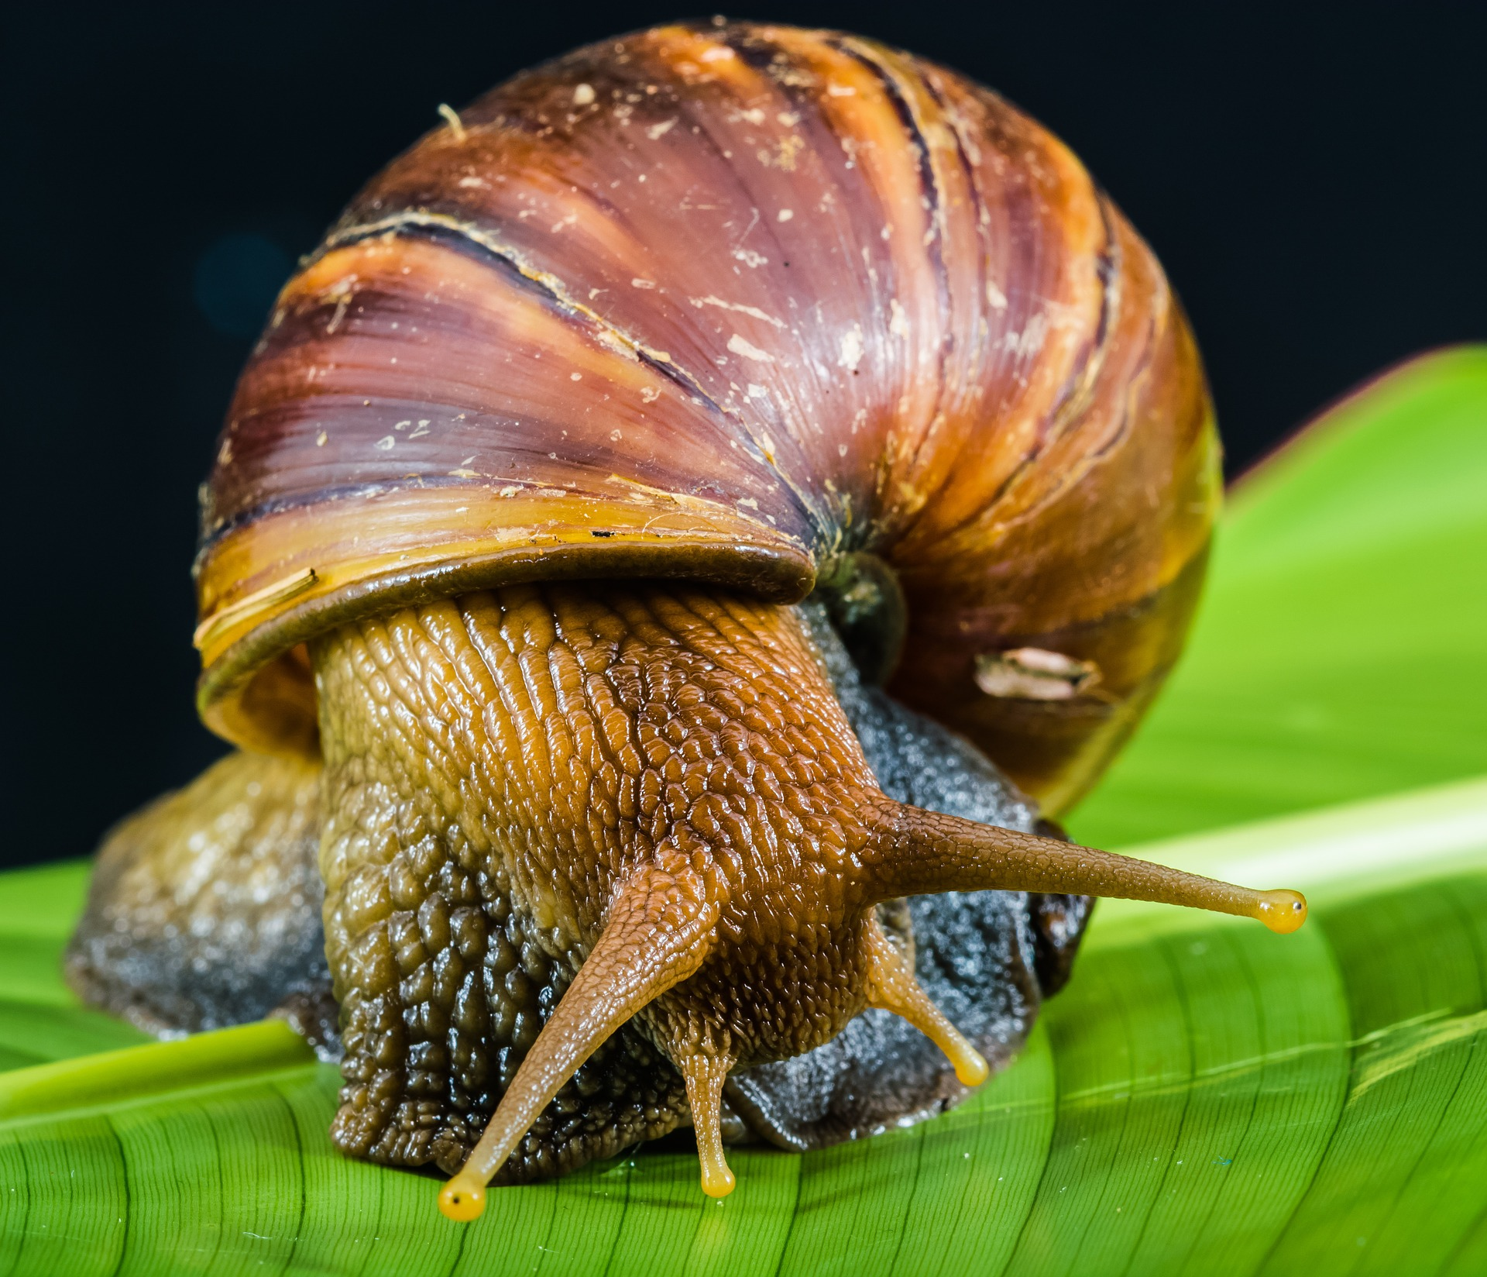



# MINIBEAST HUNT