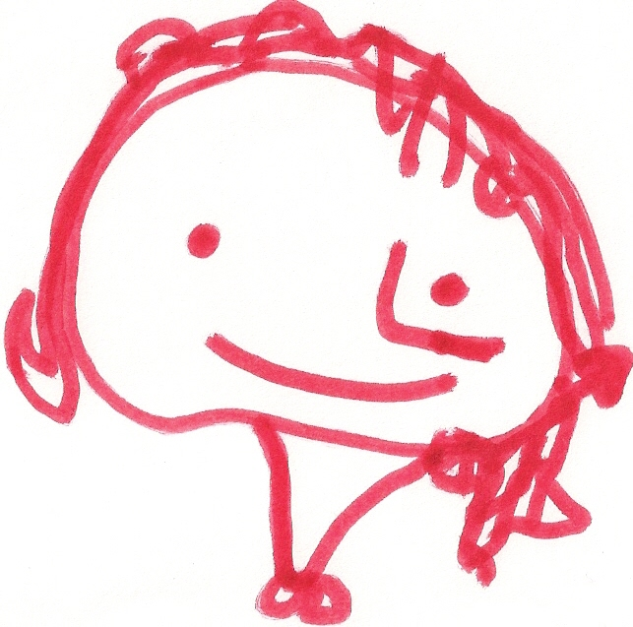
BALLYHENRY NURSERY SCHOOL
MARCH/APRIL RHYMES SONGS

Somebody’s waking up, sniff, sniff, The Easter Bunny’s running, running, running The rain dropped onto my head,
Somebody’s waking up, sniff, sniff The Easter Bunny’s running, The rain dropped onto my head,
A wriggle and a stretch and a yawn so wide, He’s looking for Easter Eggs. The rain dropped onto my head,
Come on little hedgehog, peep outside. I think I’m gonna get wet, wet, wet!
Now his whiskers are twitching, twitching, twitching,
Somebody’s waking up, sniff, sniff Now his whiskers are twitching, The rain dropped onto my nose,
Somebody’s waking up, sniff, sniff He’s looking for Easter Eggs. The rain dropped onto my nose,
A wriggle and a stretch and a yawn so wide, The rain dropped onto my nose,
Come on little dormouse, peep outside. Now his nose is sniffing, sniffing, sniffing, I think I’m gonna get wet, wet, wet!
Now his nose is sniffing,
Somebody’s waking up, sniff, sniff He’s looking for Easter Eggs. The rain dropped onto my chin,
Somebody’s waking up, sniff, sniff The rain dropped onto my chin,
A wriggle and a stretch and a yawn so wide, Now his eyes are looking, looking, looking, The rain dropped onto my chin,
Come on little brown bat, peep outside. Now his eyes are looking, I think I’m gonna get wet, wet, wet!
He’s looking for Easter Eggs.
Somebody’s waking up, sniff, sniff The rain dropped onto my ears…..
Somebody’s waking up, sniff, sniff Now his ears are listening, listening, listening, The rain dropped onto my neck….
A wriggle and a stretch and a yawn so wide, Now his ears are listening, The rain dropped onto my toes ……
Come on little badger, peep outside He’s looking for Easter Eggs.

The Easter Bunny’s running, running, running, 2 Little hedgehogs sitting by a road,
The Easter Bunny’s running, 1 named Marybell and one named Fred,
Five shiny eggs, golden and brown, He’s found his Easter Eggs. Roll up Marybell, roll up Fred,
Listen and you will hear a sound, 2 little hedgehogs sitting by a road.
Tapping away, tapping away,
One little chick is born today. Chick, chick, chick, chick, chicken, 2 little hedgehogs sitting by a road,
Lay a little egg for me, 1 named Marybell and one named Fred,
Four shiny eggs, golden and brown Chick, chick, chick, chick, chicken, Peek-a-boo Marybell, Peek-a-boo Fred,
Listen and you will hear a sound, I want one for my tea, 2 little hedgehogs sitting by a road.
Tapping away, tapping away, I haven’t had one since breakfast,
One little chick is born today. And now it’s half past three,
So chick, chick, chick, chick, chicken, Easter Bunny, soft and white
Three shiny eggs, golden and brown…. Lay a little egg for me! Hopping quickly out of sight,
Thank you for the eggs you bring,
Two shiny eggs, golden and brown…. At Eastertime we welcome Spring,
Easter Bunny, soft and white
One shiny egg, golden and brown …. Hopping quickly out of sight.
(Tune : Twinkle, Twinkle Little Star)

Hundreds and hundreds of birds, Five little ducks went swimming one day, Little Tommy Tadpole,
Singing away, singing away, Over the pond and far away, Began to weep and wail,
Hundreds and hundreds of birds, Mama Duck said, “Quack, quack, quack, quack” Because little Tommy Tadpole,
It must be Spring! But only four little ducks came back, Had lost his tail,
His mother did not know him,
Hundreds and hundreds of flowers, Four little ducks went swimming one day……. As he sat upon a log,
Nodding their heads, nodding their heads, Because little Tommy Tadpole
Hundreds and hundreds of flowers, Three little ducks went swimming one day ….. Was now …..
It must be Spring! MR THOMAS FROG!
Two little ducks went swimming one day ……
Hundreds and hundreds of lambs,
Leaping around, leaping around, One little duck went swimming one day, 5 little peas in a pea pod pressed,
Hundreds and hundreds of lambs, Over the pond and far away One grew, two grew,
It must be Spring! Mama Duck said, “Quack, quack, quack, quack” And so did all the rest,
And all the little ducks came swimming back. They grew and grew,
Hundreds and hundreds of chicks, And did not stop,
Waiting for worms, waiting for worms, Until one day,
Hundreds and hundreds of chicks, Six little ducks that I once knew, The pod went POP!
It must be Spring! Fat ones, skinny ones, tall ones too,
But the one little duck with the feathers on his back,
He ruled the others with a quack, quack, quack! I’m a yellow sunflower,
A tiny seed was sleeping underneath the ground, Strong and tall,
A tiny seed was sleeping underneath the ground, See my petals,
And the rain came, drip, drop Oats and beans and barley grow, See my stalk,
And the sun shone down. Oats and beans and barley grow, When I feel the sunshine, I will grow,
You, nor I, nor anyone knows, Taller and taller and taller I go.
A little shoot was peeping out of the seed, How oats and beans and barley grow. (Tune : I’m a Little Teapot)
A little shoot was peeping out of the seed,
And the rain came drip, drop First the farmer sows his seeds,
And the sun shone down. Then he stands and takes his ease,
Stamps his feet and claps his hands Mix a pancake, stir a pancake,
It grew into leaves of green, swaying in the breeze, And turns around to view the land. Pop it in the pan,
It grew into leaves of green, swaying in the breeze, Fry a pancake, toss a pancake,
And the rain came drip, drop Catch it if you can!
And the sun shone down. Five green leaves, high up in the trees,
Five green leaves, swaying in the breeze, Mix some flour and eggs and milk,
And from the leaves there grew a flower, yellow & bright, Along came a caterpillar, looking for his lunch, And cook them in a pan,
And from the leaves there grew a flower, yellow & bright Gobbles up the first leaf, Toss your pancake in the air,
And the rain came, drip drop, MUNCH! MUNCH! MUNCH! Then catch it if you can.
And the sun shone down Oh, where did the pancake go?
Where did the pancake go?
Where did it go? Nobody know,
Oh, where did the pancake go?

