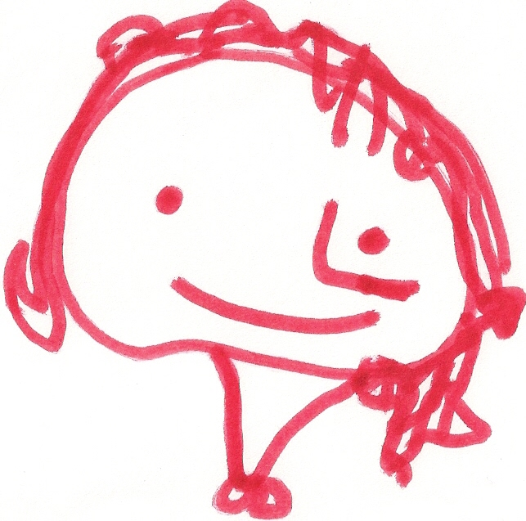
BALLYHENRY NURSERY SCHOOL
DECEMBER RHYMES/SONGS

Christmas Pudding, Christmas pudding, When Santa got stuck up the chimney, Parr-um-tum-tum, Parr-um-tum-tum
Steaming hot, steaming hot, He began to shout, Listen can you hear the drum?
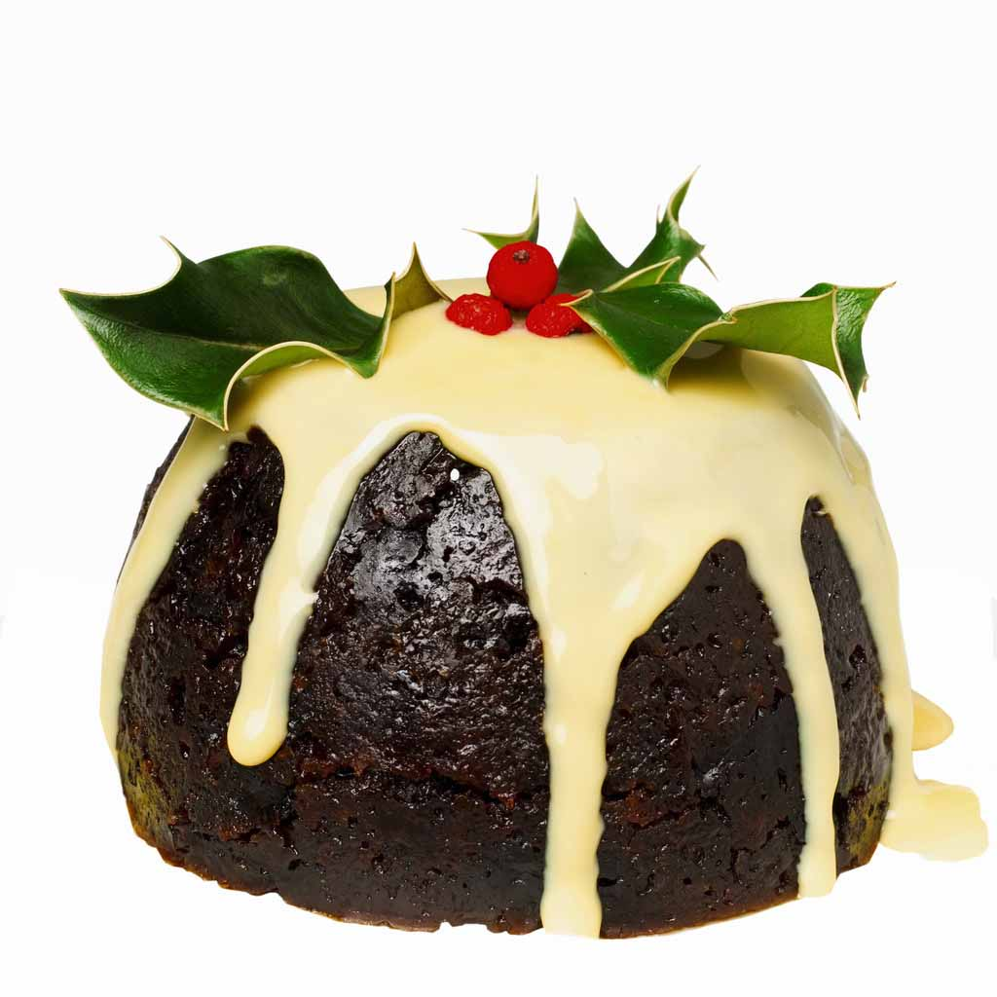
Sprinkle on the sugar, sprinkle on the sugar, “You girls and boys won’t get any toys, Parr-um-tum-tum, Parr-um-tum-tum
Eat me hot, eat me hot. If you don’t pull me out! Listen to the beating drum.
My beard is black,
There’s soot in my sack, Parr-um-tum-tum, Parr-um-tum-tum
5 Mince Pies My nose is tickling too” Crash, bang, wallop, this is fun!
5 mince pies in the Baker’s shop, When Santa got stuck up the chimney, Parr-um-tum-tum, Parr-um-tum-tum
Round and fat with sugar on the top, Atchoo, atchoo, atchoo. Crash, bang, wallop, this is fun!
Along came a boy with a penny one day,
Bought a mince pie and took it away Parr-um-tum-tum, Parr-um-tum-tum
Listen can you hear the drum?
4 Mince Pies ….. etc… Santa Claus is big and fat, Parr-um-tum-tum, Parr-um-tum-tum
He wears black boots, Listen to the beating drum.
And a bright red hat,
5 Christmas crackers on the Christmas tree, His nose is red,
5 Christmas crackers on the Christmas tree, Just like a rose,
If I pulled one and saved the rest for me, And he ‘ha, ha, ha, ho’s’
How many Christmas crackers on the Christmas tree? From his head to his toes.

Dashing through the snow,
On a one horse open-sleigh, A chubby little snowman had a carrot nose,
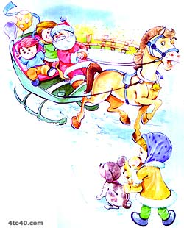
Over the hills we go, Along came a rabbit and what do you suppose?
Laughing all the way, That hungry little Bunny was looking for his lunch
Bells on bob-tail ring, Ate the snowman’s carrot nose,
Making spirits bright, Nibble, nibble crunch.
Oh what fun it is to ride and sing,
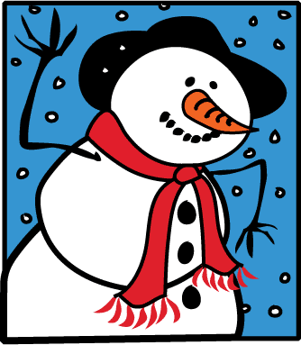
A sleighing song tonight.
We wish you a Merry Christmas,

Jingle bells, jingle bells, We wish you a Merry Christmas,
Jingle all the way, We wish you a Merry Christmas,
Oh what fun it is to ride And a Happy New Year
On a one-horse open-sleigh,
Good tidings we bring,
For you and your kin,
Away in a manger, We wish you a Merry Christmas
No crib for a bed, And a Happy New Year!
The little Lord Jesus,
Lay down his sweet head.
Here is the King, here is the King, A big yellow moon hung in the sky, How can a tiny baby be a splendid King?
Bow to the King, I’m sure I saw him wink his eye How can a tiny baby be Lord of everything?
Here is the King, here is the King, His big yellow face, jolly and round, Cause He’s the Son of God on high,
Bow to the King. Then I saw him wink at me on the ground. King of heaven, earth and sky,
He is a great and wonderful King, He’s here to love you now.
His crown is shiny and new, A big yellow moon, hung in the sky, (Repeat)
But if you forget to bow – he will shout at you! I’m sure I saw him give me a smile,
His big yellow face, jolly and round,
Then I saw him smile at me on the ground. Come down to the stable door,
Come down to the stable door,
Five fine servants stood in a row, A big yellow moon, hung in the sky, Come down to the stable door
Along came the King and shouted so, I’m sure I heard him say goodnight, Don’t pass by.
“Get me a robe that’s green and bright, His big yellow face, jolly and round,
Off you go, don’t be all night!” Then he said goodnight to me on the ground. Look inside, look inside, Jesus in a manger lies,
Look inside, don’t just pass on by,
Being bossy is such fun, Look inside, don’t just pass on by.
Oh he’s a bossy king! Busy, busy, busy, rushing round the square,
Being bossy is such fun, Busy, busy, busy, people everywhere, Come and see the new-born King,
Oh he’s a bossy king! Busy, busy, busy, dashing through the street, Come and see the new-born King,
Busy, busy, busy, what a lot of busy feet! Come and see the new-born King,
Four fine servants stood in a row, Don’t pass on by.
Along came the King and shouted so, Where is the King? Where is the King?
“Get me a robe that’s blue and bright, Where is the King we are seeking? Look inside, look inside, Jesus in a manger lies,
Off you go, don’t be all night!” Where is the King? Where is the King Look inside, don’t just pass on by,
We’d like to find the King. Look inside, don’t just pass on by.
Chorus

Three fine servants stood in a row,
Along came the King and shouted so,
“Get me a robe that’s yellow and bright,
Off you go, don’t be all night!”
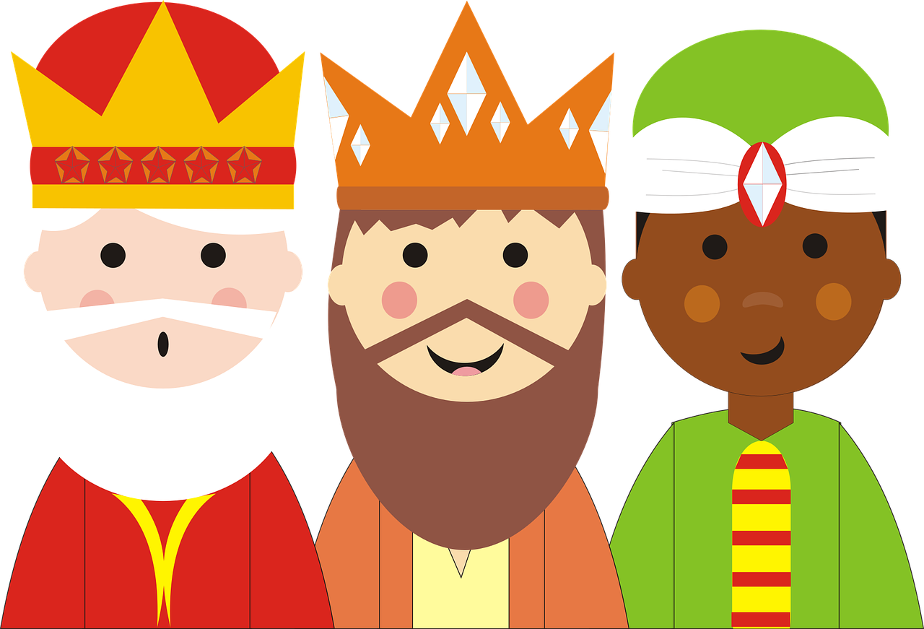

Chorus

Two fine servants stood in a row,
Along came the King and shouted so,
“Get me a robe that’s orange and bright,
Off you go, don’t be all night!”

Chorus

One fine servants stood in a row,
Along came the King and shouted so,
“Get me a robe that’s red and bright,
Off you go, don’t be all night!”
Chorus

