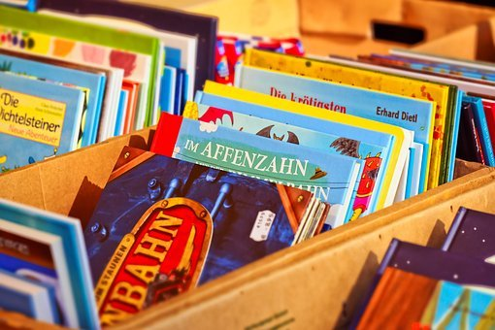

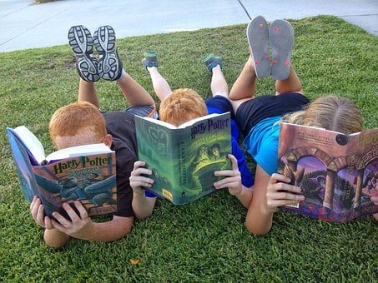

## As part of our Big Bedtime Read theme, we will be having an event in school on Thursday 17th November from 6:30pm – 7:30pm.

Research shows that teaching children to love books and reading in the early years can benefit their literacy development.

Some things to do with your child :

* Share a bedtime story together every night.
* Join the local library – it’s free and look out for other fun activities they have, eg., Story Telling or Rhyme Time.
* Be a good role model. Let your child see you reading a book or magazine and enjoying it.
* Browse through toy catalogues together as they start to appear in the build up to Christmas.
* Make a book together using pictures from a magazine or family photos and then read to other family members,

Make reading fun!

**Home School Links**