# Monthly Topic

Happy, Healthy kids

Go fly a kite

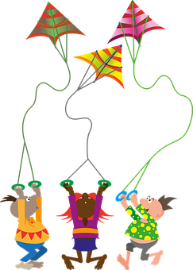

As part of our ‘Happy Healthy Kids’ theme we would encourage you and your child to be active outdoors. We will send home a paper plate for you all to make a kite.

1. Cut out the centre of the plate
2. Allow your child to decorate the plate by drawing or painting on it
3. Sellotape lengths of wrapping ribbon, crepe paper or wool to one end
4. Attach a string handle through a hole
5. Take kite outside and run along to fly the kite
6. Please bring your kite to school to show your friends

Say the rhyme :

*Hey Mr Wind stop whistling,*

*Stop whistling around my toes,*

*Did you know your whistling*

*Is making my toes all cold?*

**Home School Links**