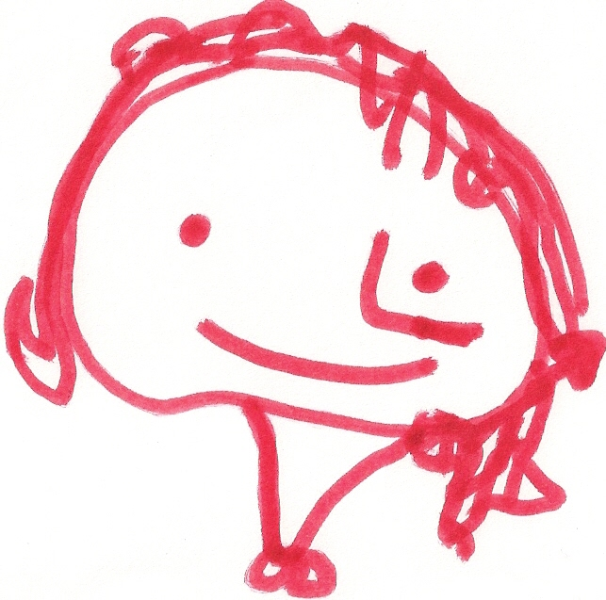
BALLYHENRY NURSERY SCHOOL
DECEMBER RHYMES/SONGS

Christmas Pudding, Christmas pudding, When Santa got stuck up the chimney, Parr-um-tum-tum, Parr-um-tum-tum
Steaming hot, steaming hot, He began to shout, Listen can you hear the drum?
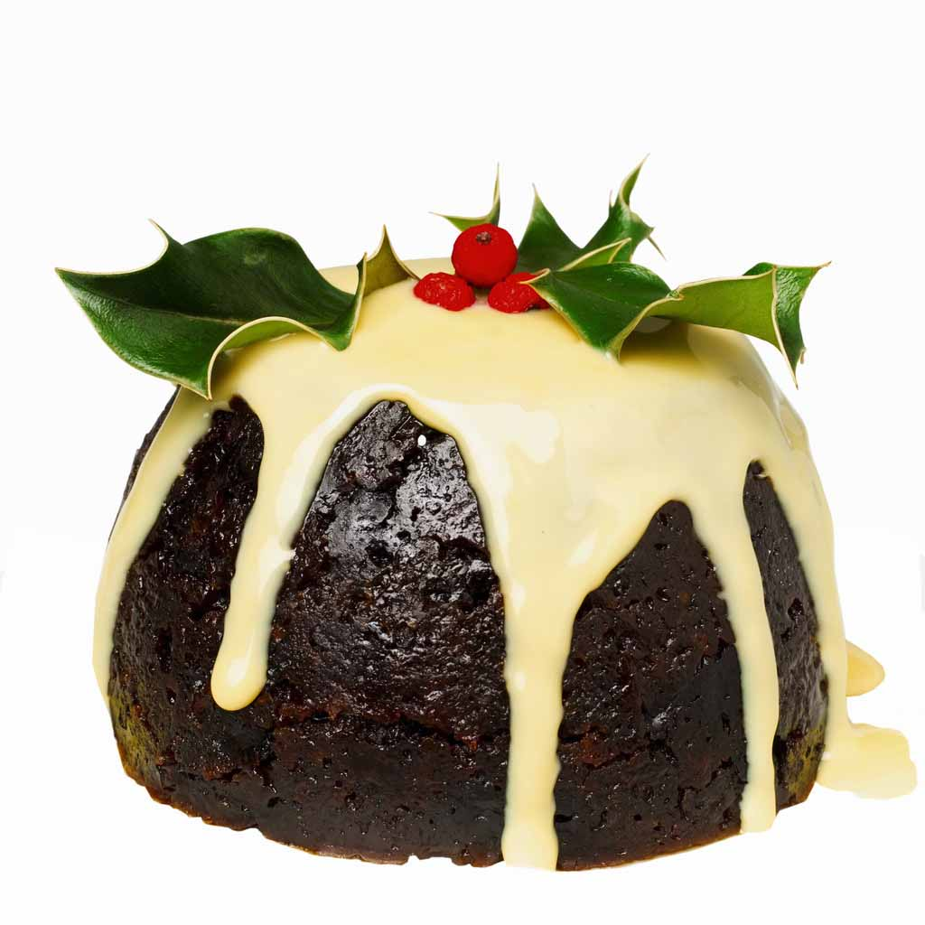
Sprinkle on the sugar, sprinkle on the sugar, “You girls and boys won’t get any toys, Parr-um-tum-tum, Parr-um-tum-tum
Eat me hot, eat me hot. If you don’t pull me out! Listen to the beating drum.
My beard is black,
There’s soot in my sack, Parr-um-tum-tum, Parr-um-tum-tum
5 Mince Pies My nose is tickling too” Crash, bang, wallop, this is fun!
5 mince pies in the Baker’s shop, When Santa got stuck up the chimney, Parr-um-tum-tum, Parr-um-tum-tum
Round and fat with sugar on the top, Atchoo, atchoo, atchoo. Crash, bang, wallop, this is fun!
Along came a boy with a penny one day,
Bought a mince pie and took it away Parr-um-tum-tum, Parr-um-tum-tum
Listen can you hear the drum?
4 Mince Pies ….. etc… Santa Claus is big and fat, Parr-um-tum-tum, Parr-um-tum-tum
He wears black boots, Listen to the beating drum.
And a bright red hat,
5 Christmas crackers on the Christmas tree, His nose is red,
5 Christmas crackers on the Christmas tree, Just like a rose,
If I pulled one and saved the rest for me, And he ‘ha, ha, ha, ho’s’
How many Christmas crackers on the Christmas tree? From his head to his toes.

Dashing through the snow,
On a one horse open-sleigh, A chubby little snowman had a carrot nose,
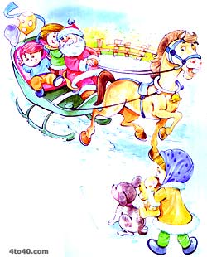
Over the hills we go, Along came a rabbit and what do you suppose?
Laughing all the way, That hungry little Bunny was looking for his lunch
Bells on bob-tail ring, Ate the snowman’s carrot nose,
Making spirits bright, Nibble, nibble crunch.
Oh what fun it is to ride and sing,
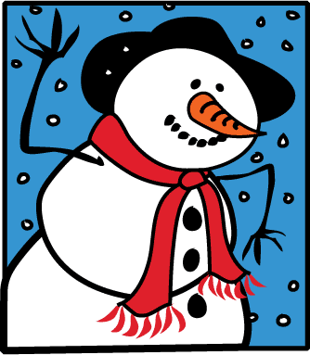
A sleighing song tonight.
We wish you a Merry Christmas,

Jingle bells, jingle bells, We wish you a Merry Christmas,
Jingle all the way, We wish you a Merry Christmas,
Oh what fun it is to ride And a Happy New Year
On a one-horse open-sleigh,
Good tidings we bring,
For you and your kin,
Away in a manger, We wish you a Merry Christmas
No crib for a bed, And a Happy New Year!
The little Lord Jesus,
Lay down his sweet head.
Welcome Welcome An angel appeared in the sky, spreading her wings, spreading her wings
Listen to our story An angel appeared in the sky, spreading her wings
Clap Hands (CLAP CLAP) He spoke in a beautiful voice, loudly and clear, loudly and clear
A baby will soon be born He spoke in a beautiful voice, loudly and clear
Clap hands (CLAP CLAP) He told all the shepherds below, Jesus is born, Jesus is born
A baby will soon be born He told all the shepherds below, Jesus is born
An angel appeared in the sky, spreading her wings, spreading her wings
Welcome Welcome An angel appeared in the sky, spreading her wings
We have a lot to tell you
Welcome Welcome
Such a lot to tell you
Clap hands (CLAP CLAP) Knock, knock, knock
A baby will soon be born We’re knocking on the door
Clap hands (CLAP CLAP) We’ve knocked on a dozen more before
A baby will soon be born All we need is a place to stay
Please Mr Innkeeper, what do you say?
Welcome Welcome
This is our Christmas story Knock, knock, knock
Welcome Welcome Is there any room for us
Listen to our story We really don’t want to make a fuss
Clap Hands (CLAP CLAP) All we need is a place to stay
A baby will soon be born Please Mr Innkeeper, what do you say?
Clap hands (CLAP CLAP)
A baby will soon be born Knock, knock, knock
We’re knocking on the door
We’ve knocked a dozen more before
All we need is a place to stay
Plodding along to Bethlehem Please Mr Innkeeper, what do you say?
Plodding all through the day
Clip Clop, don’t stop
Carry Mary all the way

Plodding along to Bethlehem
No time to stop and play
Clip Clop, don’t stop
Carry Mary all the way

Plodding along to Bethlehem
Plodding all through the day
Clip Clop, don’t stop
Carry Mary all the way

