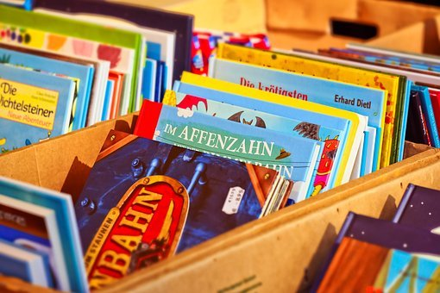

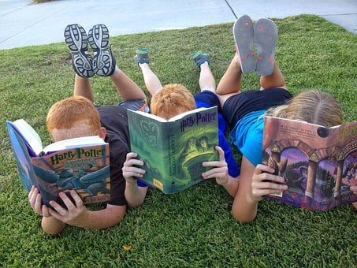

## As part of our Big Bedtime Read theme, we will be sharing stories online at the end of the month with your child.

Research shows that teaching children to love books and reading in the early years can benefit their literacy development.

Some things to do with your child :

* Share a bedtime story together every night.
* Join the local library – it’s free and look out for other fun activities they have, eg., Story Telling or Rhyme Time.
* Be a good role model. Let your child see you reading a book or magazine and enjoying it.
* Browse through toy catalogues together as they start to appear in the build up to Christmas.
* Make a book together using pictures from a magazine or family photos and then read to other family members,

Make reading fun!

**Home School Links**