Many children will be excited about starting Primary 1 and others may be anxious.

Over the holiday period, talk with your child about going to Primary 1.

To make the transition easier, you could try the following things :

* Drive or walk past their new school
* Talk to them about their teacher and other children from nursery who may be in their class
* Practise and encourage putting on and zipping up coats
* Encourage them to put on and take off their jumpers and shoes
* If you buy a school bag or lunch box, allow the children to practise opening and closing them
* Read lots of stories together

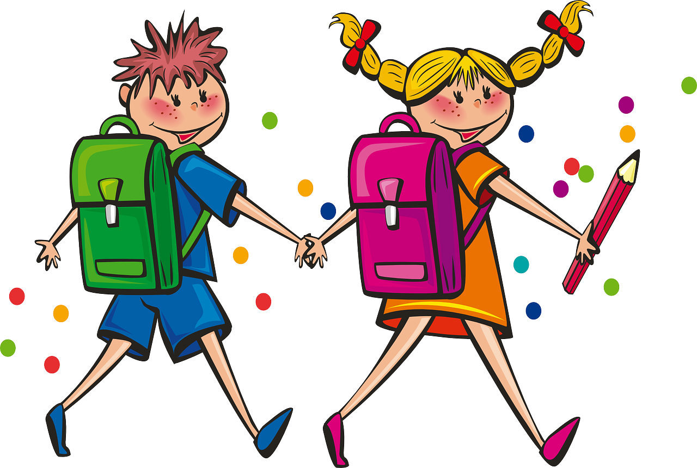

**Home School Links**

# Getting Ready For P1