]

**Thank You!**

Wishing you all the best for the next school year. Do keep in touch to let us know how you are enjoying Primary 1.

.

* Sunhats are available to buy at £3.
* Please return your sponsored ‘Trike Ride’ money as soon as possible. Pass on our thanks to all your friends and family who have contributed so generously. We will inform you of how much we have raised.
* If you are going on holidays and your child will be leaving before 28th June, please let us know.

Transition Reports and Parental Questionnaires will be issued later this month. We would appreciate if you could complete and return these as soon as possible, as we value your opinions.

We will be mounting a display at the rear of the school showing which school the children will be transferring to in September, for your information.

.

* **Wednesdy 30th June – Nursery closes at 11:30am.**

# Important Items to Note

Please remember for ease of administration all outstanding snack and dinner money must be paid by Friday 25th June. If your child happens to be off on Monday 28th and Tuesday 29th June and you have paid dinners you will be issued with a refund.

# Reminders for Parents/Carers

This month our topic will be :

***HOLIDAYS & STARTING SCHOOL***

Everyone is looking forward to sunny days, holidays and Primary 1.

# Monthly Topic

# DATES FOR YOUR DIARY

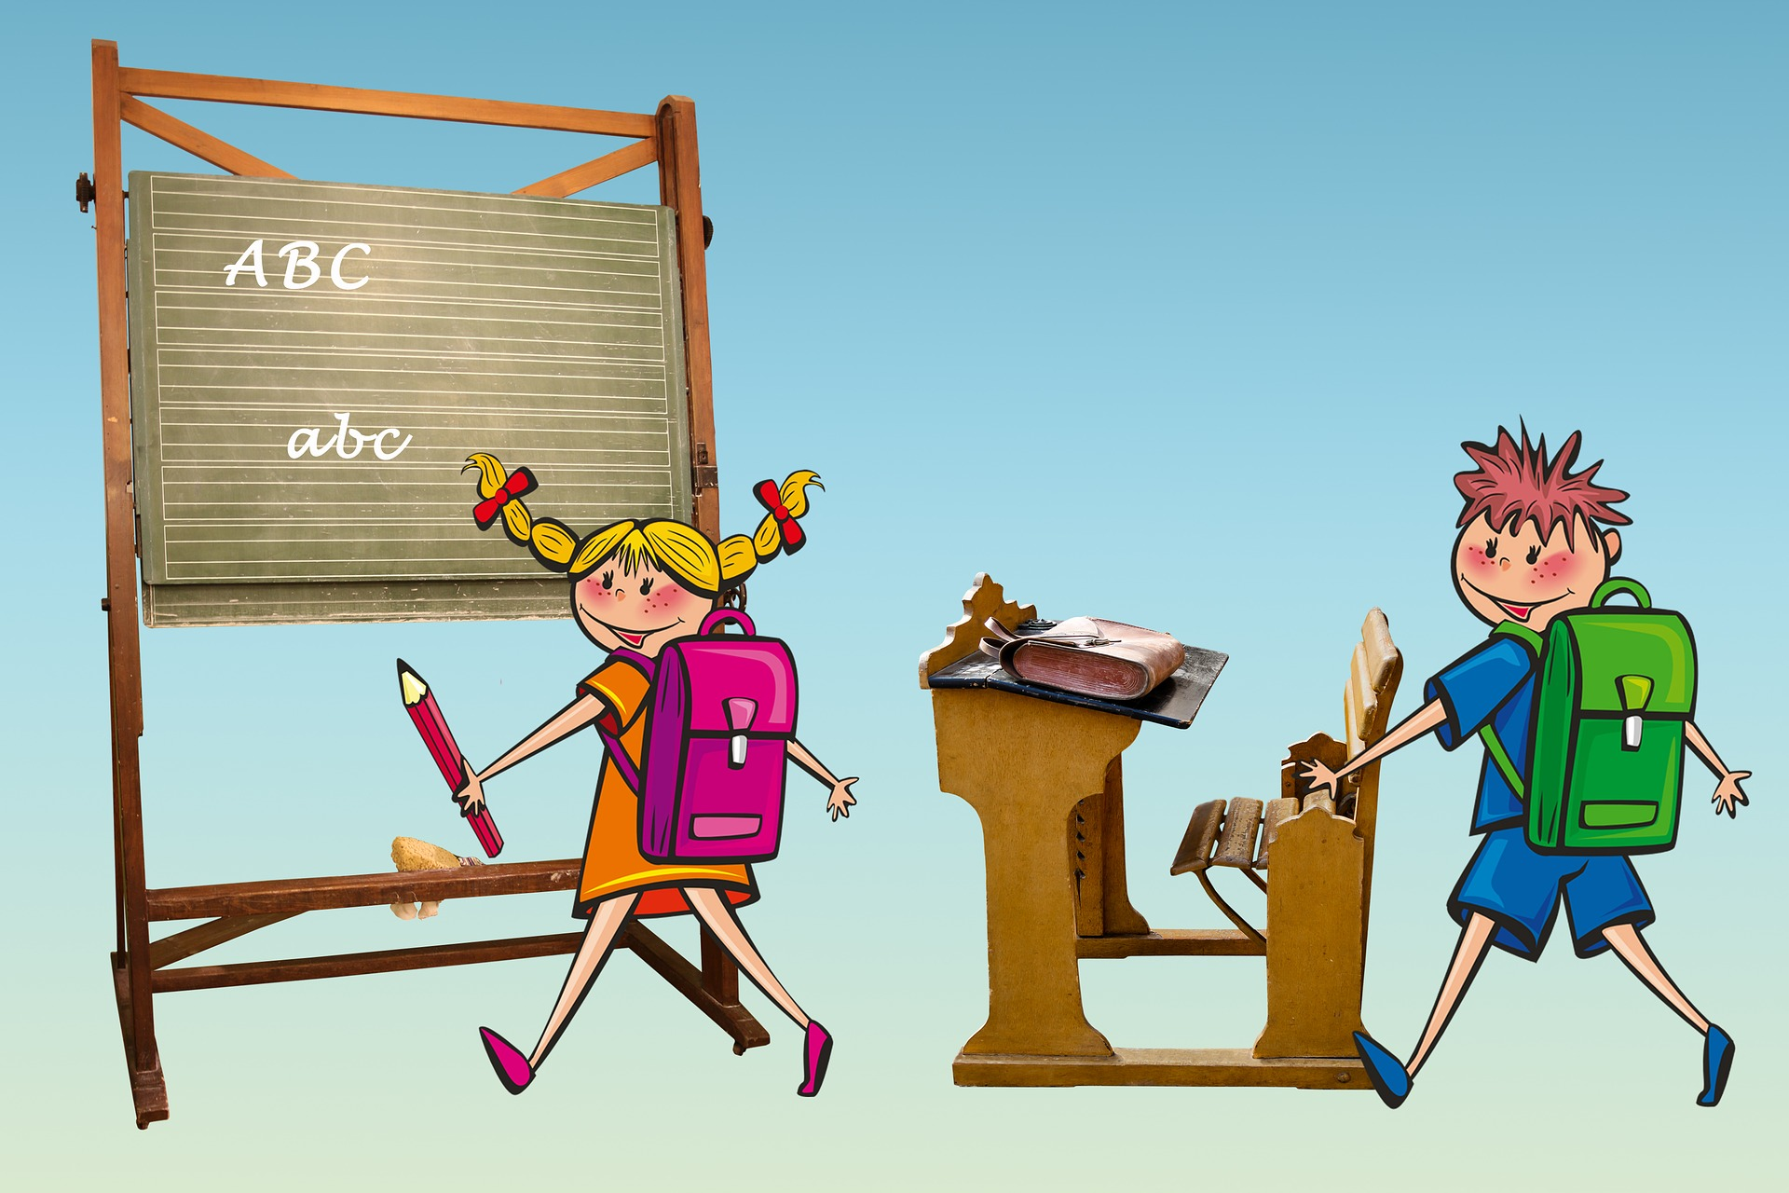

# Transition Reports

June 2021

Nursery News & Home School Link

Ballyhenry Nursery School

Glenvarna Court Newtownabbey, BT36 5JD

Tel : 028 90 833 884

Principal : Mrs L Pollock B.A Hons

Email: info@ballyhenryns.glengormley.ni.sch.uk

Web : www.ballyhenrynurseryschool.co.uk

Ballyhenry Nursery

banner with apples and crayons