Go into your garden or park and look for bugs.

Take an old yoghurt pot to put them in.

Can you find any of the following :

**Home School Links**

## Woodlouse

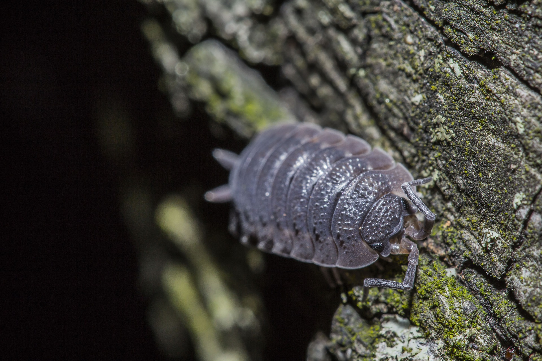

## Millipede

## Ladybird

## Spider

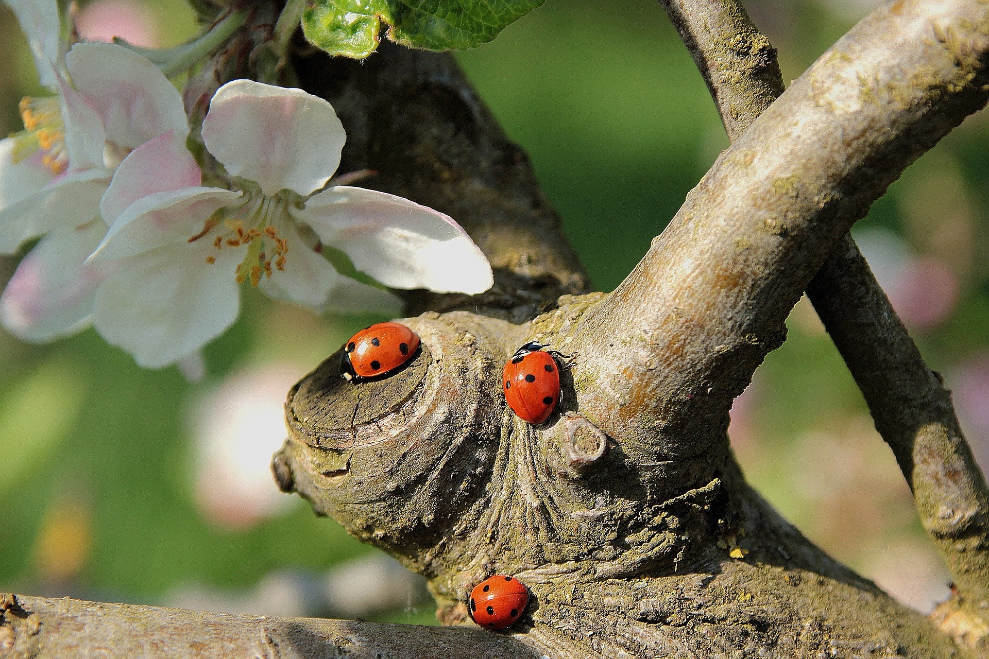

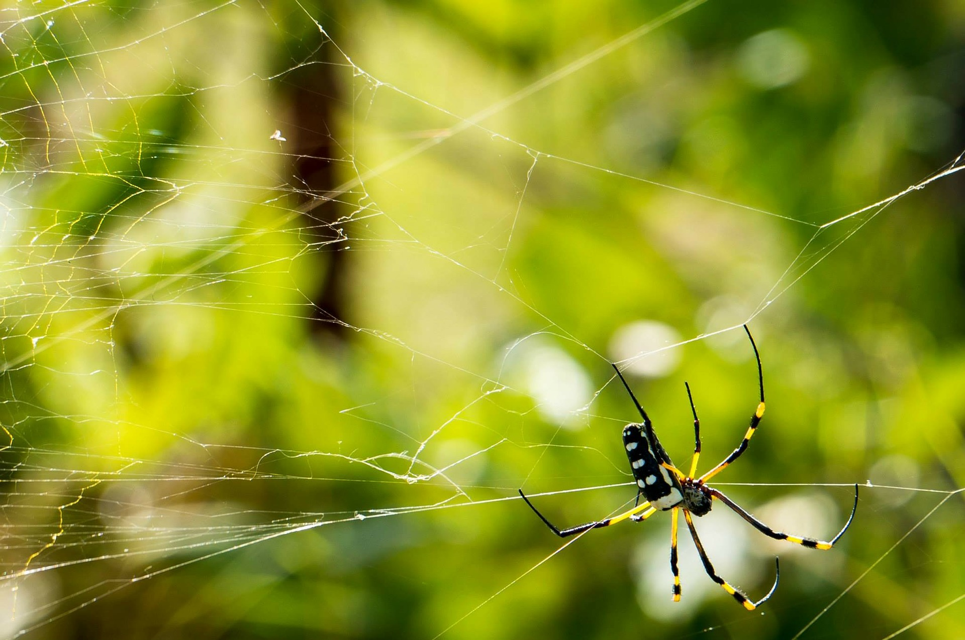

## Snail

## Worm

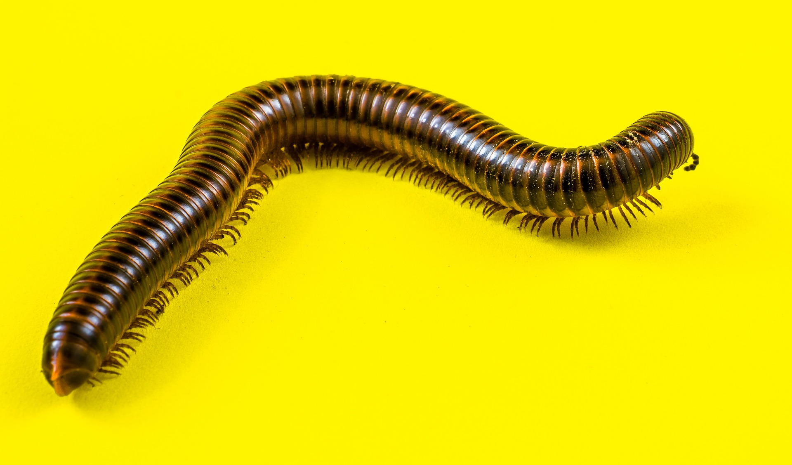

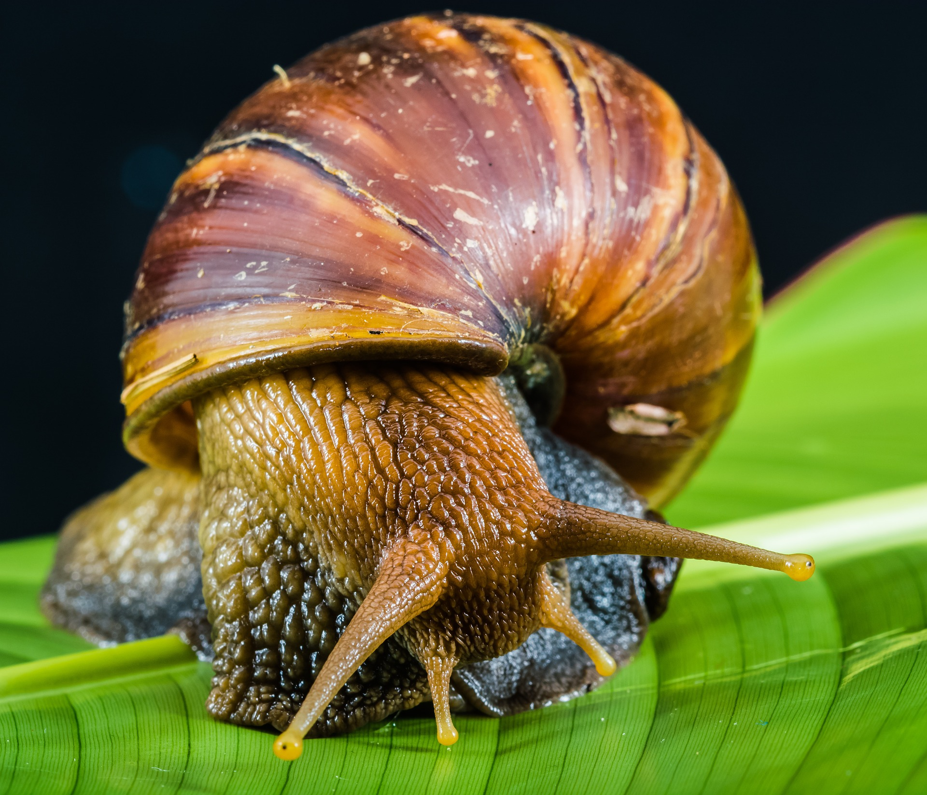

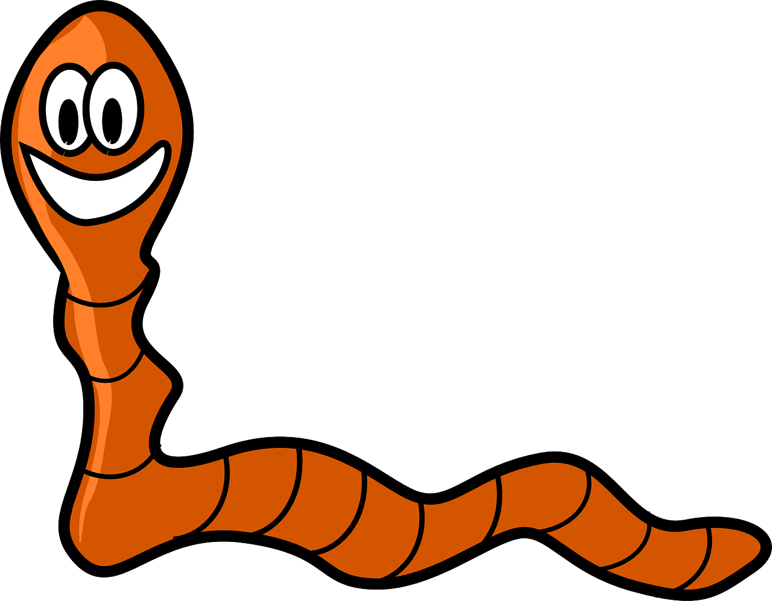

# MINIBEAST HUNT