**Happy, Healthy Kids**

**Go Fly a Kite**

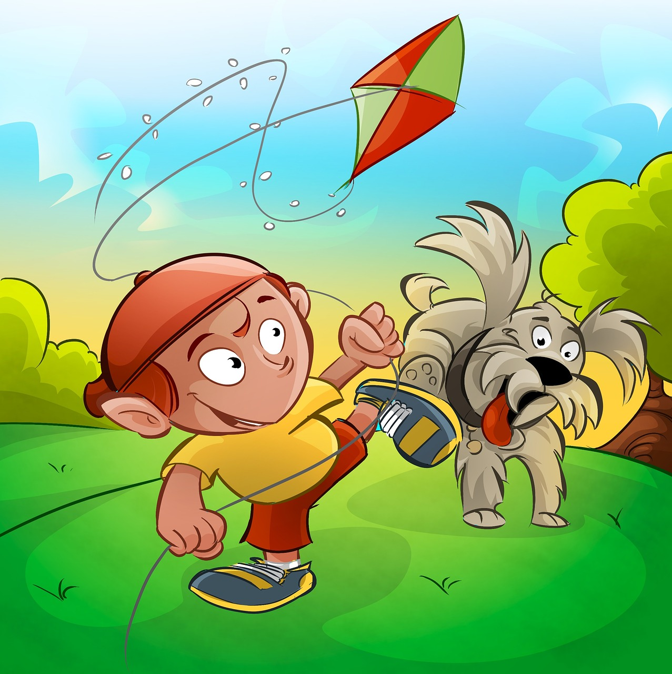

As part of our ‘Happy, Healthy Kids’ theme we would encourage you and your child to be active outdoors. Use a paper plate to make a kite.

1. Cut out the centre of the plate
2. Allow your child to decorate the plate by drawing or painting on it
3. Sellotape lengths of wrapping ribbon, crepe paper or wool to one end
4. Attach a string handle through a hole
5. Take outside and run along to fly the kite

Say the rhyme :

Hey Mr Wind stop whistling,

Stop whistling around my toes,

Did you know your whistling

Is making my toes all cold?

**Home School Links**