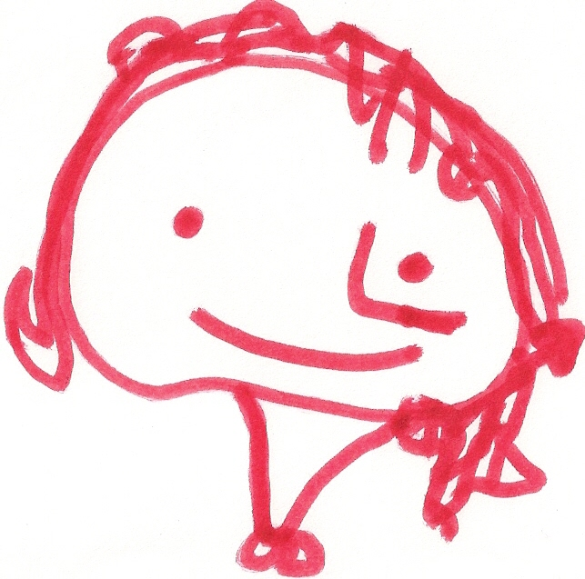
BALLYHENRY NURSERY SCHOOL
FEBRUARY RHYMES/SONGS
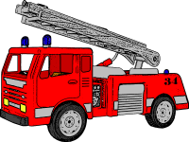

4 Little firemen standing in a row, Lollipop man, lollipop man, I am a firefighter, I wear a yellow hat,
1,2,3,4 ….. whoosh they go! Wave your magic stick, And when the bell rings you can tell,
Hop on the engine with a shout, And make the traffic, stop a while There’s a fire to put out.
Quicker than a wink, the fire is out! So that we can cross the street! So down the pole I slide so fast,
And off in the engine I go,
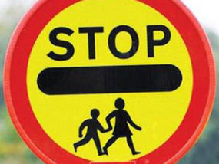
3 Little firemen etc… Racing through the traffic with my siren blowing so….
Hold mum’s hand,
1 Little fireman standing in a row, Hold mum’s hand, Nee-naw, nee-naw, nee-naw, nee-naw,
1,2,3,4 …. Whoosh he goes! To cross the road, Now unwind the hose,
Hops on the engine with a shout, To cross the road, Nee-naw, nee-naw, nee-naw, nee-naw
Quicker than a wink, the fire is out! Stop and look and listen with care, Up the ladders we go,
Stop and look and listen with care, Nee-naw, nee-naw, nee-naw, nee-naw
Of the traffic you must beware, Spray the water on, rescue all the people,
London’s burning, London’s burning, So hold mum’s hand Until the fire’s gone!
Fetch the engines, fetch the engines, (Tune : Three Blind Mice) (Repeat)
FIRE! FIRE! FIRE! FIRE!
Pour on water, pour on water. Jelly on the plate, jelly on the plate,
Brush your teeth each morning, Wibble wobble, wibble wobble,
Brush your teeth each night, Jelly on the plate.
Matches, matches, never touch, That’s the way to keep them,
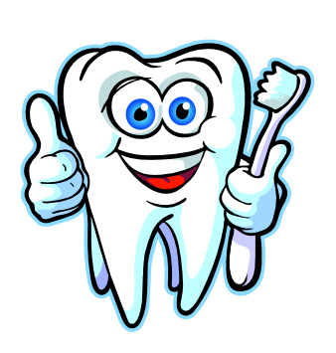

They can hurt you very much, Strong and shining white! Mousie in the hole, mousie in the hole,
Remember what the firemen say, Scritchy, scratchy, scritchy,. scratchy,
Fire is dangerous, stay away, Eat a piece of apple, Mousie in the hole!
Matches, matches, never touch, After having lunch,
They can hurt you very much. Better than a sweet to eat!
It cleans teeth as you munch! Who’s that knocking at my door?
Can it be a dinosaur?
The postman knocks at my front door, If you keep these simple rules, Dinosaurs are huge and grand,
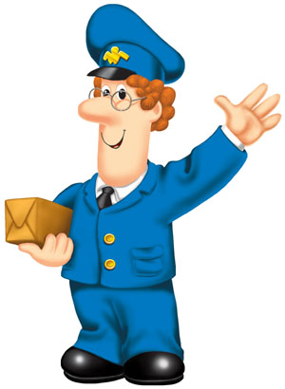
Just like this! Everyone will say, Leaving footprints on the land,
The milkman brings the bottles in, What lovely teeth, As big as anything can be,
Just like this! You children have, I hope he isn’t after me!
The bin man empties all the bins, Let’s see you smile today!
Just like this! (Tune : Here we go round the Mulberry Bush) 10 fat sausages, sizzling in the pan,
And the baker bakes us currant buns, One went POP!
Just like this! And another went BANG!
9, 8, 7 fat sausages etc…

