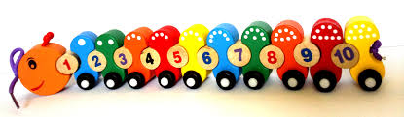

**Numbers Are All Around Us**

Make your child aware of numbers by talking about their age or their siblings ages and what age they will be on their next birthday.

Look for numbers in the environment with your child, eg., mobile phones, or television controls, number plates, house numbers or on clocks.

Use opportunities to rote count with your child through daily activities. As you go up the stairs to bed, count them, sing number rhymes together in the car or walking to nursery, eg., five currant buns or 1,2,3,4,5 Once I caught a Fish Alive. Count toes when getting ready for bed or fingers when putting on gloves. Put magnetic numbers on your fridge and mix them up. Look at the numbers on your car number plates or front door. Use dough to make number 1-5.

Remember, take advantage of fun learning experiences.

**Home School Links**