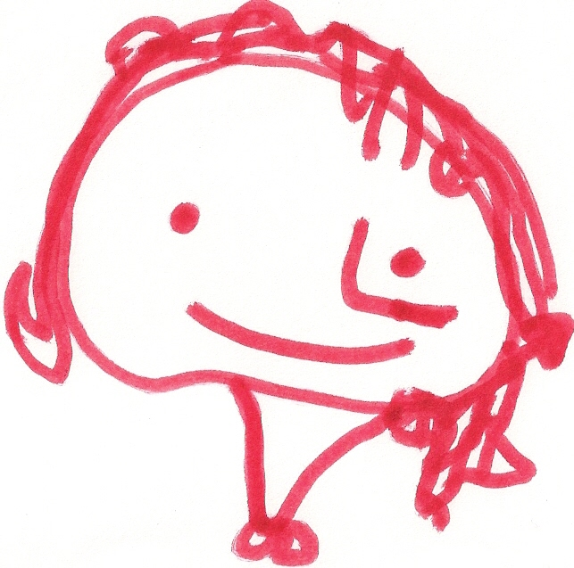
BALLYHENRY NURSERY SCHOOL
JANUARY RHYMES/SONGS
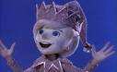

5 little snowmen, standing in a line, Bears are sleeping, bears are sleeping Jack Frost, Jack Frost,
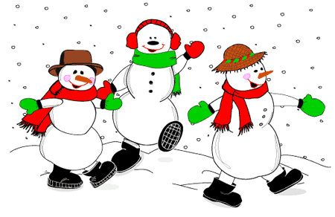
1, 2, 3, 4, 5, so fine In their caves, in their caves What did you do last night?
Out comes the sunshine with a sigh, Wonder when they’ll wake up You came dancing down my street
We’ll see you next year, bye bye. Wonder when they’ll wake up? Turning all the pavements white.
In the spring, in the spring.
4 little snowmen, standing in a line etc
Snowdrop, snowdrop,
Time to wake up, time to wake up Standing on the hill,
Peter, Peter Penguin, marching by, Sleepy bears, sleepy bears, Snowdrop, snowdrop,
Toes turned out and head held high, It is springtime, it is springtime Standing on the hill.
Long black coat and a clean white vest, Wake up now! Wake up now! Green and white, pure and bright,
Peter, Peter Penguin, you’re the best! (Tune Frere Jacques) Snowdrop

I’m a little snowman, white and fat, Hey, Mister Wind, stop whistling, Put your coat on, put your coat on,
Here’s my scarf and here’s my hat, Stop whistling round my toes, And make yourself nice and cosy,
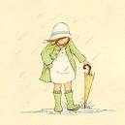
I’ve got buttons, 1, 2, 3 Did you know your whistling, Put your coat on, put your coat on,
Will you count them now with me? Is making my toes all cold? And come along out to play.

Put your hat on, put your hat on,
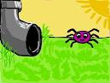
And make your head nice and cosy,
Incy Wincy Spider, One little, two little, three little planets, Put your hat on, put your hat on,
Climbing up a tree, Four little, five little, six little planets, And come along out to play.
Down came the snow, Seven little, eight little, nine little planets,
And made poor Incy freeze. Spinning round the sun. Put your scarf on, put your scarf on,
Out came the sun and melted all the snow. (Tune : Ten little Indians) And make your neck nice and cosy,
Incy Wincy Spider had another go! Put your scarf on, put your scarf on,
And come along out to play.
Five little men in a flying saucer,
A chubby little snowman, Flew around the world one day, Put your boots on, put your boots on,
Had a carrot nose, They looked left and right, And make your feet nice and cosy
Along came a rabbit But they didn’t like the sight, Put your boots on, put your boots on,
And what do you suppose? So one man flew away. And come along out to play.
That hungry little bunny,
Looking for his lunch, Four little men….. three little men… Put your gloves on, put your gloves on,
ATE the Snowman’s carrot nose Two little men…. And make your hands nice and cosy
NIBBLE, NIBBLE, CRUNCH One little man in a flying saucer, Put your gloves on, put your gloves on,
Flew around the world one day, And come along out to play.
He looked up and down and he saw a little town,
And decided he would stay!

