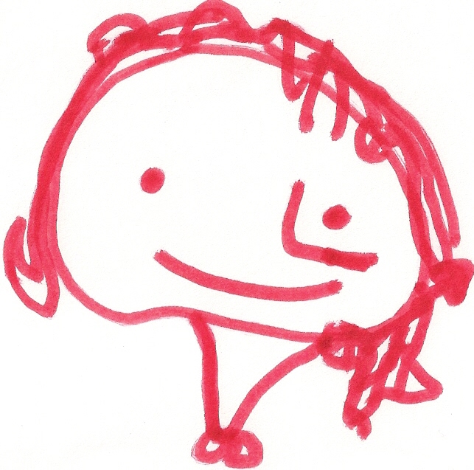
BALLYHENRY NURSERY SCHOOL
NOVEMBER RHYMES/SONGS

When children travel in the car Tommy Thumb, Tommy Thumb, Bend your body,
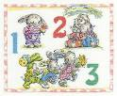
What must they do? Where are you? And touch your toes,
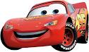
They must sit in the back seat Here I am, here I am Straighten up
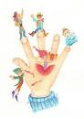
And be strapped in too How do you do? And touch your nose,
Wave your arms
With a toot-toot here, Peter Pointer, Peter Pointer …. And pat each knee,
A toot-toot there, Stamp your feet,
Here a toot, there a toot, Toby Tall, Toby Tall…… And count to 3 …
Everywhere a toot, toot! 1, 2, 3
You must sit in the back seat, Ruby Ring, Ruby Ring…..
I must sit there too!
(tune : Old Macdonald) Baby Small, Baby Small….. Can you wiggle your fingers
Can you wiggle your toes,
Running in the raindrops (x3) Can you wiggle your bottom,
This is the way we hold a hand, hold a hand, hold a hand, We’re getting very wet. Can you wiggle your nose
This is the way we hold a hand,
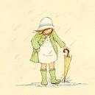
When we’re out for a walk with a grown-up Put your umbrella up (x3) I got the wiggles, I got the jiggles,
We’re getting very wet. I got the wiggles and the jiggles,
This is the way we look left and right, left and right And it makes me want to wriggle,
Left and right, Jumping over puddles (x3) The wiggles and the jiggles today
This is the way we look left and right, We’re getting very wet.
When we’re our for a walk with a grown-up. Can you wiggle your elbows,
Clap, clap goes the thunder (x3) Can you wiggle your knees,
This is the way we listen for cars, listen for cars, We’re getting very wet. Can you wiggle your shoulders,
Listen for cars, Can you smile and say “cheese”
This is the way we listen for cars Splashing in the water (x3)
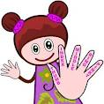
When we’re out for a walk with a grown-up We’re getting very wet.
Pat your nobbly knees (x2)
Now we’re wet and muddy (x3) Pat, pat, pat
If you’re happy and you know it clap your hands (twice) So we are going home. Pat your nobbly knees
If you’re happy and you know it,
And you really want to show it, Clap your little hands (x2)
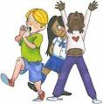
If you’re happy and you know it, clap your hands Can you walk on tip-toe as softly as a cat? Clap, clap, clap
Can you stamp along the road, Clap your little hands
If you’re happy and you know it, stamp your feet… STAMP, STAMP, STAMP?
Can you take some great big strides Ten little fingers, ten little toes,
If you’re happy and you know it, nod your head….. Just like a giant can? Two little eyes, one little nose,
Or walk along so slowly One little mouth, And oh, I declare,
If you’re happy and you know it do all three…… Like a poor bent old man? Two little ears, hidden under my hair!

