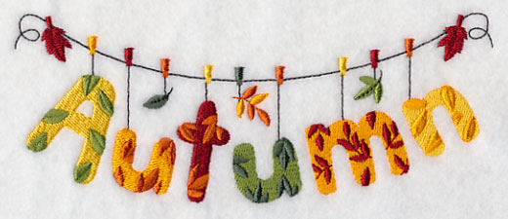

In nursery we are thinking about Autumn. Go for a walk and see if you can find and collect these leaves.

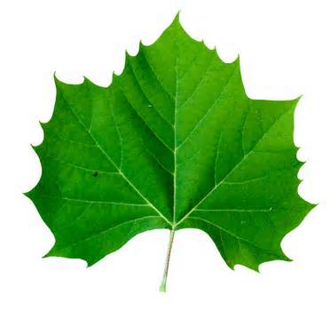 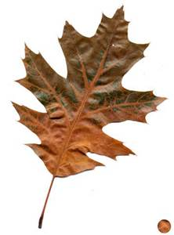 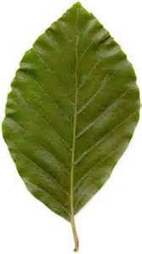 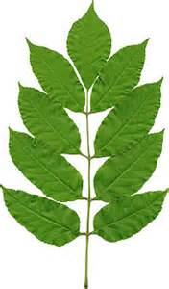 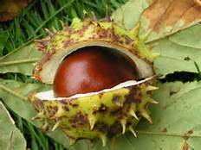

Sycamore Leaf Oak Leaf Beech Leaf Ash Leaf Horse Chestnut

As the weather is getting colder in Autumn, you may wish to make vegetable soup with your child. Encourage your child to be involved in choosing, naming, washing and chopping the vegetables to make soup.

**Vegetable Soup**

Ingredients

2 leeks 2 potatoes 3 carrots

Other vegetables according to your taste (turnip, parsnip, celery)

Olive Oil Salt and Pepper 1 Pint of vegetable stock

## Heat the olive oil in a large pot.

## Slice and cook the leeks for about 10 minutes over a medium heat until golden.

## Chop up all the vegetables into smallish chunks then add these to the pot.

## Cover with the vegetable stock, add salt and pepper

## Bring to the boil and let it simmer for 30-45 minutes

**Home School Links**