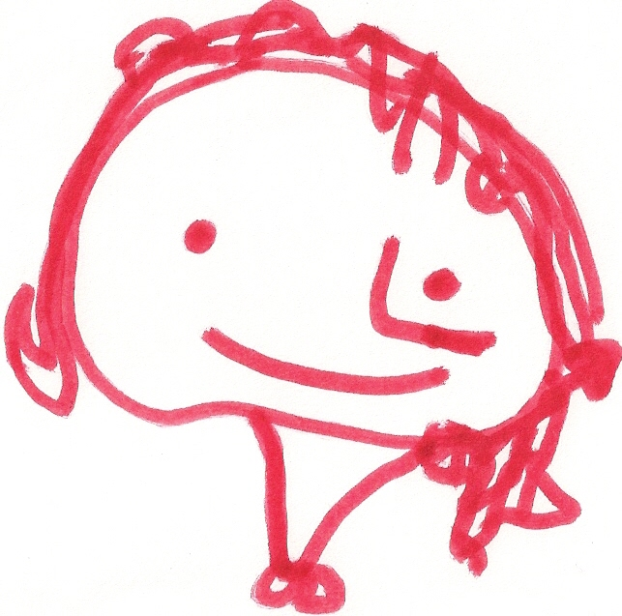
BALLYHENRY NURSERY SCHOOL
OCTOBER RHYMES/SONGS
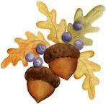

There’s a wide-eyed owl Chop, chop, choppity chop One, two, three little acorns,
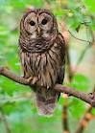
With a pointed nose, Chop off the bottom and Squirrel, can you see them?
Two pointed ears Chop off the top. One, two, three little acorns,
And claws for toes. What there is left we will put in Take them to your store.
He sits in a tree the pot
And he looks at you Chop, chop, choppity chop.
Flaps his wings Gather up a box of pears,
And says Stir it round Box of pears, box of pears,
“Twitt twooo!” Stir it round Gather up a box of pears,
Tell me what you have found Thank you, God, for the harvest.
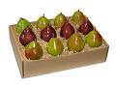
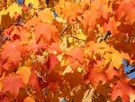
Whisky, Frisky, Hippety Hop, Orange leaves are falling down Don’t go pecking in the cornfield,
Up he goes, to the treetop, Spinning, spinning all around, Don’t go pecking in the cornfield,
Whirly, twirly, round and round, Floating by without a sound, Don’t go pecking in the cornfield,
Down he scampers, So catch them if you can. ‘Cause Mr Scarecrow’s there.
To the ground.
Mister Scarecrow, Mister Scarecrow
Something is sitting up in a tree, Mister Scarecrow is waiting for you,
With two big eyes staring at me, Mister Scarecrow, Mister Scarecrow,
2 little hedgehogs, rolled in a ball Something is sitting up in a tree, Mister Scarecrow is waiting for you.
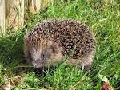
1 quite big, and the other quite small, It’s the owl!
Out popped their noses,
They began to sniff. Tu-whit, tu-whoo, I’m watching you, 5 little leaves, so bright and gay,
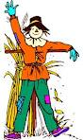
What’s that smell? Tu-whit, tu-whoo, I’m wathcin gyou Were dancing about on a tree one day,
It’s a badger’s whiff! Tu-whit, tu-whoo The wind came blowing through the town,
So the 2 little hedgehogs rolled in a ball, And 1 little leaf came ‘fluttering’ down.
1 quite big, the other quite small. Wise old owl in the tree,
Looking around for his tea, 4 little leaves so bright and gay etc….
Wise old owl in the tree,
It’s the owl!
I have a little spider, I’m very fond of him, 5 pumpkin faces, round and bright,
He climbs onto my shoulder, and then onto my chin, Chorus Glowing orange, candle light,
He crawls down my arm, and he jumps onto my leg, Hallowe’en – no time for fears!
Now he’s a tired little spider, Something is sitting up in a tree, Just blow!
So I’ll put him to bed! With two big eyes staring at me, And 1 face disappears.
Something is sitting up in a tree,
It’s the owl! 4 pumpkin faces etc….

