2222222222222222222222222222222222222222222222222222222222222222222222222222222222222222222222222222222222222222222222222222222222

Ballyhenry Nursery School

  - Welcome to Our Weekly Activities
  - 22nd June 2020

It is hard to believe that we would have been embarking on our last full week of nursery! We would have been welcoming Primary One Teachers from all the various Primary Schools to nursery and the children would have been going for their play sessions.
I know many of your children have been engaging online with their new schools and teachers. As Parents, you need to prepare your child for going to Primary One, although currently we don’t know what will be in place for September.

Some things to try now and over the summer.
- Read lots of stories about starting school

- Mr Men go to School
- Little Owl’s First Day
- Starting School
- Topsy and Tim start School
- Spot goes to School
- I’m too Absouletly Small for School

- Talk about things your child liked at nursery, eg., play dough or outside and how in Primary One they will have similar activities.
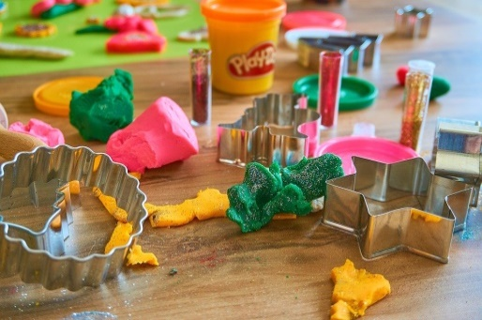

- Drive past your childs new school or walk to it and have a look at the crest on the sign and talk about how at nursery we have a smiley face for our school crest.

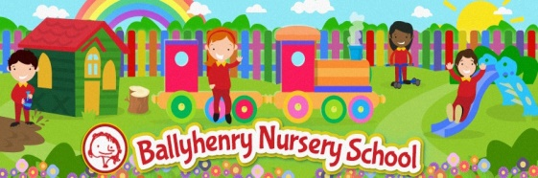

- Look online. Many schools have photos of staff or induction videos for new pupils.

- It is important to acknowledge your child’s feelings about going to school – how do they feel? Excited, scared and why?
- Discuss breaktime and lunch time (dinner or packed lunches).
- Look at pictures of children at their new school and discuss the colour of their uniform.
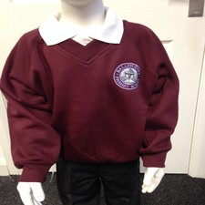
- Collect bottle tops and do lots of mathematical activities with them.

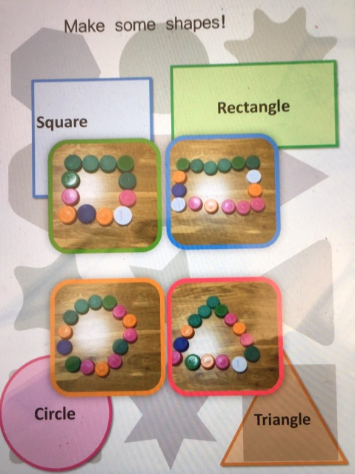
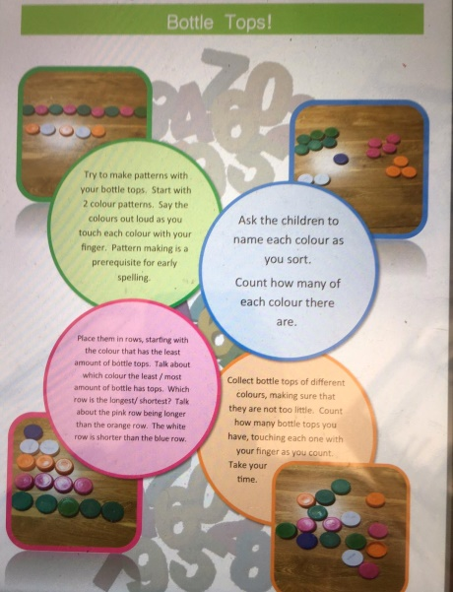

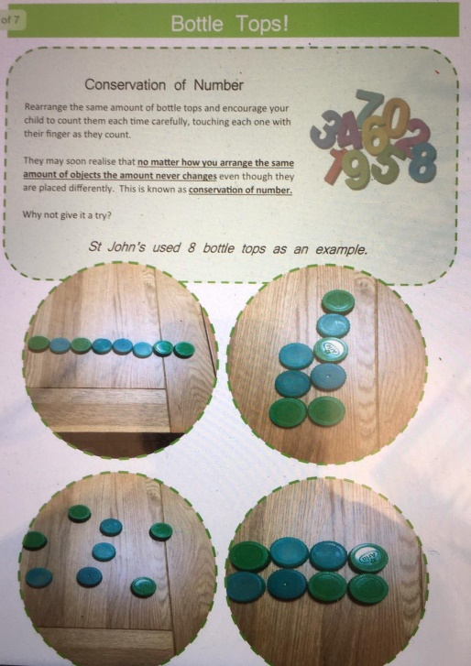

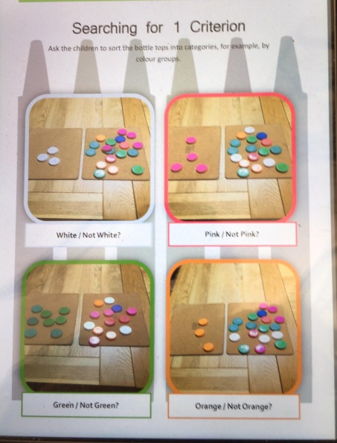
- Fill jam jars with different amounts of coloured water and tap to make your own xylophone – a musical instrument. Take care with the glass and ensure an adult supervises!

- Paint or draw a picture of your favourite thing in nursery and send us a picture for the website. Get an adult to tell us what you liked best.

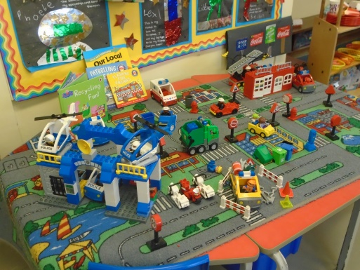

- Get lots of exercise every day. In the garden use a football to dribble up and down.
- Practice throwing and catching a ball to another person.
- Use a bat and ball to dribble a big ball along the ground.
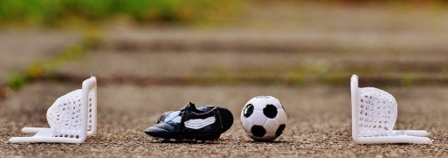

- Ask an adult to throw a ball and try to hit it with a bat.

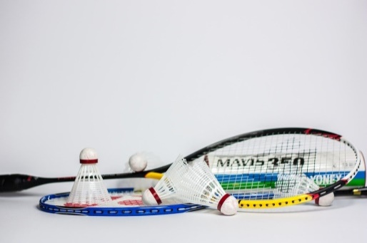

- Throw a ball at a bucket and see if you can hit it.
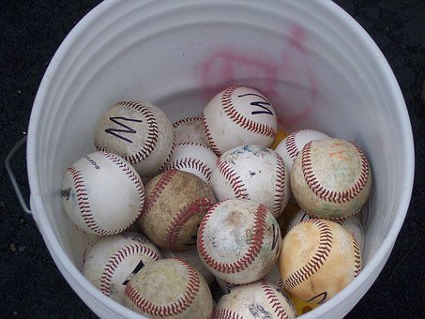

Remember Miss Ramsey’s class to collect reports and profiles book on Friday 26th June and Mrs Pollock’s class on Monday 29th June. Please remember health and safety and social distacing on both dates.

Enjoy your summer and we wish every child and family health and happiness as you leave us to embark on the next phase of the education journey.

Thank you for choosing Ballyhenry Nursery School.

