2222222222222222222222222222222222222222222222222222222222222222222222222222222222222222222222222222222222222222222222222222222222
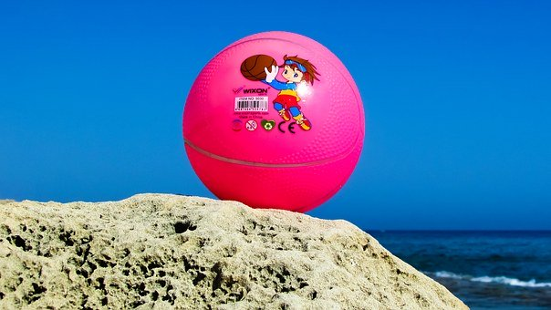 |  | Ballyhenry Nursery School  - Welcome to Our Weekly Activities  - 15th June 2020

We hope everyone is still well and enjoying having some of the lockdown restrictions eased.
This week we will be thinking about holidays although for many, plans have changed and weekends at the caravan haven’t happened. Look at old photographs of past holidays or day trips and talk with your child about these past experiences.
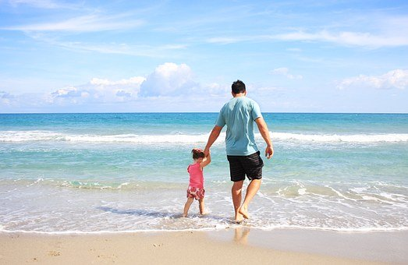

Stories to share (some are available on Youtube) related to our holiday theme :
- Maisy goes on Holiday
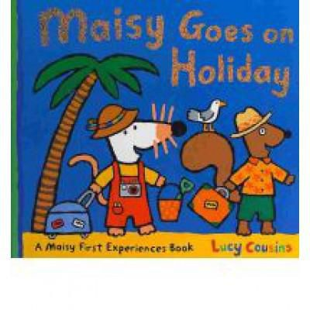
- Spot goes on Holiday
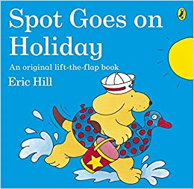
- Peppa goes on Holiday

- The Lighthouse Keepers Lunch
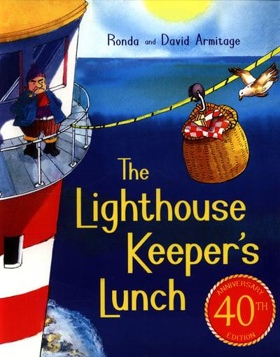
Rhymes are available on our website :
- 1,2,3,4,5 Once I caught a fish alive
- Oh I do like to be beside the seaside
- The sun has got his hat on
- Row, row, row your boat
- The Teddy Bears Picnic song
Watch together on Youtube Mr Tumble Holidays
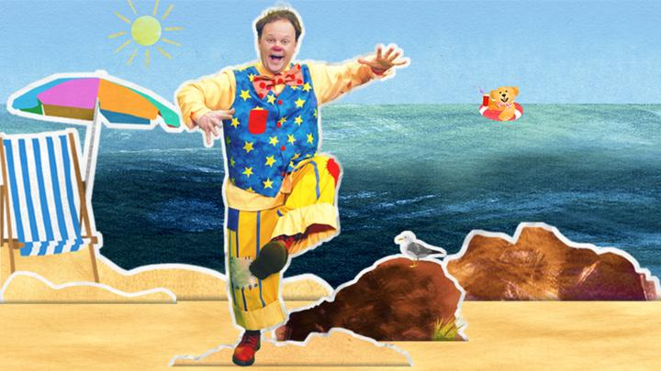

As we can travel to outdoor areas now, visit a beach or the Loughshore. Plan taking a picnic with your child. Make a list together of what to take to play with and to eat. This will present lots of opportunities for maths learning to take place.
Discuss
- What shape will we cut the sandwiches?

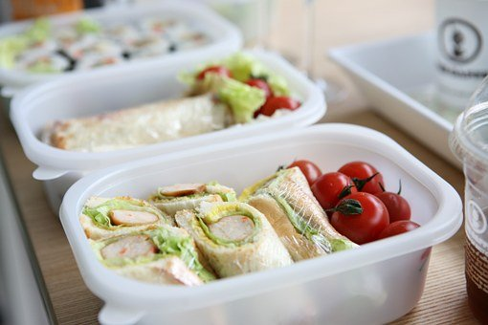
- How manny slices of bread will we need?
- Estimating how much butter to spead on the bread.
- Counting pieces of fruit to take.
- Counting cups to take.
- The shapes of different containers when packing the food.
- How to make everything fit into the picnic bag/basket.

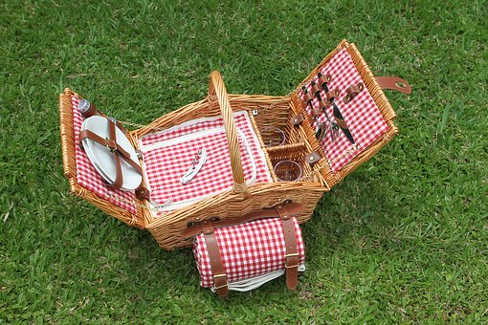
During Covid-19, rainbows have been a sign of hope. Make fairy bread – butter bread and sprinkle on 100’s and 1000’s.
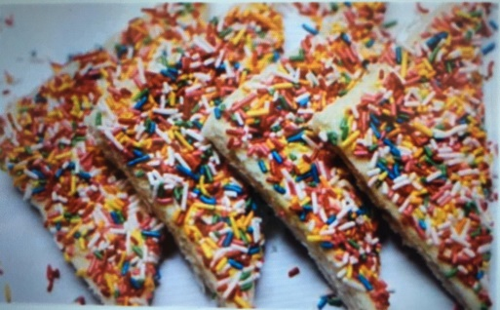
Before you to to the seaside, talk about safety near the water, stranger danger and staying safe in the sun.
At the beach, some fun things to do :
- Use seaweed, pebbles, sheels to make collage pictures.
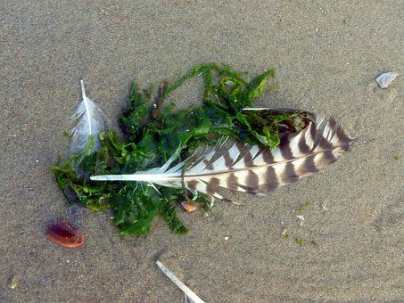
- Put on wellies and go with an adult to the rockpool and collect items in your bucket.
- Have a beach treasure hunt. Who in your family /friends will be first to find :
Something wet
Something rough
Something smooth
Something white
Something heavy
Something light
A large shell
A small stone
- Collect shells and pebbles to create patterns. Put them in a straight line, wiggly line, a circle shape, a square shape.
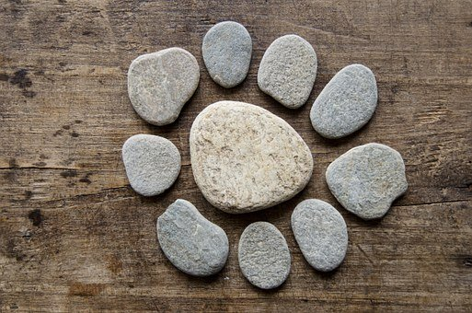
- Take a ball and practise throwing and catching.
- Take a bat and ball – practise developing hand and eye
co-ordination.

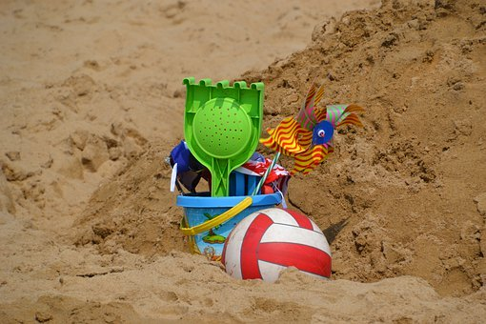
At Home
- Make Ice Lollies together by freezing orange juice and adding a lolly stick. Discuss the process of liquids turning into solids, freezing and melting.

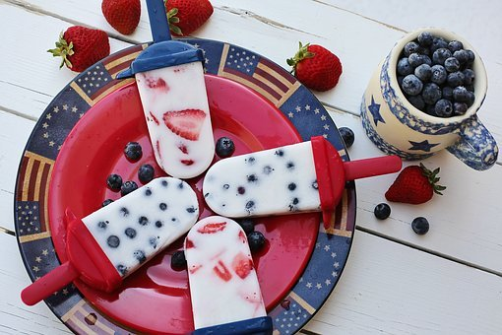
- Make lollipops from craft materials and improve fine motor skills by cutting out shapes and following a line.
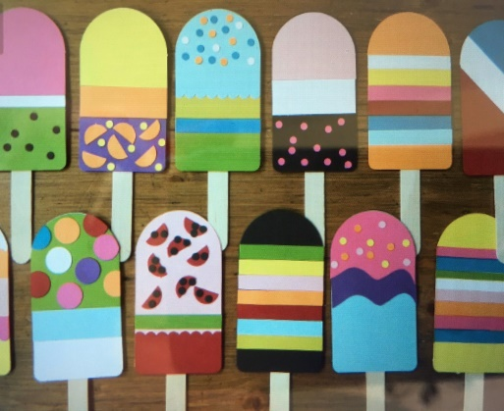
- Make a big sun for summer by cutting out a circle shape and rays.
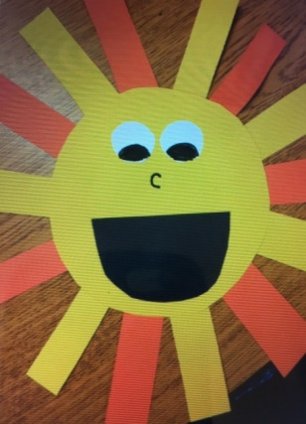
- Use junk to make boats eg., use a vegetable/meat tray washed or a magarine/yoghurt tub. Add a sail and lego people. Try then in a basin of water or a paddling pool. Do they float or sink? Have a race, which is the best and why?
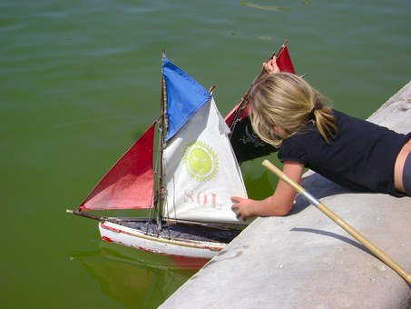
- Talk about winter and summer clothes. Let your child pack items they need in a bag or suitcase eg., sun hat, shorts, t-shirt, swimming costume, suncream, sunglasses.

- If you have a tent, go camping in it or make one from a chair and some blankets.

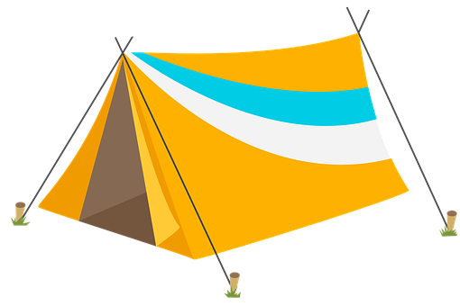
- Make a postcard and post it to someone you love or take a photo of it and send it to them
Remember to send us your photos for the website!

