2222222222222222222222222222222222222222222222222222222222222222222222222222222222222222222222222222222222222222222222222222222222
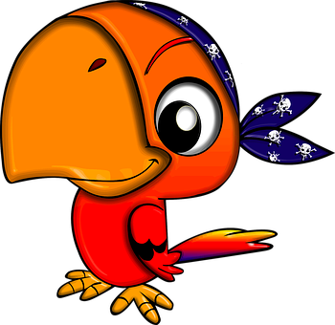 |  | Ballyhenry Nursery School  - Welcome to Our Weekly Activities  - 8th June 2020

As we continue our seaside theme, this week we will focus on pirates – Ahoy me hearties!
Some stories to share and they are available on youtube.
- 10 Little Pirates
- Pirates love Underpants
- Blackbeard the Pirate kids story
- Penguins make bad Pirates
- I want to be a Pirate
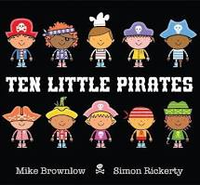

Rhymes for the Week
Continue with rhymes from our June rhyme sheet – available on the website.
Some Activities to Try
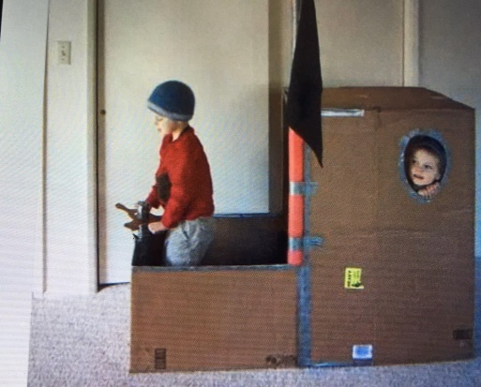
- Make a pirate ship from a large box, add a brush handle or a tube to make a mast and add a sheet for a sail. Add a circle shape for a steering wheel.

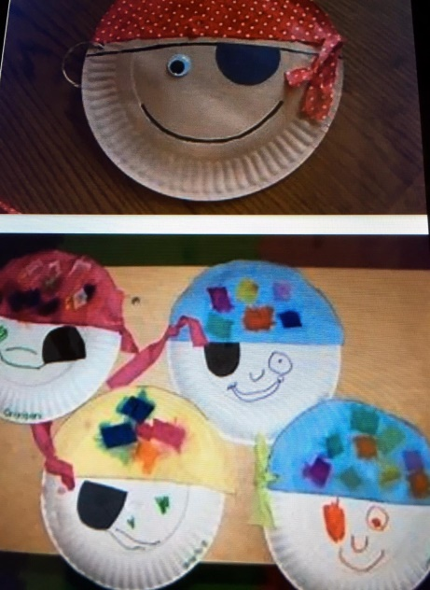
- Discuss what items pirates need :
- A telescope - make from a kitchen roll tube or tinfoil tube.
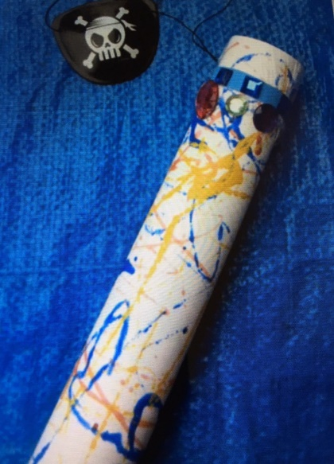
- An eyepatch - make from a piece of material.
- A beard – use face paint or mum’s make-up pencils!
- A parrot – make one from a paper cup and decorate or draw/paint a parrot.
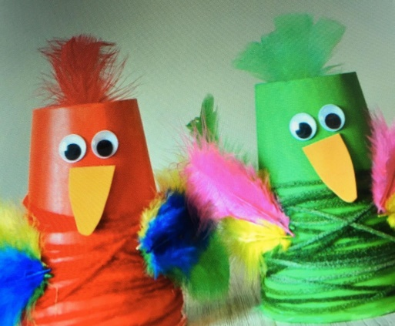
- A flag with a skull and crossbones – dress up as a pirate and play in your pirate ship. Take some snacks with you for the long journey.
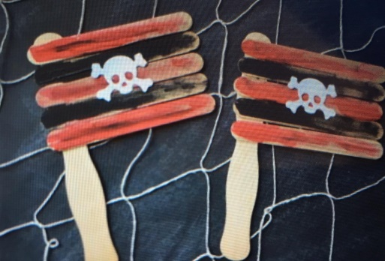
- Use an old plastic bottle and write a message to put inside it (scribble witing is fine!)
- Make a treasure chest by covering an old teabag box or margarine tube with tinfoil and decorate it.
- Wrap items in tinfoil to put in your treasure chest – make sure they fit!
- Count 1p coins and put in your treasure chest.
- Hide treasure indoors/outdoors and to improve listening skills, give your child clues to find each item, eg., the first item of treasure is behind the blue plant pot etc.
- Draw treasure maps and put an ‘X’ on it where the treasure is hidden.
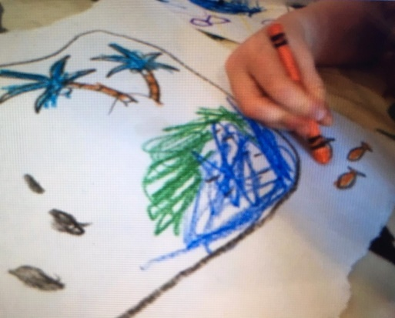
- Watch CBeebies ‘Pirates’ – there are different activities available.
- On youtube sing the song ‘If you want to be a Pirate’.
Play music and mime the pirate actions - 1 person can be the Captain and call out the actions.
- Scrub the deck
- Look through your telescope for other pirate ships
- Walk the plank
- Raise the flag
Have fun !
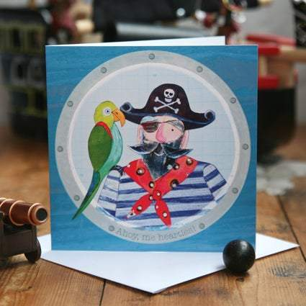
Shiver me timbers!
Remember to send us photos of your activities and we have lots of birthdays this month!

