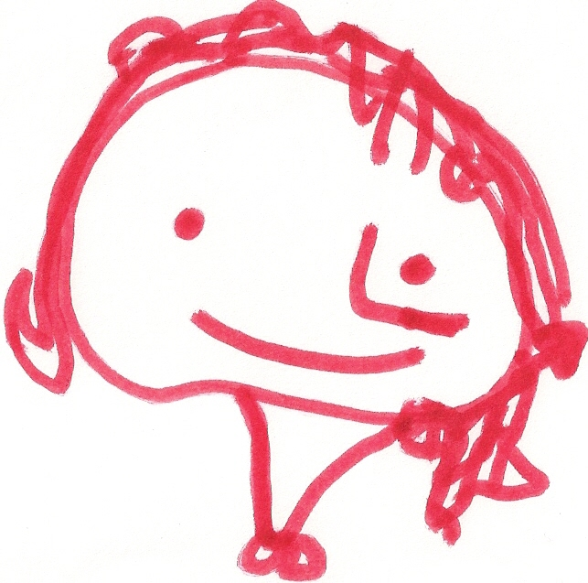
BALLYHENRY NURSERY SCHOOL
JUNE RHYMES/SONGS

Wiggle my toes in the water,
Wiggle my toes in the sand,
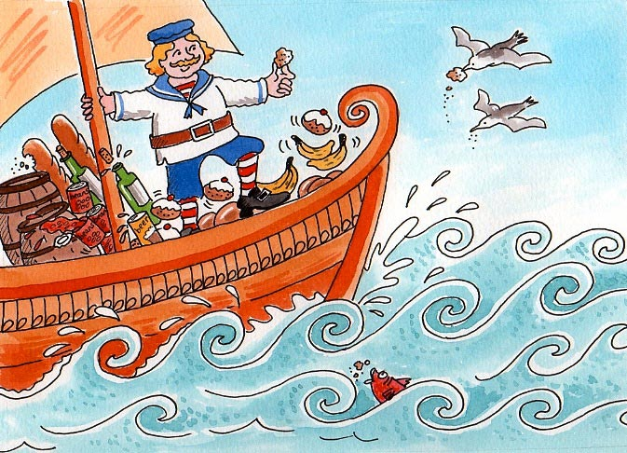
I’m off to wiggle my toes,
In Wigglematozy Land

Bobby Shaftoe’s gone to sea,
Silver buckles on his knee,
He’ll come back and marry me,
Bonny Bobby Shaftoe.

Bobby Shaftoe’s bright and fair,
Combing down his yellow hair,
He’s my love for evermore,
Bonny Baby Shaftoe.

Sand in your fingernails,
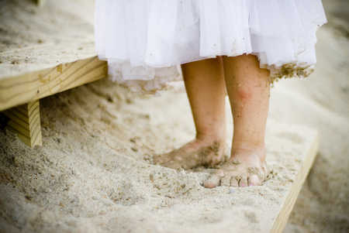
Sand between your toes,
Sand in your earholes,
Sand up your nose!

Sand in your sandwiches,
Sand on your bananas,
Sand in your bed at night,
Sand in your pyjamas!

Sand in your sandals.
Sand in your hair,
Sand in your knickers,
Sand EVERYWHERE!

,

The sun has got his hat on,
Hip, Hip, Hip, Hooray,
The sun has got his hat on,
And he’s coming out to play,
Now we’ll all be happy,
Hip, Hip, Hip, Hooray,
The sun has got his hat on,
And he’s coming out today.


I see blue skies,
I see blue skies,
Way up high,
Way up high,
Hurry up, the sunshine,
Hurry up, the sunshine,
I’ll soon dry!
I’ll soon dry!
(Tune : I hear thunder)

I had a little engine,
But it wouldn’t go,
I had to push and push and push,
But still it wouldn’t go.

I had a little motor car,
But it wouldn’t go,
I had to wind and wind and wind,
But still it wouldn’t go.

I had a little aeroplane,
My aeroplane could fly,
I jumped right in, away I flew,
Right into the sky!

4 little fishes,
Swimming out to sea,
One met a great big shark,
That left three.

3 little fishes,
Wondering what to do,
One hid in a great big shell,
That left two.

2 little fishes,
Looking for some fun,
One chased after a wave,
That left one.

1 little fish,
With all his friends gone,
Went back home to find his mum,
And that left NONE!

The big ship sails on the alley-alley-o
The alley-alley-o, the alley-alley-o,
The big ship sails on the alley-alley-o
On the last day of September.

The Captain says “This will never, never do,
Never, never, do, etc…

The big ship sank to the bottom of the sea,
The bottom of the sea, etc….

We all dip our heads in the deep blue sea,

The deep blue sea, etc…

Row, row, row your boat,
Gently down the stream,
Merrily, merrily, merrily, merrily,
Life is but a dream.

Row, row, row your boat,
Gently out to sea,
Merrily, merrily, merrily, merrily,
Home in time for tea.

Row, row, row your boat,
Gently down the stream,
If you see a crocodile,
Don’t forget to ….
SCREAM!!

Oh I do like to be beside the seaside,
Oh I do like to be beside the sea,
Oh I do like to stroll along the prom, prom, prom
Where the brass band plays tiddly-om-pom-pom

Oh I do like to be beside the seaside,
Oh I do like to be beside the sea,
Oh there’s lots of folks besides
That would like to be beside,
Beside the seaside, beside the sea!

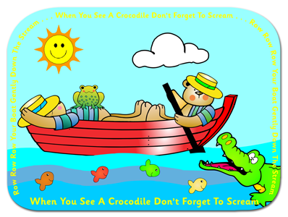

Three little sandcastles sitting on a beach
Watching the boats go by,
Three little sandcastles sitting on a beach,
Watching the seagulls fly,
Three little sandcastles sitting on a beach,
Watching the clouds so high,
When along came a wave and washed one away,
And this is what the other ones said ….

Now we are two little sandcastles sitting on a beach,
Watching the boats go by,
Two little sandcastles sitting on a beach,
Watching the seagulls fly,
Two little sandcastles sitting on a beach,
Watching the clouds so high,
When along came a wave and washed one away,
And this is what the other one said ….

Now I am one little sandcastle, sitting on a beach,
Watching the boats go by,
One little sandcastle sitting on a beach,
Watching the seagulls fly,
One little sandcastle sitting on a beach,
Watching the clouds so high,
When along came a wave and washed one away,
And now there is nothing to say!

