2222222222222222222222222222222222222222222222222222222222222222222222222222222222222222222222222222222222222222222222222222222222
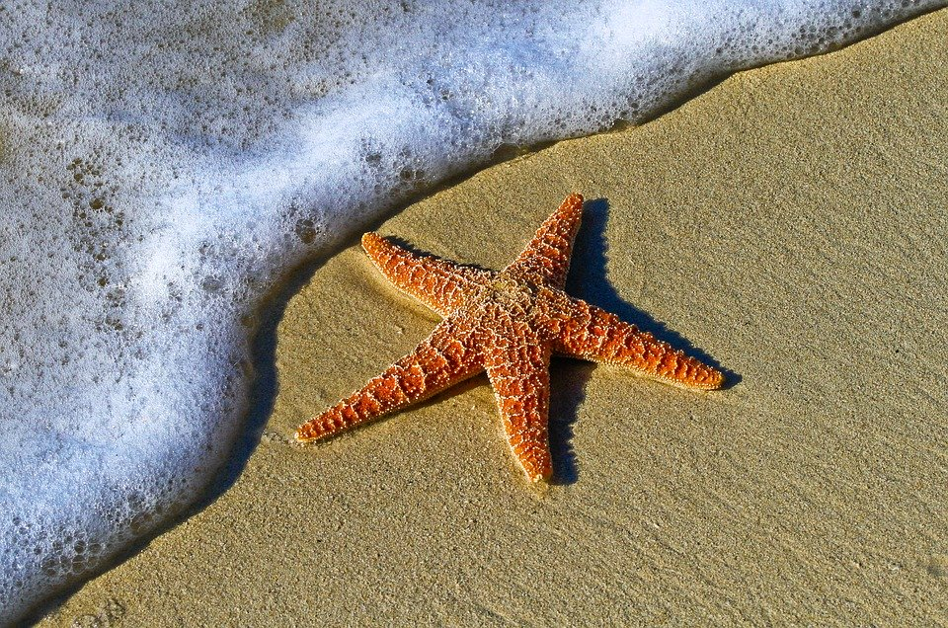 |  | Ballyhenry Nursery School  - Welcome to Our Weekly Activities  - 1st June 2020

We had planned to go this month on a school trip to the beach with Maggie from Beach Schools NI. As we can’t go, we will be encouraging you to try some seaside activities with your child.
Use this theme to discuss safety near water and to call 999 for the Life Boat.
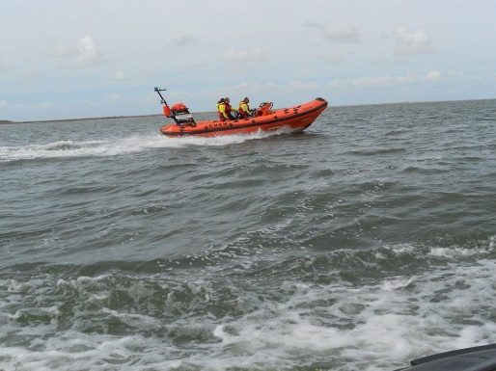

Rhymes for the week
Available to download from the June rhyme sheet.
- 1,2,3,4,5 Once I caught a fish alive
- The sun has got his hat on
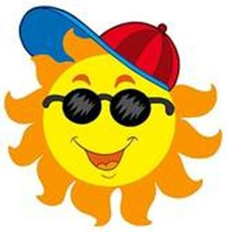
- The big ship sails on the ally, ally, oh
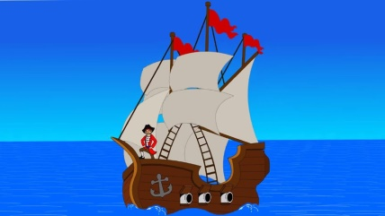

- 5 little fishes swimming in the sea
- Sand in my sandwiches

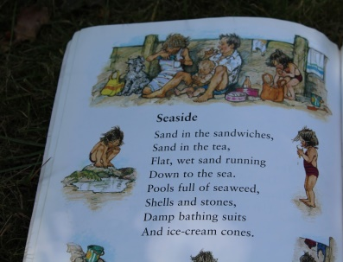

Stories to read or to listen to on youtube :
- What the Ladybird heard at the Seaside
- The Snail and the Whale

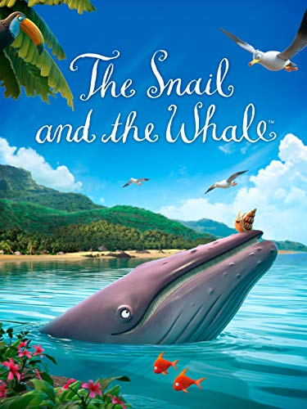

- What the Ladybird heard on Holiday
- The Rainbow Fish (discuss sharing)
- A house for Hermit Crab
- Commotion in the Ocean
- Shark in the Park (discuss rhyming words)
Watch online Kipper at the Seaside.

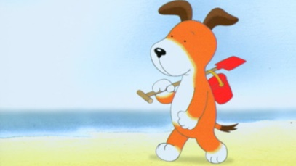
Some Activities to try
- In the garden fill the paddling pool or basin with water and colour it blue. Add some toy fish, boats, or any sea creatures you have at home to create an ocean.
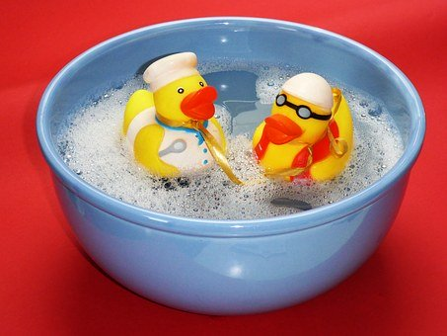
- Add blue food colouring to rice and some vinegar. Put it in a container and shake it. The rice will turn blue. Put it on a tray and add sea creatures, mermaids, stones etc to make a sea scene for imaginative play.

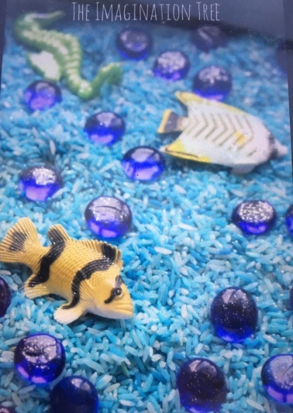

- Make a Rainbow Fish. Finger paint his scales or use a cotton bud and then add some shiny scales using tinfoil.

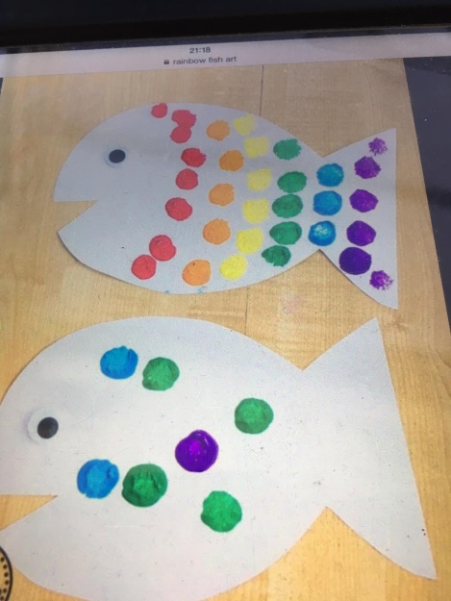

- Encourage your child to retell the story.
- Use sand in your sandpit to make sand castles. Discuss the different sizes – tall, short, bigger, smaller or shapes of buckets or containers.
- Use mathematical language – half full, nearly full, empty, heavy or light.
- Guess how many spades of sand it will take to fill each bucket and then count and check.
- Decorate sandcastles by adding cut out squares, circles, triangles or rectangles to create flags. Draw pictures on the flags.
- Use stones, beads, to decorate your castle and create patterns.
- Make jellyfish to hang up.
- Make a jellyfish in a bottle (kidspot on youtube).

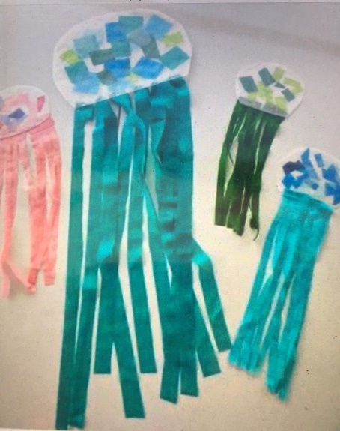

- Cut out a star shape from card and glue on cheerios, rice krispies, sequins etc., to create a star fish.

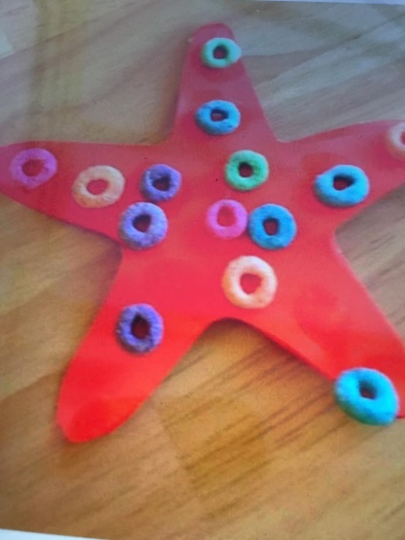

- Use dough to cover play figures with mermaid tailes.

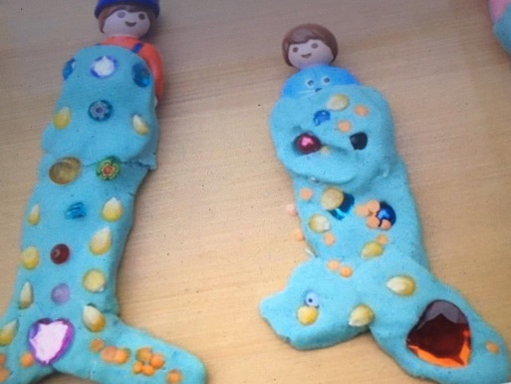

- Make Ice-Cream in a bag for a treat. Recipe on BBC Goodfood.com
- Play some music to dance to and when it stops do the action that one person calls out:
- Lie down and make a starfish shape
- Snap like a shark
- Jiggle like a jellyfish
- Step sideways like a crab
- Move our arms like an octopus
- Puff out your cheeks like a puffer fish
- Jump the waves
Discuss with your child what they like to do at the seaside and plan for this when we can all go again to the beach. Talk about any memories they have of being at the beach.

