2222222222222222222222222222222222222222222222222222222222222222222222222222222222222222222222222222222222222222222222222222222222

Ballyhenry Nursery School

  - Welcome to Our Weekly Activities
  - 25th May 2020

We hope you are enjoying our Jungle/Wild Animal theme.
Continue to practice your nursery rhymes from our May rhyme sheet.
Some stories you could share together are :
- Dear Zoo by
Rod Campbell. Then discuss which animal people in your family would like best.

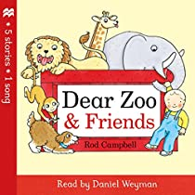

Discuss the pros and cons of having these animals at your home.

- The Tiger Who Came for Tea by Judith Kerr

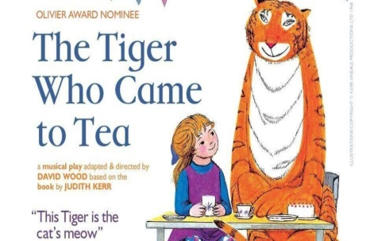

- Noah’s Ark – discuss the significance of the rainbow then and now. Sing Noah’s song –
Mr Noah built an Ark

- Rumble in the Jungle by Giles Andreae

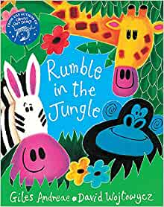

- Gorilla by Anthony Browne. Talk about the patterns and the animals coats. Discuss the name of baby animals and male/female names of animals eg., lion/lioness. Discuss which are reptiles, primates, those who like hot or cold lands. Discuss camouflage and what it means.

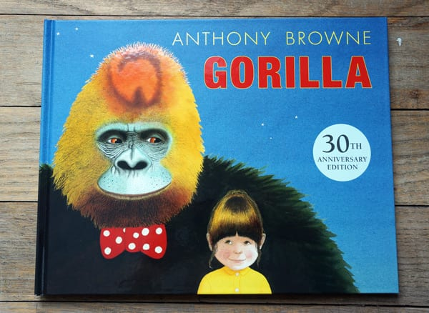

Clap syllables for the animals names eg.,
Tiger – 2 claps
Elephant – 3 claps
Have a vets and care for the sick animals. Use toy animals, cold bandages, plasters. Use a toy stethoscope or other resources if you have a doctor’s bag at home.

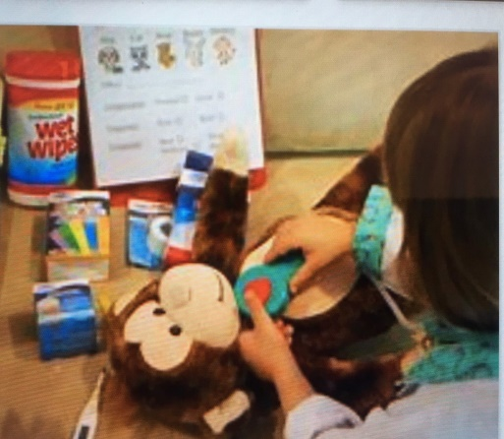

Fill a basin of hot water and wash the animals outside.
Use junk – shoeboxes, teabag boxes, toilet roll tubes etc., to create cages for the animals and put them in them.
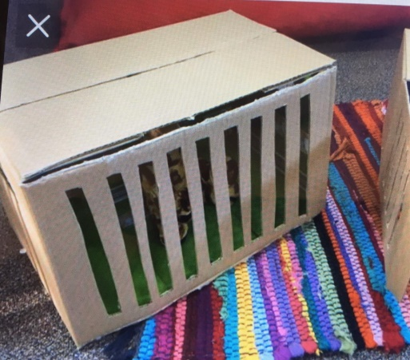

Fill a container with sand or soil and add the toy animals. Add grass, leaves, stones, twigs, petals to make a safari environment.
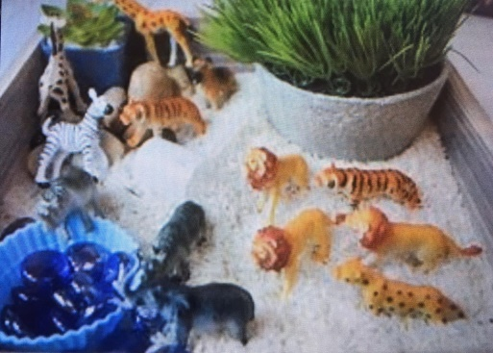
Tune into Wee Critters facebook page.
Watch on You Tube MrTumble Wild Animals.
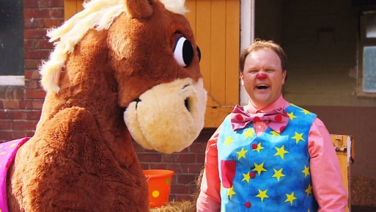
Keep fit and do some animal yoga moves for kids – lots of ideas online.
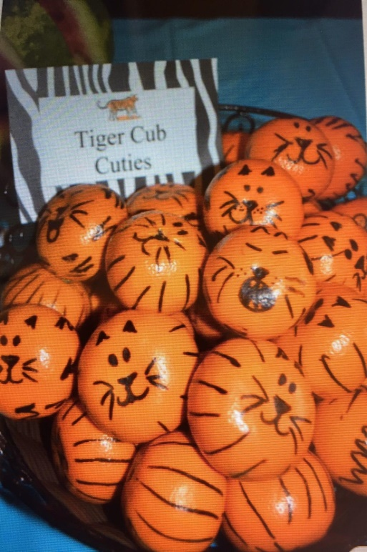

Make some jungle snacks/treats.

Remember to send us your photos of your work and any birthdays to share on the website with your friends.

