African animals.
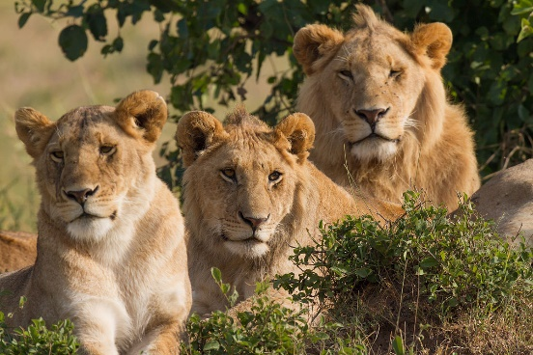
Lions live together in groups known as prides. The mummy lion is called a lioness. Lions spend most of the day sleeping. Lions eat a big meal every few days. What kind of lion is perfectly harmless? A dandelion!
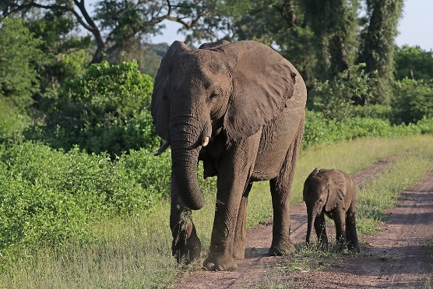
Elephants are the largest animals that live on land. They suck up water in their trunks and shower themselves. Baby elephants suck their trunks, like babies suck their thumb. Why do elephants paint their toenails red? To hide in the strawberry jam!
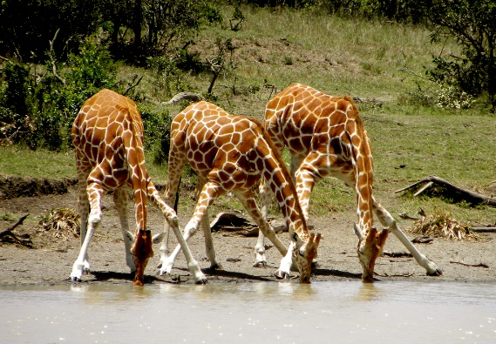
Giraffes are the tallest animals in the world. When giraffes drink, they have to stretch their front legs wide so that they can reach the water. Giraffes use their long necks to reach leaves high up in the trees.
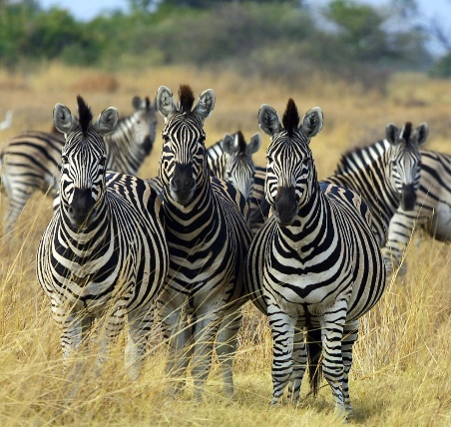
Where do giraffes go school? In high school.
Zebras roam across the open plains eating grass and leaves. They have wide black and white stripes. When zebras are gathered in a group, it is difficult to tell one from another. Zebras use the tuft of hair at the end of their tail to get rid of flies.
What’s black and white and red all over? A zebra with sunburn.
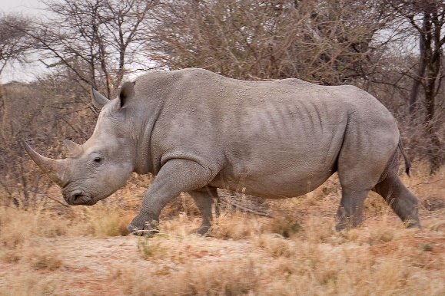
Rhinos use their horns to dig up trees so they can eat roots. Rhinos have very tough skin. They use their horns to defend themselves against attackers. They wallow in mud to keep cool in the sun.
What is as big as a rhino but weighs nothing? It’s shadow.
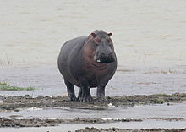
Hippos have very heavy bodies. They move more easily in the water than on land. Hippos have huge teeth. They use their teeth to defend themselves. Hippos often lie down in the water, with only their eyes, ears and nostrils showing above the water.
What time is it when a hippo sits on your bed? Time to get a new bed.
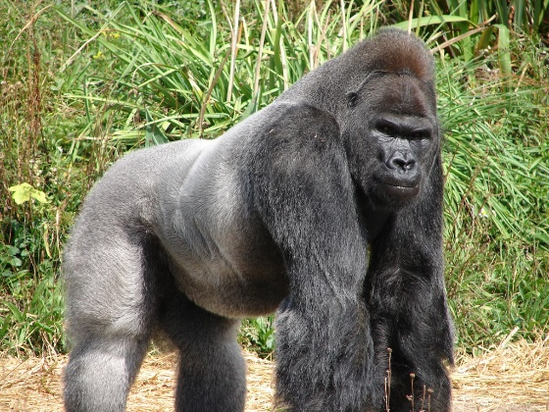
Gorillas live in forests, where they can find plenty of fruit, leaves and twigs to eat. Mummy gorillas and baby gorillas like to climb trees, but the daddy gorillas are much too heavy to climb. When gorillas are angry, they beat their chests with their fists.
Where does a monkey cook his toast? Under a gorilla.
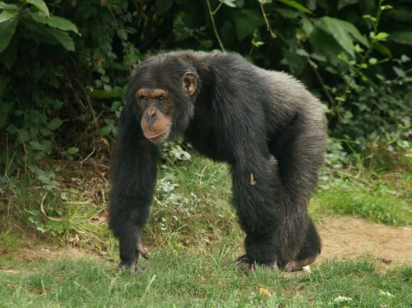
Chimpanzees live together in large family groups. They talk to one another by using their hands, and by making faces. They build nests in trees to sleep in at night. What is a chimp’s favourite Christmas song? Jungle bells.

