2222222222222222222222222222222222222222222222222222222222222222222222222222222222222222222222222222222222222222222222222222222222

Ballyhenry Nursery School

  - Welcome to Our Weekly Activities
  - 18th May 2020

We would be thinking about the Jungle and Wild Animals. As the zoo is closed, Longleat Safari Park, on their website, allow you to take a virtual tour. Have a look and see what animals you can spot!
Rhymes for the Week
- Tiger, Tiger, Orange and Black
- An elephant goes like this and that
- Down in the Jungle
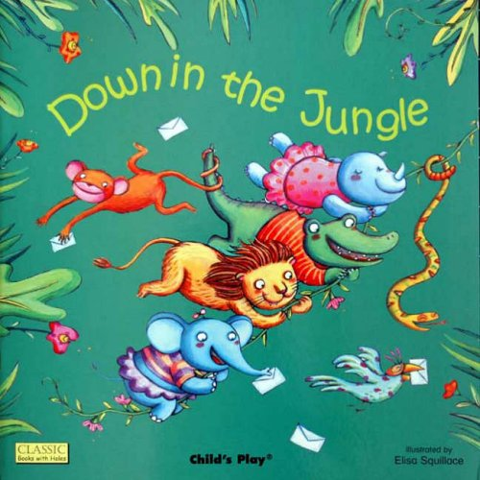

- 5 Little Monkeys bouncing on the bed
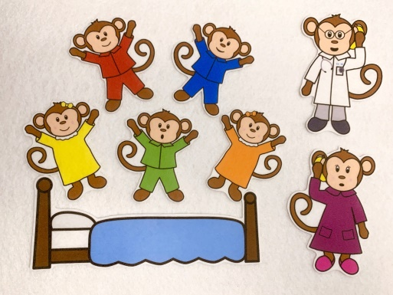

- 5 Little Monkeys teasing Mr Alligator
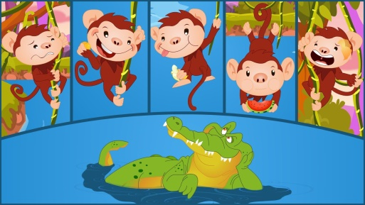

Some Things to Try
- Make your own zoo. Put a large piece of paper on the floor and draw the paths, the animal enclosures, the café, the entrance and the exit. If you have real animals, add them to your zoo.
- Draw/paint some zoo/jungle animals.

- Play ‘Who am I?’ … take it in turns to give clues – the other person guesses the animal …
Eg., I am a bird
I have feathers
I am black and white
I waddle
Who am I?
This is good for listening skills.
- Mime an animal’s movements and the other person guesses who you are … eg., an elephant/a snake.
- Go on a safari. Make a tent to watch for animals, pack your rucksack to take, tke binoculars and pens and paper to draw or write about what you see on your adventure.

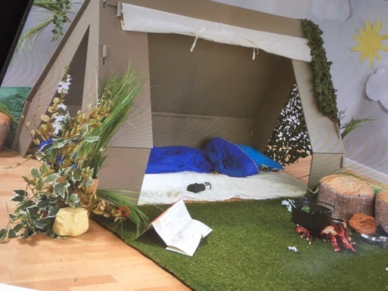

- Use an old cardboard box to paint and create a jeep for going on a safari.
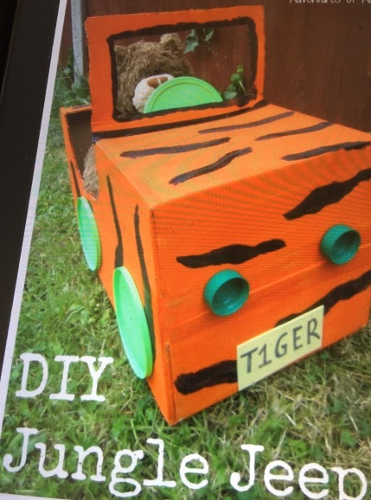
- Make animal masks. Use a circle shape, attach a lolly stick or a wooden spoon. These can be used as puppets or to retell stories.
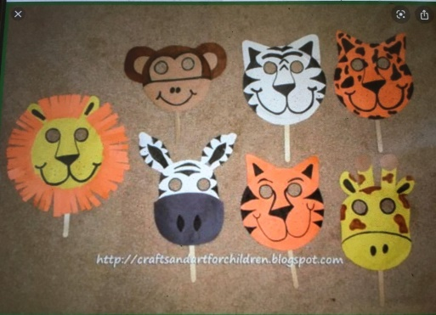
- Cut out snake shapes and then paint a pattern or add coloured shapes.

