2222222222222222222222222222222222222222222222222222222222222222222222222222222222222222222222222222222222222222222222222222222222
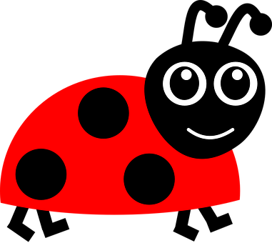 |  | Ballyhenry Nursery School  - Welcome to Our Weekly Activities  - 11th May 2020

We hope everyone is still okay. Remember if you need us or are concerned about any child, please contact us via email or phone the local Gateway Team on 028 94 42 44 59.
Remember to send us any photographs of your bug activities for the website, we love seeing them and sharing them with your friends.
Try moving like a mini-beast and add some music - freeze when the music stops.
- Wiggle Like a Worm
- Crawl on your tummy like a slug or a snail
- Curl into your shell like a snail

- Flitter, flutter like a butterfly
- Buzz and fly quickly like a bee
- Crawl like a butterfly
- March like an ant
Have spider races in your garden with your siblings – go along on your hands and feet or hands and knees.

Rhymes for the week
(from the May Rhyme Sheet)
- Incy Wincy Spider
- Ladybird, ladybird, fly away home
- Here is the beehive but where are the bees?
- There’s a tiny caterpillar on a leaf
- There’s a worm at the bottom of my garden

Activities to try at home
- Make, with playdough, some slugs/snails (make a coil for his shell)
- Paint a stone/rock to make a ladybird
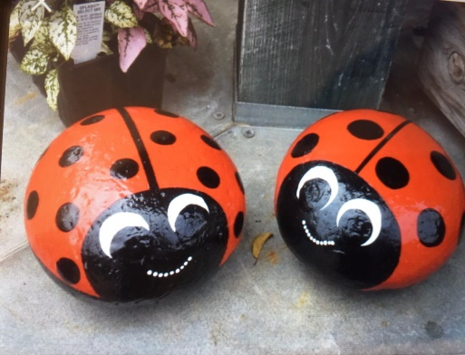
- Cook/use some leftover spaghetti or noodles and add to paint, then apply to paper to make a picture

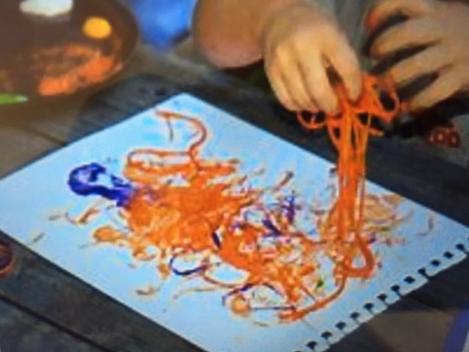

- Paint or draw spiders webs with water or use chalks outside
- Use water to paint a snail trail along the ground, add white paint if you wish
- Paint pasta tubes and thread to make a worm
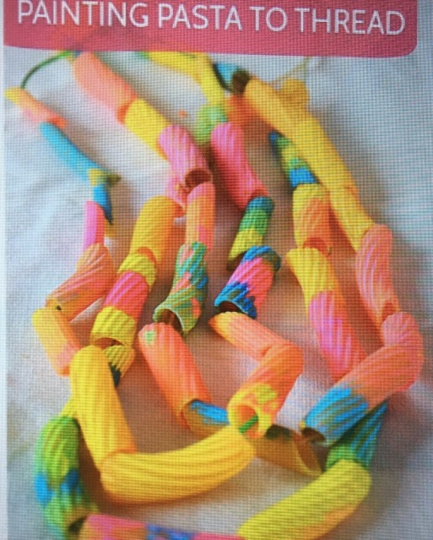
- Make 3d bugs from junk, toilet roll/kitchen roll tubes for bees, rolled up paper, paint and then add wings, antenna, eyes etc.
- Hammer golf tees into polystyrene or nails into wood and wrap wool or string around them to create a web
- Make a snail and decorate its shell
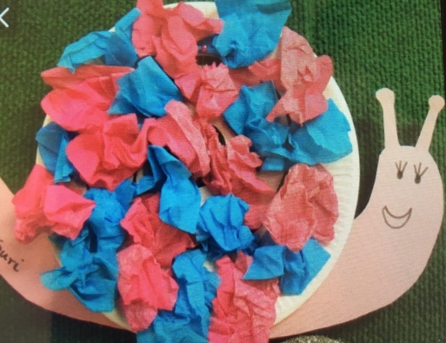
- Draw your own bugs
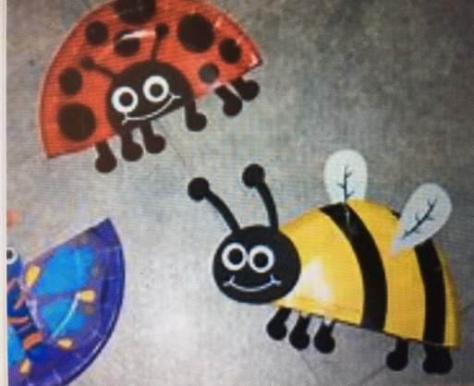

Simple Cooking
- For snack/a treat, make ladybird biscuits – use digestive biscuits and coloured icing

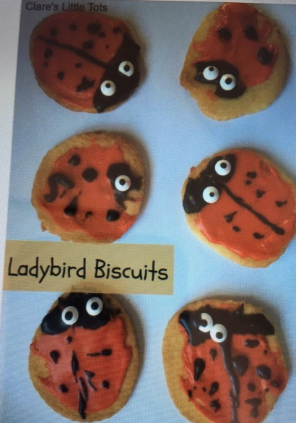

- Make Incy Wincy Spider treats
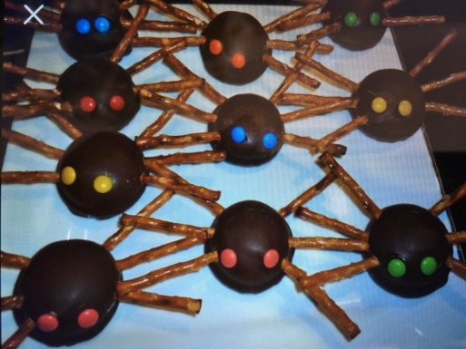

- Butterfly Buns

Eric Carle Minibeast Stories are available on Youtube :
- The Very Quiet Cricket
- The Very Busy Spider
- The Very Lonely Firefly
- The Grouchy Ladybug

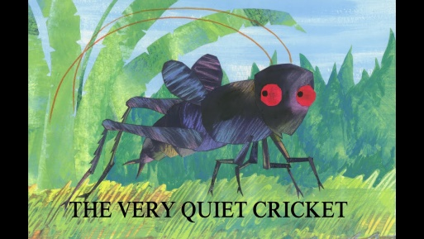

Some of these stories will you an opportunity to discuss feelings and emotions with your child.

Watch ‘Come Outside Aunty Mabel & Pippin – Snails’

Have fun!

