Who can you find when you are outdoors?

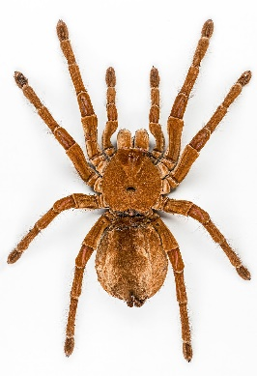
Can you find different sizes of spiders?
Can you count how many legs they have?
Can you find a spider’s web?
Can you say the rhyme, ‘Incy Wincy Spider’?
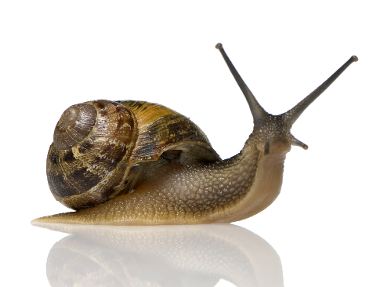
Can you find some big snails and some smaller snails?
Look for snail trails to see where they have been.
Look at the patterns on their shells.

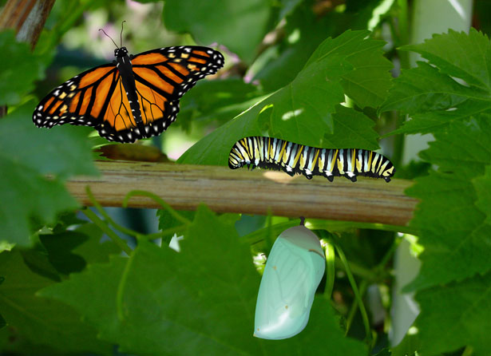
Look for different colours of butterflies. How many wings do they have? How many feelers?
Can you find any caterpillars?
The caterpillar will build a cocoon and then become a butterfly.
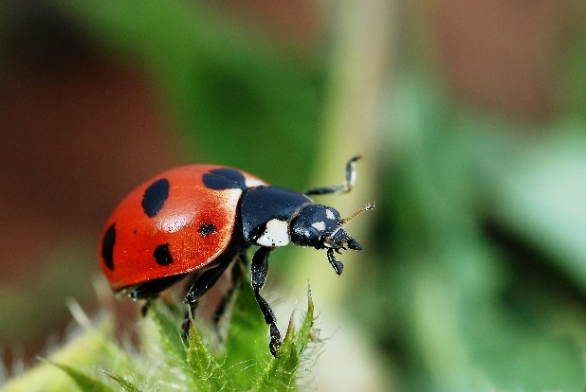
Can you count how many spots on your ladybird? How many legs?
How many feelers?
Maybe you could paint or draw a ladybird?
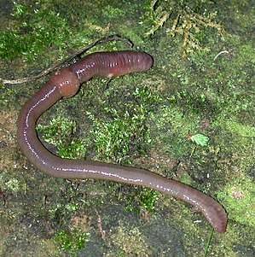
Worms come out at night and then hide in the ground during the day. Worms get their food from the soil.
Can you find any really long worms where you live?

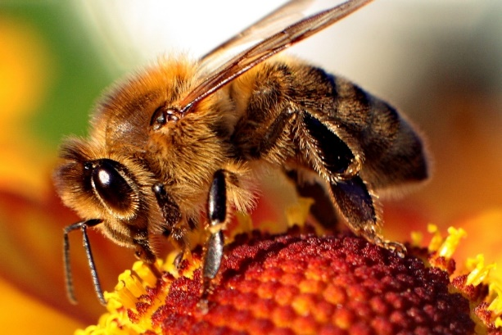
Can you buzz like a bumblebee?
Bees look for flowers full of sweet nectar to drink.
Can you see the patterns on the bee?
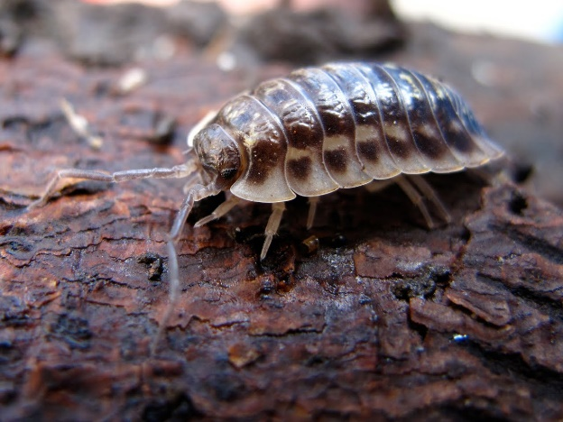
This is a woodlouse. It lives in damp, dark places. It feeds on old, rotting plants and leaves. Look under logs and stones to find a woodlouse.
Can you count 7 pairs of legs?
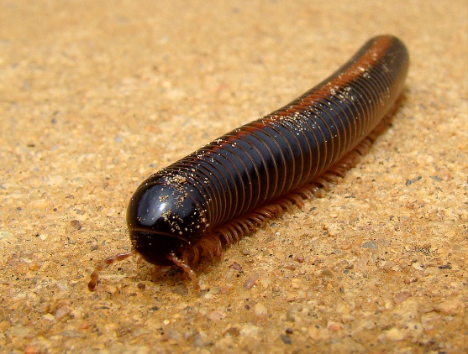
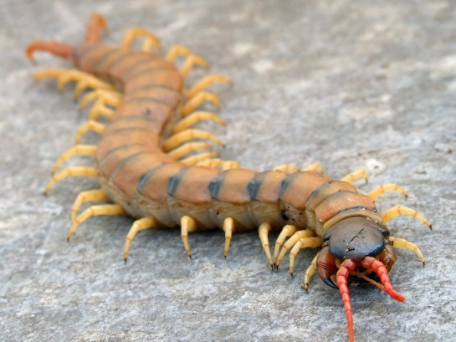

Can you spot the differences between a millipede and a centipede?

