2222222222222222222222222222222222222222222222222222222222222222222222222222222222222222222222222222222222222222222222222222222222
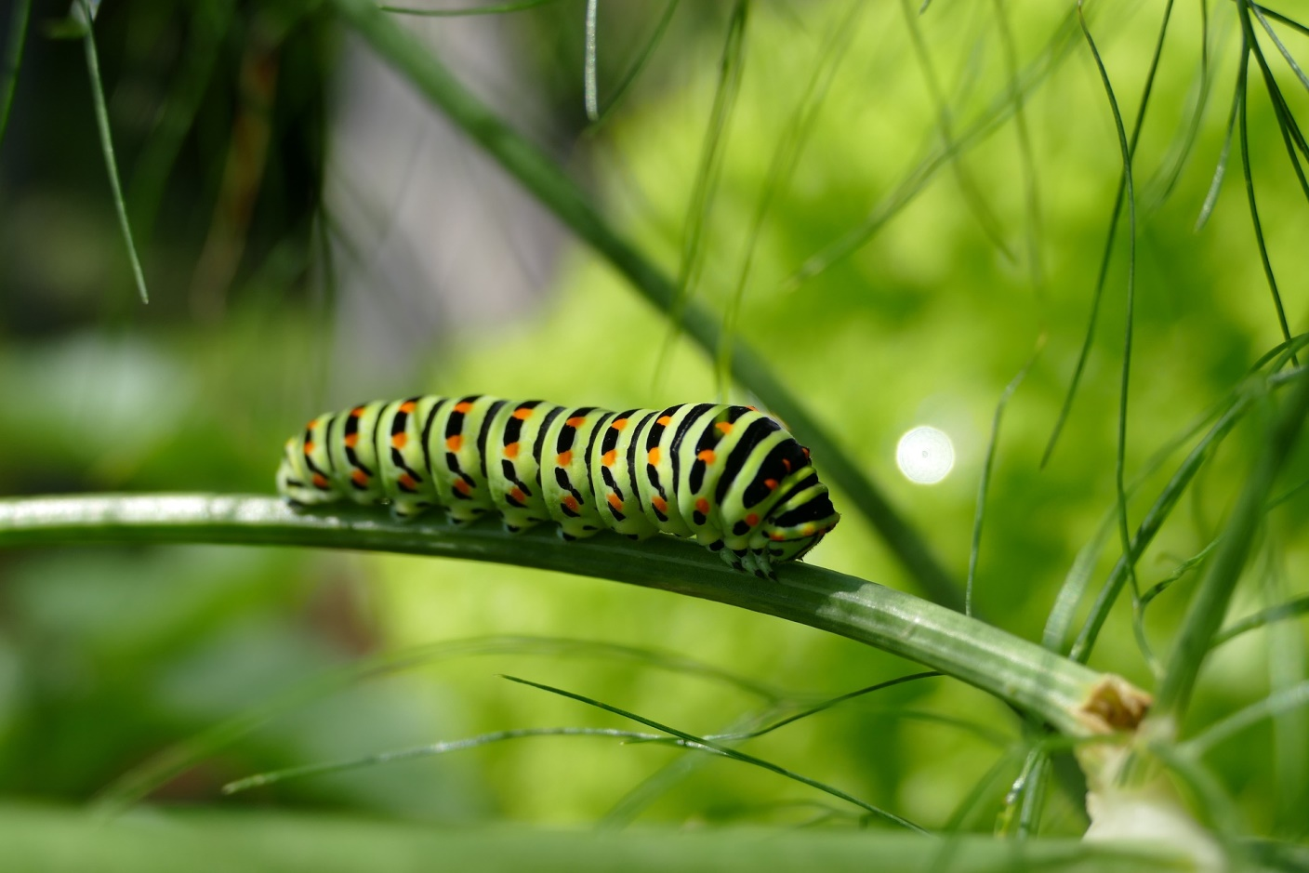 |  | Ballyhenry Nursery School  - Welcome to Our Weekly Activities  - 4th May 2020

This week we will be learning about Minibeasts.

Go into your garden and see what bugs you can find. Can you name them?
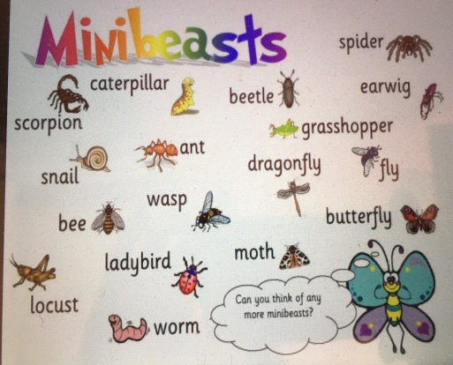

Try to create a trap for minibeasts by putting a plastic cup in the ground. Sprinkle some soil in the bottom and cover with a stone. The next day go and see what you can find.
Why not send us some photographs for our website and we can see what variety of bugs we can get for the Ballyhenry Bug Hotel.
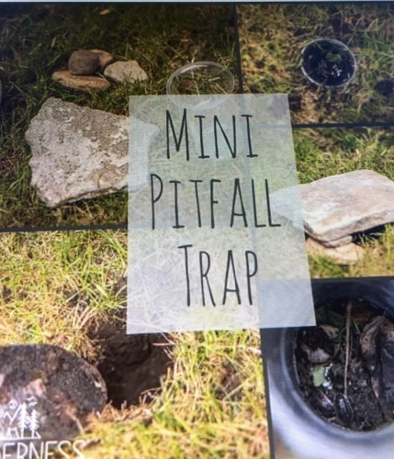

Create a recycled bug hotel for your minibeasts.

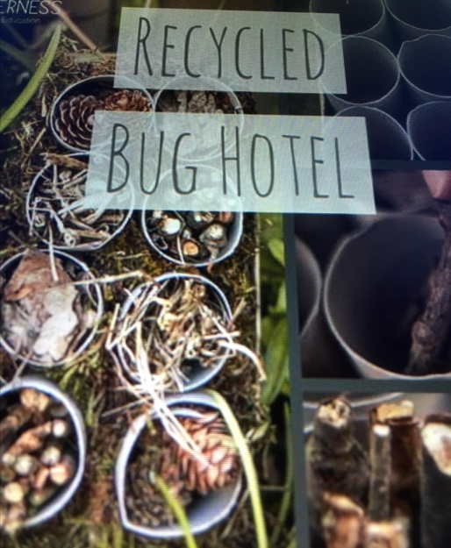

Try making some healthy mini-beast snacks and send us your pictures.
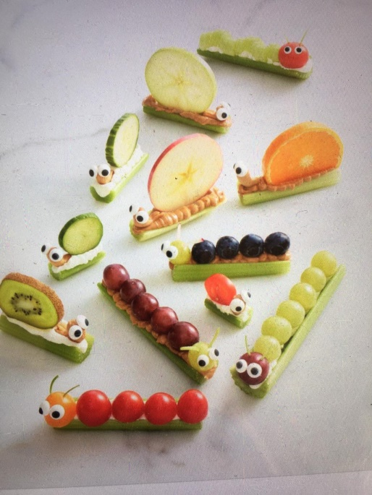

Rhymes for the Week
These are available on the May rhyme sheet section on the website.
- There’s a tiny caterpillar on a leaf
- Caterpillars only crawl
- Little Arabella Millar

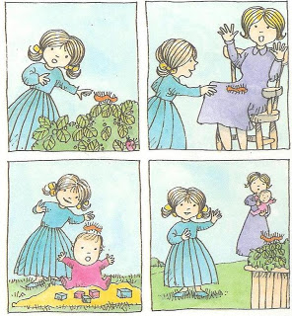
As we think about caterpillars changing into butterflies, watch this on YouTube :
‘Come Outside’ Aunty Mabel and Pippin ‘Butterflies’.
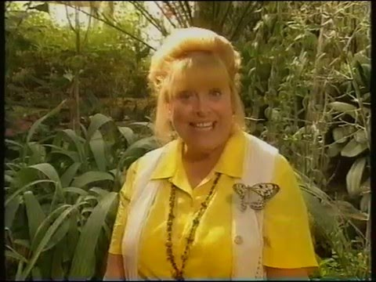

Some minibeast stories are available to listen to on YouTube
- The Very Hungry Caterpillar
- Bugs! Bugs! Bugs!
- Mixed up Chameleon
- Learn Ladybug facts for Kids
- Bug Hunt
- Caterpillar Shoes
- I love Bugs

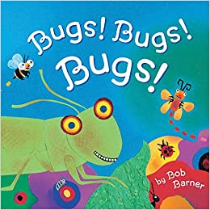

Some Things to Try
- Print with a half a potato or apple to create caterpillars.
- Draw circle shapes and get your child to cut them out and stick on a page to create a caterpillar.
- Make caterpillars from dough – long and short ones, fat and thin. Which is the longest and which is the shortest?
- Make, from playdough, some food which the Very Hungry Caterpillar ate and retell the story.
- Paint a butterfly using foot prints.

