Good questions to ask!

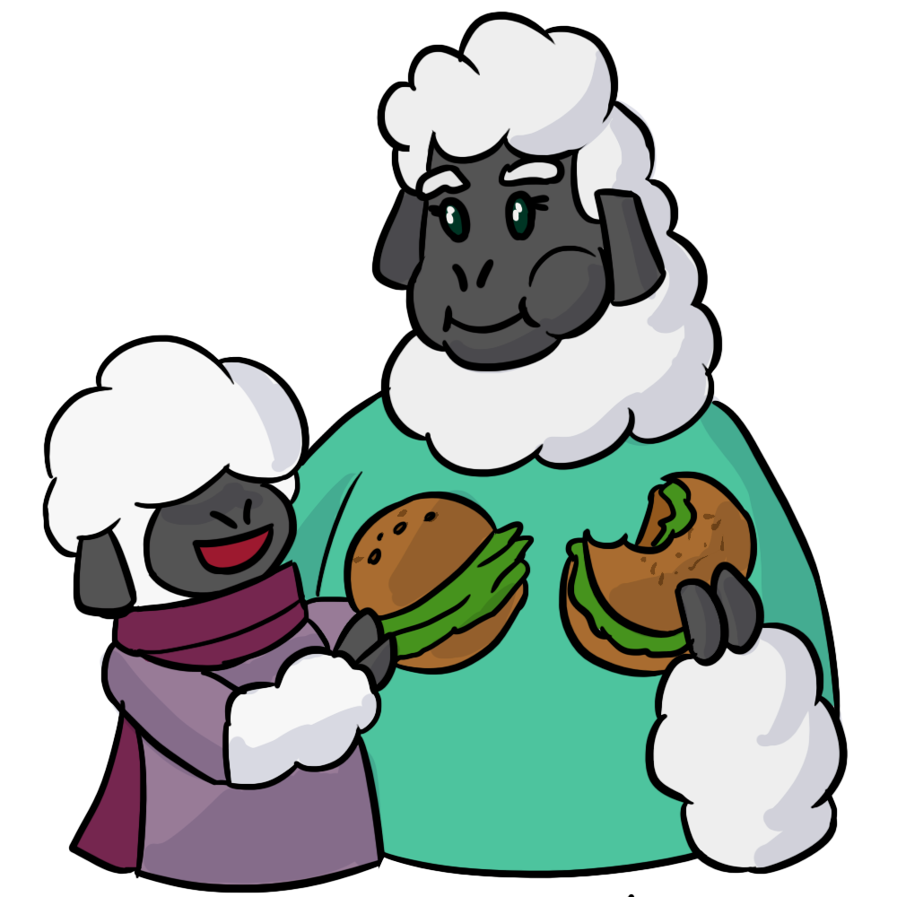
As you play with your child these are some of the questions you could ask ..
What do you think?
Why do you think that?
How do you know?
Do you have a reason?
Can you be sure?
Is there another way?
What do you think will happen next?
What if?
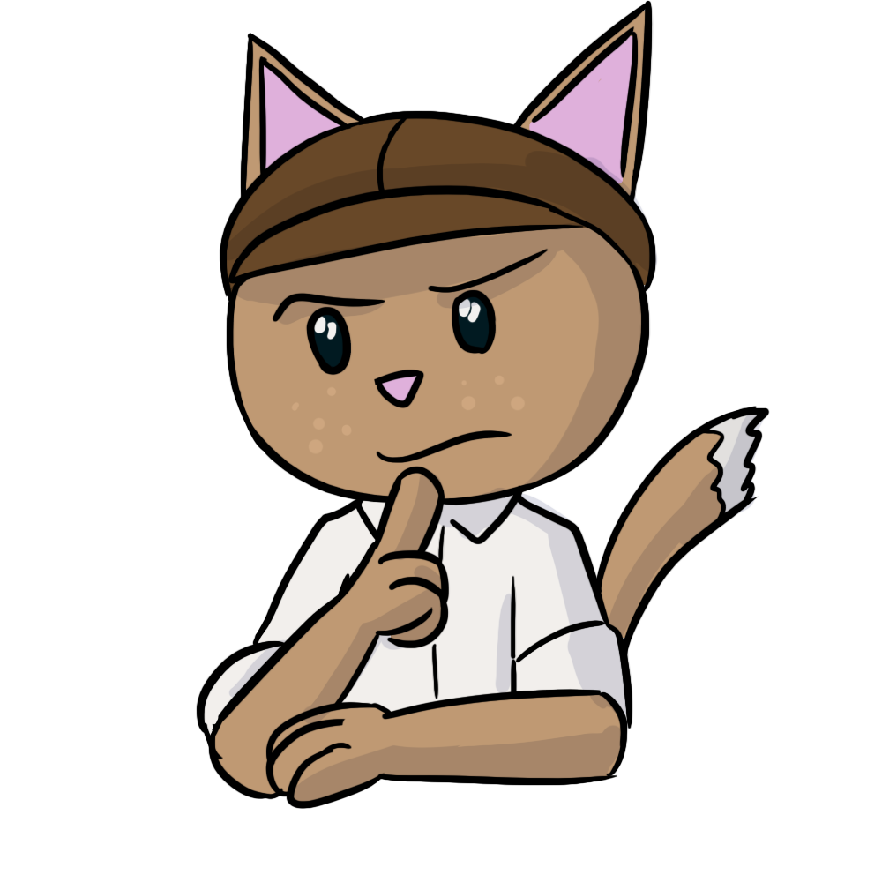
I wonder ………

Who am I game?
Some examples …
I am an animal, I have whiskers, I like drinking milk, I purr.
I drive a big, red vehicle, it has a ladder and siren, I wear a special uniform, you can call 999 if you need me to help you.
I am white, I am cold, you make me in winter, I often have a carrot for my nose, I melt when the sun comes out.
I wear a red cloak, my Grandma lives in the woods, I am afraid of wolves!
Following instructions in the home!
First put your pyjamas away and then bring me a book please.
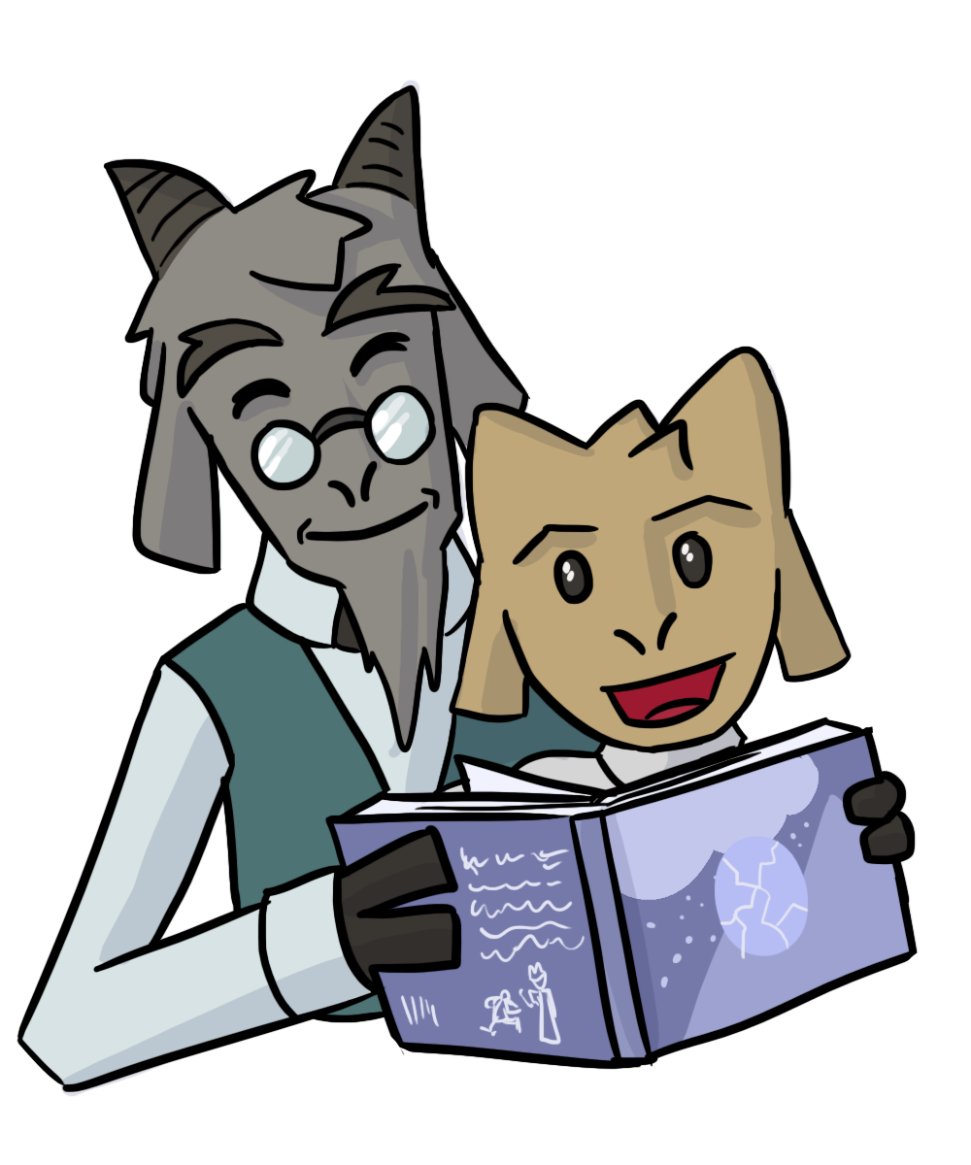
First water your plants and then put your coat on.

When sharing storytime with your child.
Looking at the pictures in the books..
What is this? Who is this?
Show me the …
What are they doing?
Find me something that makes me feel warm, cold, sad, happy ..
Find me something that is not green, not a fruit, not an animal ..
Reading the story ..
What’s happened?
Who? What? Where?
What size, shape, colour is it?
How many?
Show me the one we use for eating? travelling? dressing? cleaning?
How are these different? the same?
Show me a fruit? vehicle? animal? insect?
What will happen next?
What do you think he/she might be saying?
How are these the same?
What is a …..? (define word)
Tell me the story.

