2222222222222222222222222222222222222222222222222222222222222222222222222222222222222222222222222222222222222222222222222222222222
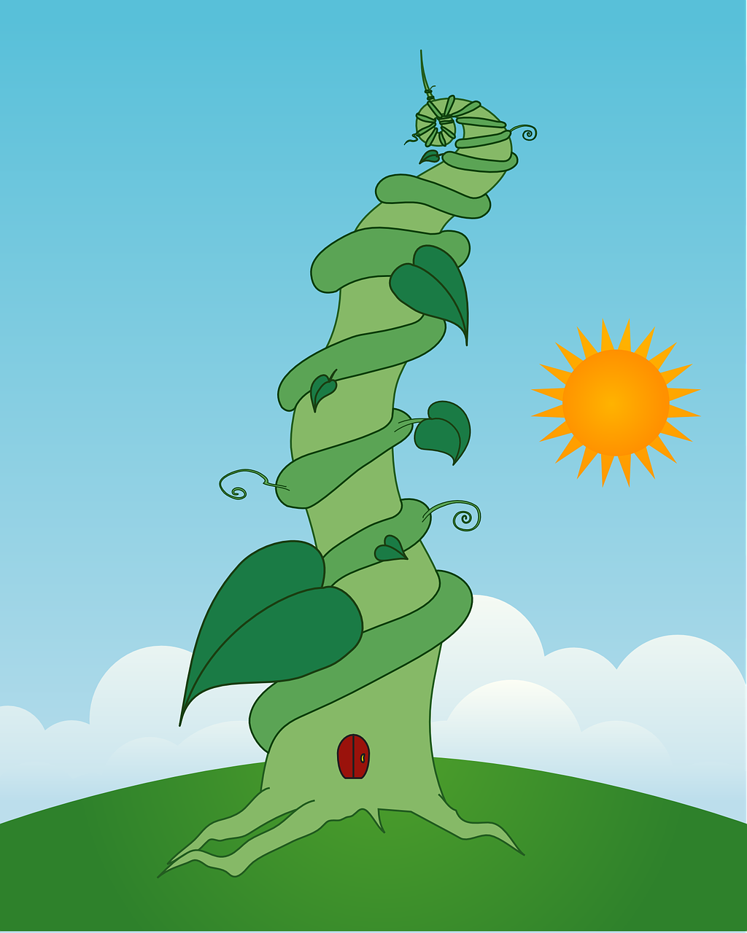 |  | Ballyhenry Nursery School  - Welcome to Our Weekly Activities  - 27th April 2020

We would have been reading in nursery this week, ‘Jack and the Beanstalk’ and learning some songs from the story. Read a version of the story with your child, lots are available online and encourage your child to join in the repetitive lines – ‘Fe, Fi, Fo Fum’.
Draw or paint some characters from the story and email them to us for our website.
Our role play area would have been a castle.
Rhymes for the Week
The Grand Old Duke of York
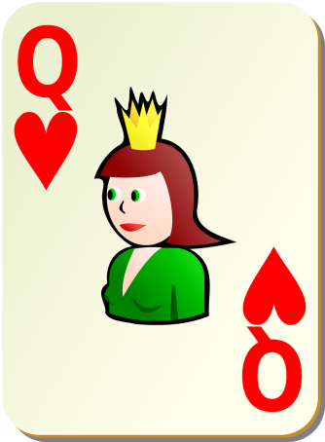
Pussy Cat, Pussy Cat where have
you been?

Old King Cole
The Queen of Hearts
5 Fat Peas
Sing a Song of Sixpence

Make a castle from junk – use boxes, cardboard tubes, straws, tinfoil etc.. Use your building blocks to create a castle and discuss the parts of a castle – the moat, drawbridge, tower, and dungeon.

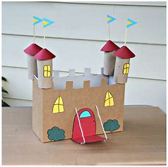
Make a potion to make the giant fall asleep so that Jack can escape. Use daisies, leaves, petals, dandelions, water, fairy liquid or food colouring, mix it up and pour into a plastic bottle or bowl.
Use play dough to make some food for the Giant’s dinner.
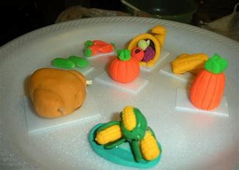

Useful online resources :
- Mr Hullaballoo has activities on Facebook
- Streamvale Farm has clips on their Facebook page
- Libraries NI staff are reading stories for children on You Tube
Activities for Inside
Fill a bag of shopping and take out two items at a time and compare which is heavier/lighter. Also discuss the shape of the containers.

Create repeating patterns by making a tower of bricks/blocks : red, blue, red, blue or use everyday objects eg., fork, spoon, fork, and spoon. Look for clothes with patterns on them and discuss.
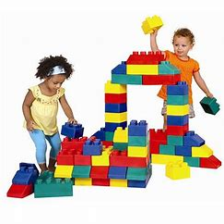

Write numbers 1-10 on post its or 1-20. Lay them out and add them 1 to 10 or 10-1. Take turns to close your eyes and guess which number the other person has taken away.
Go on a number hunt. Hide the numbers around your house and give your child clues to find them eg., number 1 is under the chair, number 2 is behind the toy box, number 3 is in the drawer etc.

On your daily walk, look for numbers in the local area, on number plates, doors, post box etc..
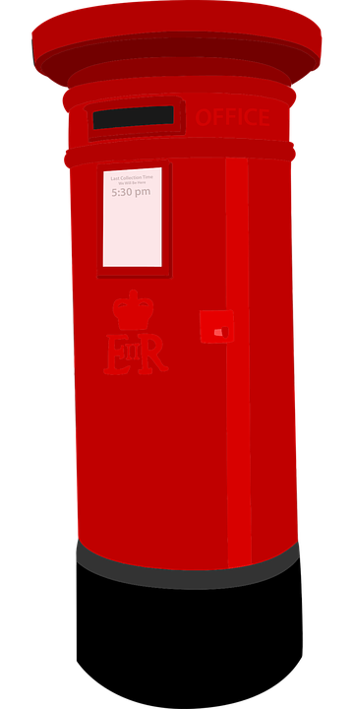

If your child is celebrating a birthday while nursery is closed, please send us a photograph and we will upload onto our website so your friends can join in the celebrations.
Remember to email us photographs of all the fun activities you are all doing at home for our website.

