2222222222222222222222222222222222222222222222222222222222222222222222222222222222222222222222222222222222222222222222222222222222

Ballyhenry Nursery School

  - Welcome to Our Weekly Activities
  - 20th April 2020

It’s hard to believe we would have been starting our last term at Nursery and the Easter break is over.
The Department of Education NI has launched a Safer School App for parents to download from their website to keep children safe online.
This week in Nursery we had planned to plant seeds and watch them grow.
Rhymes for the week
- 5 Fat Peas in a Pea Pod Pressed
- I’m a Little Sunflower (tune I’m a little teapot)
- 10 Green Bottles
- Mary, Mary Quite Contrary

In the garden there are lots of jobs to do:
- Help to cut the grass using a pair of scissors
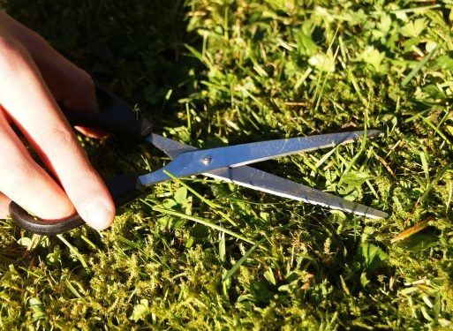
- Help to water the plants and do any weeding

- Grow a carrot top by cutting off the top and place in a dish of water. Leave on a window sill and observe what happens.

- Plant any seeds you have at home.
- Watch with your child online – BBC Gardeners Corner, David Maxwell plants peas with his five year old daughter
- On Youtube ‘Come Outside – Bulbs’ with Auntie Mabel & Pippin

- Play mobile – watch on Youtube Robert explains coronavirus to the children.
https://youtu.be/5DlOGKpMNs4
Activities for Outside
- Get everyone in our family to stand in a line, roll a ball under everyone’s legs. The person at the back of the line lifts the ball and runs to the front - repeat (tunnel ball).

- If you have siblings, play parachute games – use a blanket or a sheet. Make waves gently and then create a storm, toss teddy on the parachute, toss a ball on it, call out one name at a time, they run round or underneath the parachute.

- Fill a bucket of water with fairy liquid. Pour and fill a collection of plastic containers or bottles. Mix with a spoon, whisk, use a jug, ladle or slotted spoon.
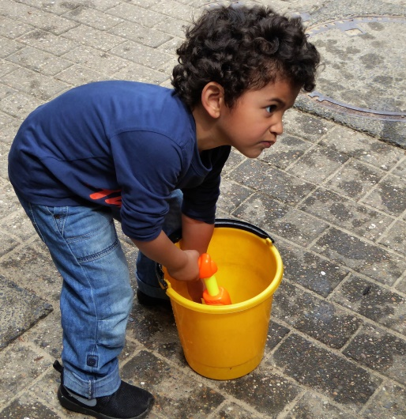
In the garden/daily walk – Can you find ?
Something rough/bumpy
Something heavy
Something light
Something taller than you
Something shorter than you
- Make a face with things you have found in the garden or on your daily walk.

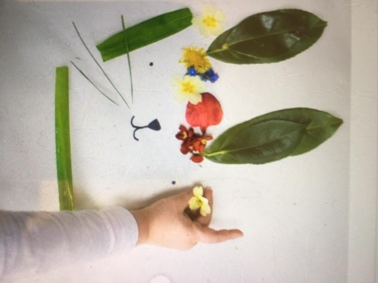

Visit the Getting Ready to Learn Website at www.gettingreadytolearn.co.uk, where you will find, under the Parents Section, 20 activities for 20 days.

