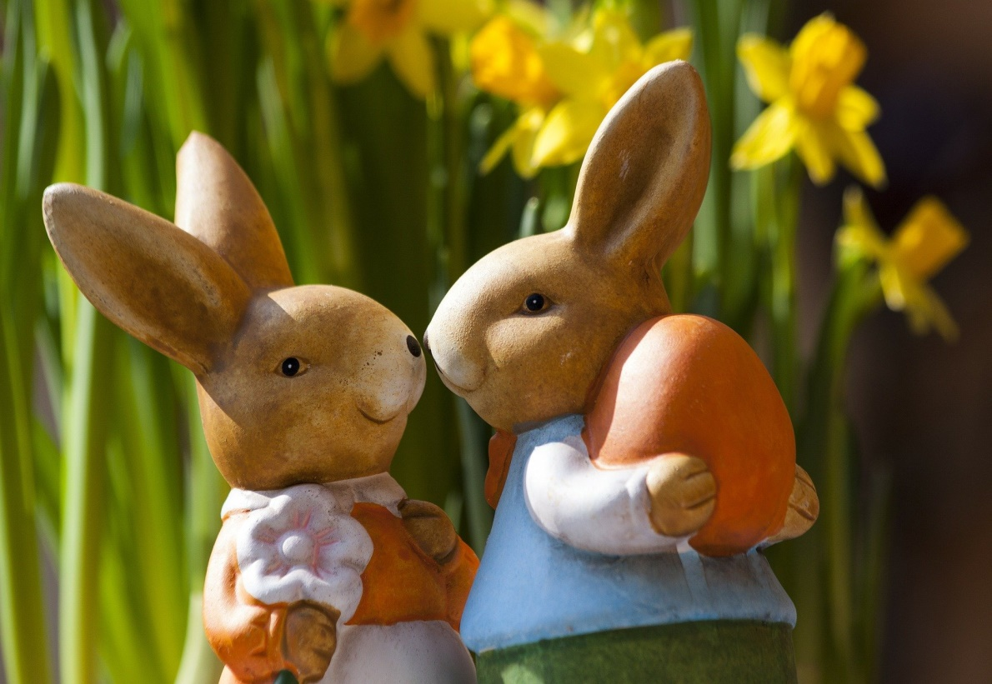 |  | Ballyhenry Nursery School  - Welcome to Our Weekly Activities  - 13th April 2020

We have loved seeing your colourful rainbows. Please keep sending your photos of any activities you have tried at home or any news you want to share with your friends on our website.
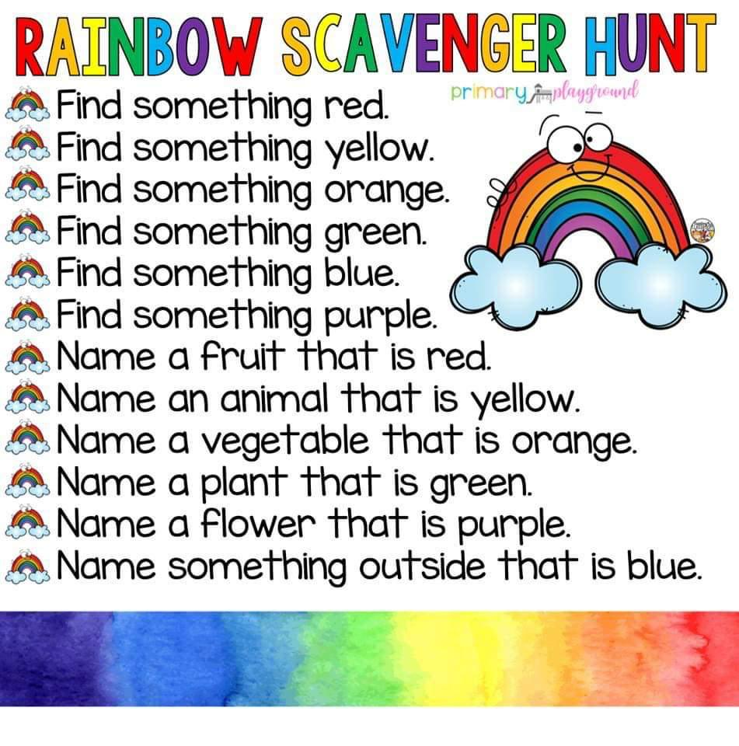
You can grow a rainbow. Have a look on Youtube. All you need is kitchen roll.
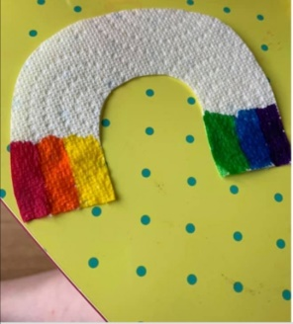

Draw around your hand and see how many small objects you can fit onto the whole hand.
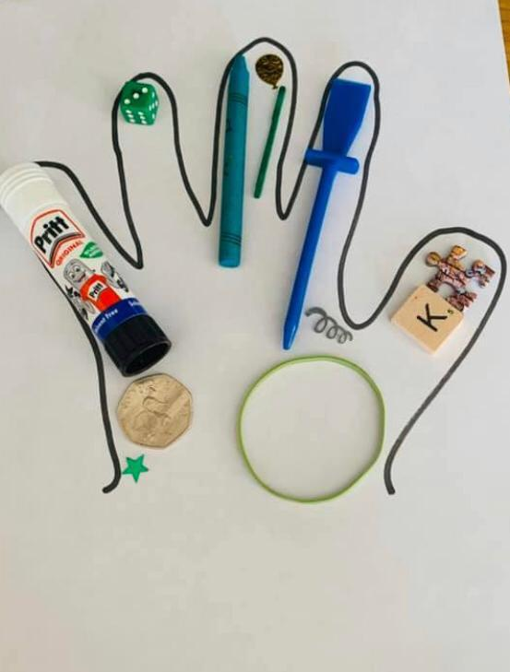
Make the Easter Bunny … lots of ideas on google.
Look on our school website with an adult and talk about the photos and the people you see :
www.ballyhenrynurseryschool.co.uk
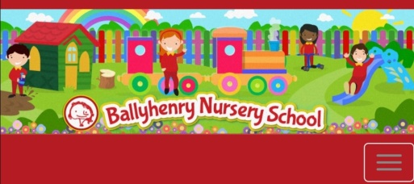

Try making an Easter card or picture for someone you miss. Then send them a photo of it and make their day!
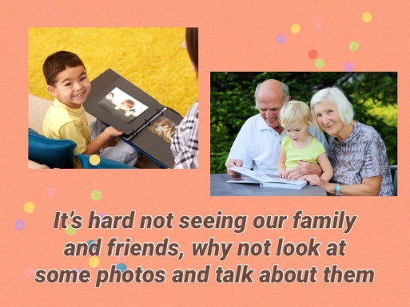

If you have lot of mini eggs, have an egg hunt in the garden. Remember to share them!

Play and create a shop and use real items and 1p coins. Sort real coins, a pile of brown coins, a pile of silver coins, large coins, small coins. Do you see any numbers on them?

Use tweezers or tongs to put pom poms, smarties or mini eggs into bottles – count them carefully.
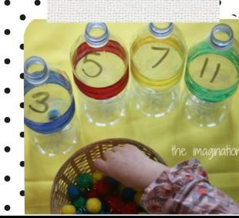

In the garden fill a basin or bucket with water and add items. Can you guess if they will float or sink? Did you get it right?

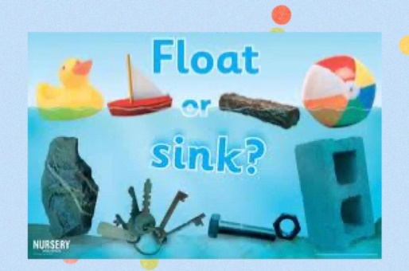

Put a bear in your window for all your friends to see when you go for a walk. You can go on a bear hunt. Draw or paint your bear and send us a picture.

Tune into Wee Critters on Facebook and also look out for Joe – The Gathering Drum and Teddy Tots on Facebook. They are all doing live activities!

