Let’s get moving!

Here are some ideas to help increase children’s physical activity. It is important that children have the opportunities to develop both fine and gross motor skills in tandem.

Gross motor skills
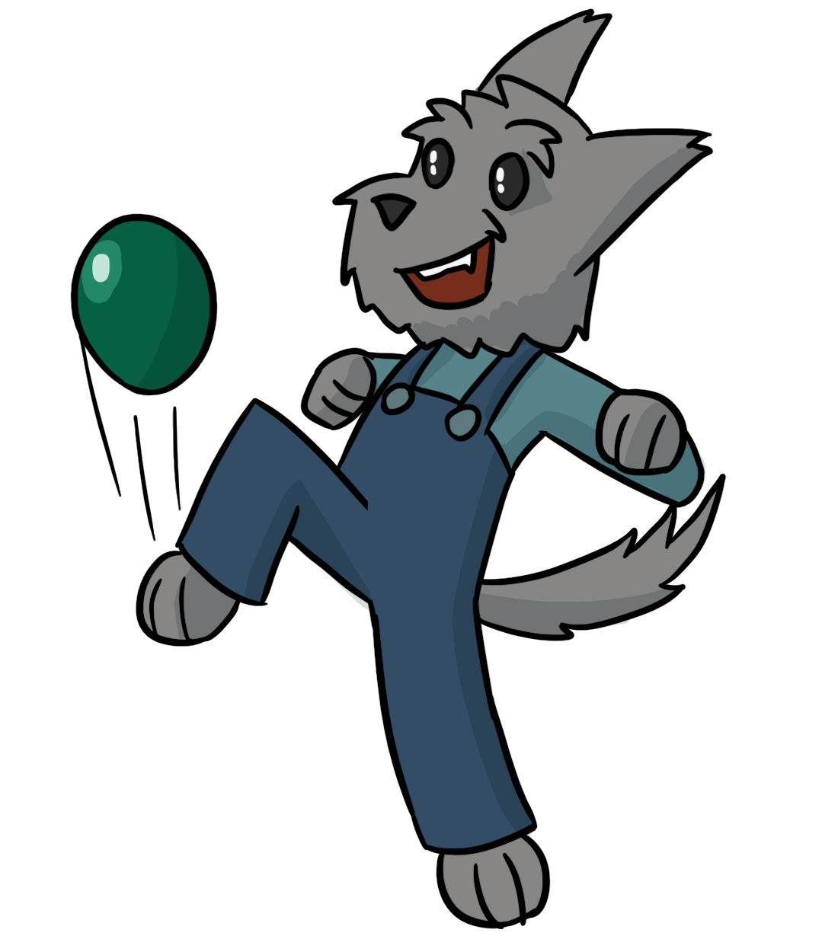
Your child needs to develop control in large (gross) body movement to enable them to manage control in smaller (fine) movements
March
Climb
Run
Skip
Crawl
Walk
Football
Catch
Pedal
Gallop
Tiptoe
Jump
Swim
Leap
Balance
Hop
Obstacle Courses

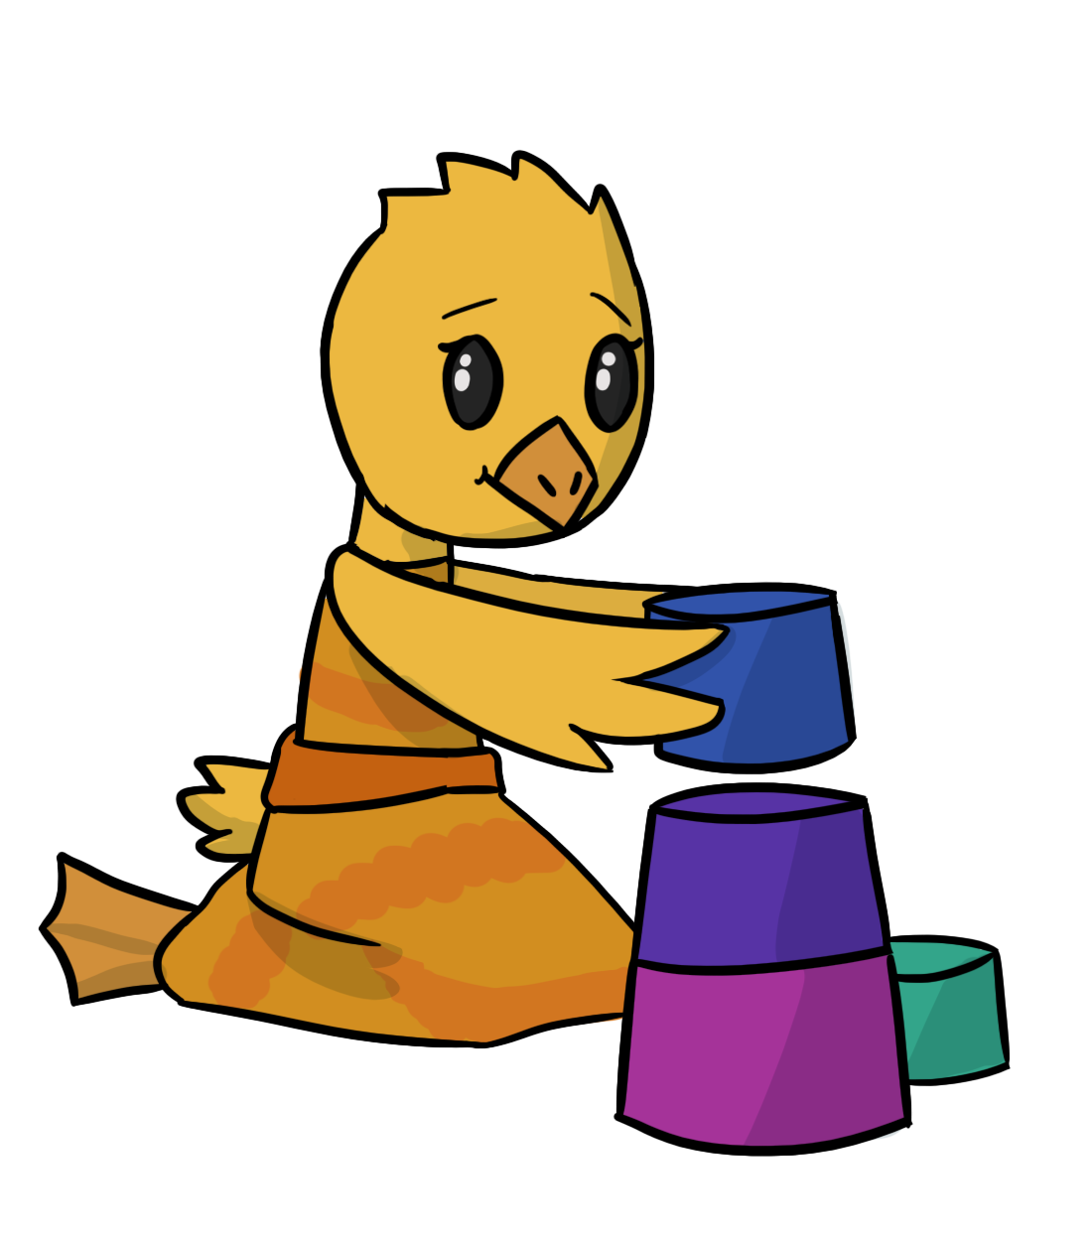
To develop core stability encourage your child to engage with activities in different positions
Half Kneeling
Lying on Tummy

Kneeling
Standing
Tall Kneeling
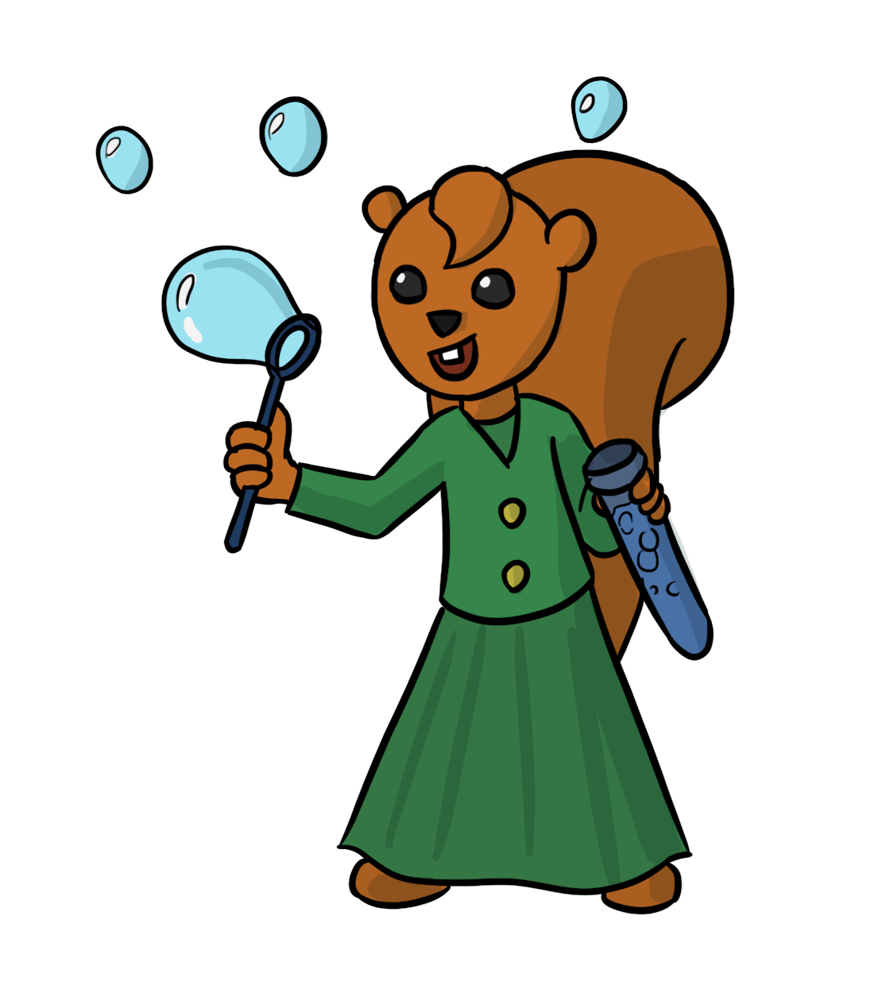
To develop hand eye co-ordination engage with any activity where your child needs to get their eyes and hands to work together!

Filling and Emptying Containers
Ball skills
Catching Bubbles

Skittles
Balloon Games

Fine motor skills
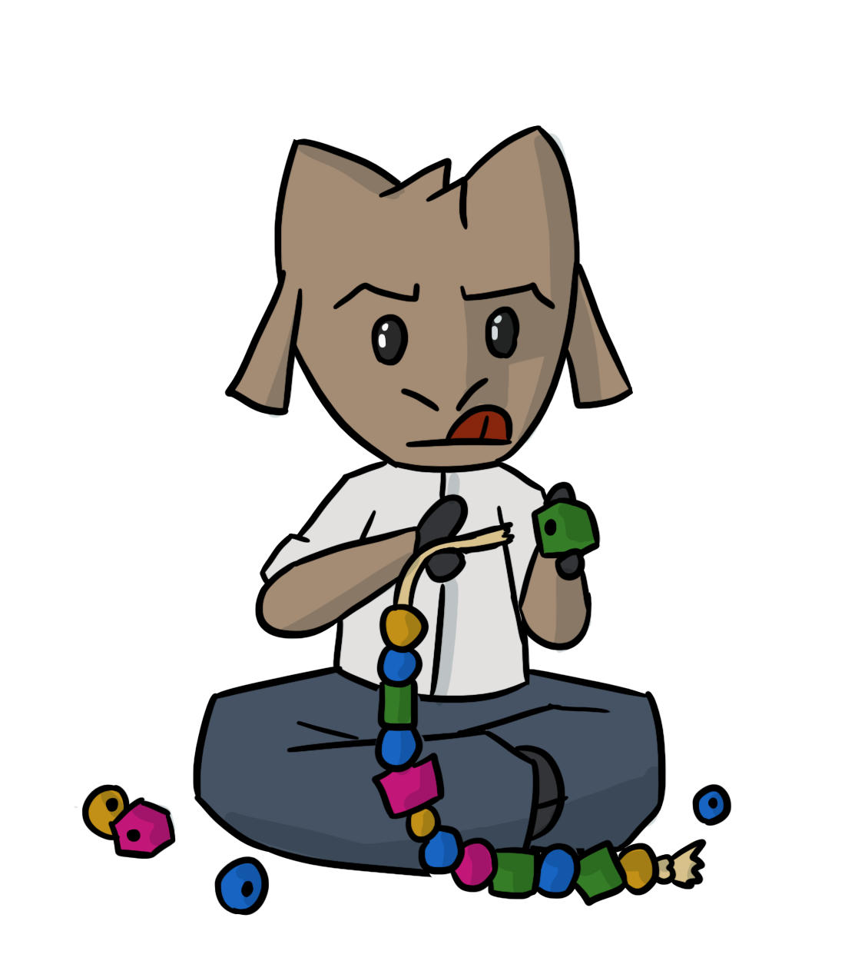
Grasp
Control

Twist
Hand Dominance

Squeeze

Manipulate

Activities to help develop fine motor skills:-

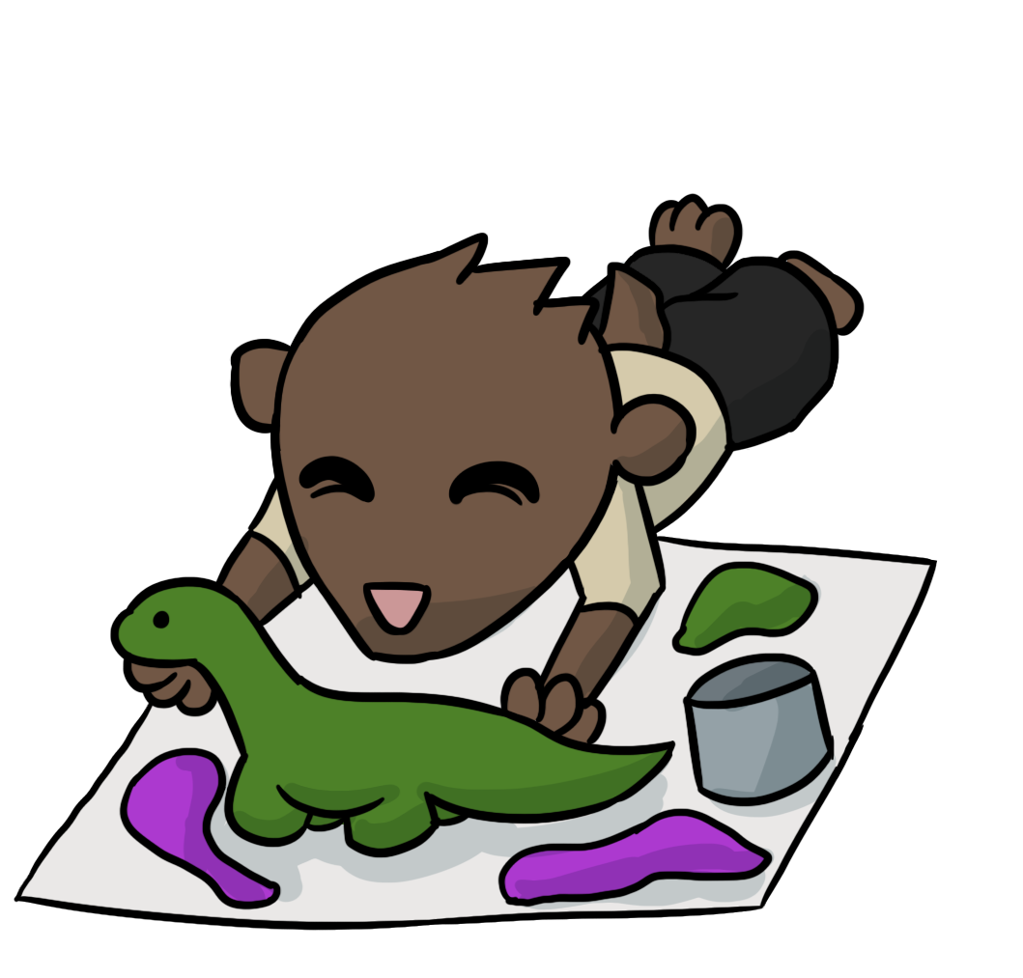
Work with clothes pegs to hang out washing

Pegboards
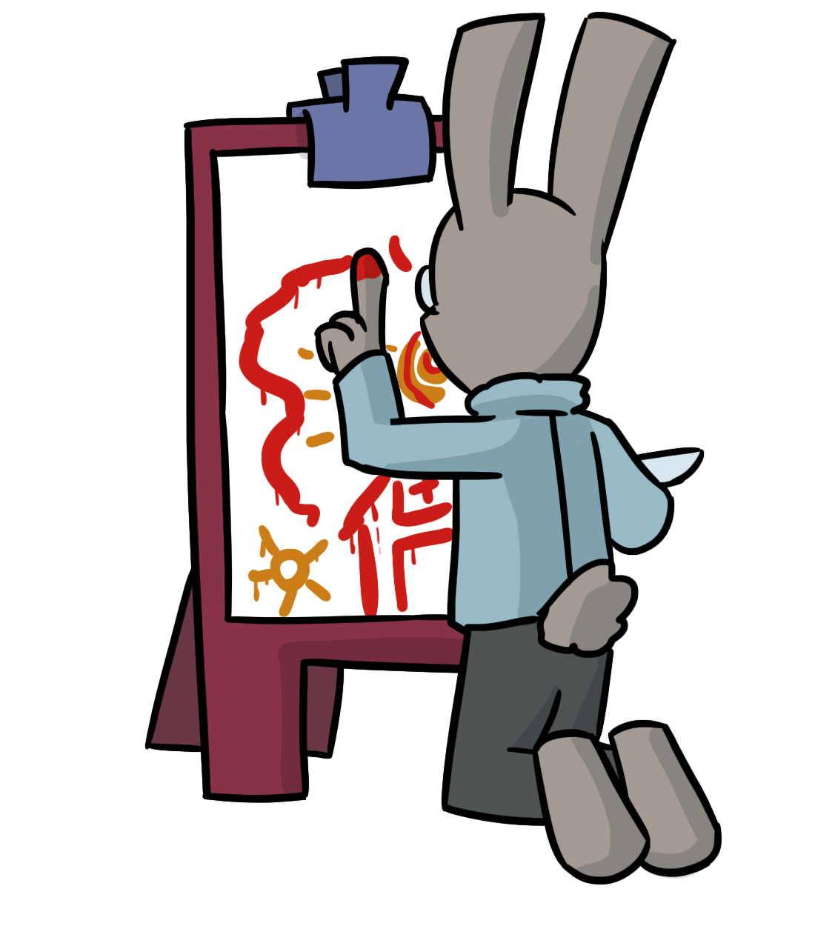
Making
jewellery
Paints
Playing with sand and water
Have fun with Spray Bottles
Working with playdough- roll, cut, squeeze, pinch
Threading with beads or pasta

Use tweezers
Paint outside with a big brush and water
Construction materials
Chalks
Lacing
Baking
Dressing and undressing dolls
Finger paint
Messy play with foam

