Ballyhenry Nursery School

  - Welcome to Our Weekly Activities
  - 30th March 2020

We hope everyone is okay and coping with these changes to our daily routines, which are a challenge to all of us.
If you want to talk to your child about coronavirus read this story together www. Elsasupport.co.uk and download coronavirus story.
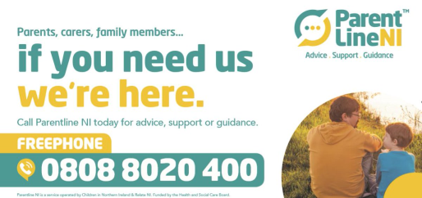

Remember to keep to a routine going.
In nursery our day looks like this
9 – 10:30am Indoor play activities
(incorporating snack time)

10:30 – 11:30am Outdoor/physical
play

11:30 – 12noon Stories, rhymes

12 – 12:40pm Lunch & Jobs
(feeding the fish, collecting the cups)

12:40 – 1pm Talking time (Adventure Ted, Road Safety, topic discussions)
1 – 1:30pm Table top games/activities
This week in nursery we would have been thinking about Easter, eggs and chicks.

Rhymes for the week. These are available to download from our website.
Chick, chick, chick, chick, chicken
The Easter Bunny is Running
5 Shiny Eggs
Easter Bunny, Safe and White
6 Little Ducks that I Once Knew

Activities

Boil some eggs with your child. When cold decorate them. Use felt tips, paint, wool or any materials you may have at home.

Set a challenge for your child to care for their egg. How many days did it last?

Play egg and spoon races, have an egg rolling race with siblings, hide the eggs and have a treasure hunt in the garden.

Use potatoes cut in half to print egg shapes and decorate when dry. Make an Easter egg wreath. Your child can cut out egg shapes and stick them onto a circle shape. Discuss the shape of eggs (oval). Discuss what creatures hatch out of eggs. If you made dough from last week’s recipe, use it to roll and make eggs or chicks. Decorate dough eggs by pressing in dried peas, pasta, lentils or rice.

Make Easter nest buns together with rice krispies and chocolate. Discuss how the chocolate melts and where the buns need to go to harden. Encourage your child to count out the bun cases and the mini eggs/smarties on top.

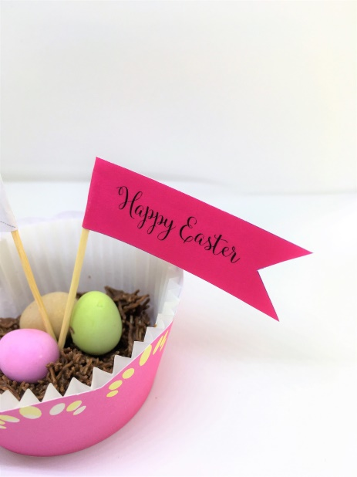

Use some light card to cut out egg shapes. Punch holes the egg shape and thread a pattern.

Go for a spring walk or hunt in the park or forest and look or listen for these things :
- A daffodil or flower growing
- Baby lambs in the fields
- Listen or look for birds
- Buds on the trees
- The sun shining
- A blue sky
- A puddle to jump in

Please remember the social distancing rule that we are to adhere to.

If the weather is suitable, have snacks in the garden and encourage your child to help you to prepare it and to wash their dishes (as we do in nursery).
Make a den in the garden using a sheet, blanket and clothes pegs.

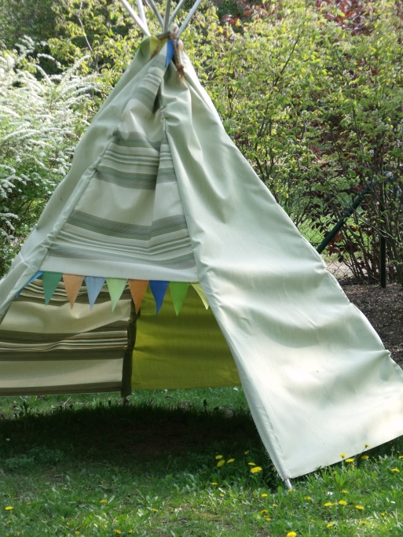

Jo Jingles Co Antrim, on their facebook page, did a live session (20 March 2020) which would be great fun to do along with your child.
Joe Wicks, the Body Coach, does PE with Joe each morning at 9am on You Tube and he has a 5 minutes more session which will help to keep everyone active.
Remember to read lots of stories every day! Lovemybooks.co.uk is a free resource to use.

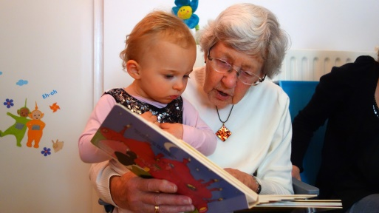

Rainbows are currently being used as a sign of Hope during the Covid 19 situation. If your child has participated and painted, drew or made a rainbow which you have displayed on your home window, please send us a picture to info@ballyhenryns.glengormley.ni.sch.uk and we will upload these onto our website.

