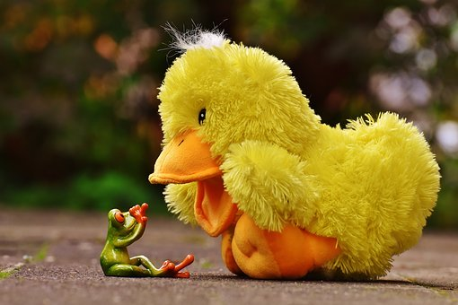 |  | Ballyhenry Nursery School  - Welcome to Our Weekly Activities  - 23rd March 2020
 |  | PLAY DOUGH RECIPE

We hope all our mums had a lovely Mother’s Day.
We would encourage you all to try to keep a daily routine in place for your child(ren) during this time.
Remember how important it is to keep active! Weather permitting, play in the garden each day. Read lots of stories with your child every day and make up stories together.
If we had been in nursery we would have been learning about ducks and frogs.
Rhymes for this week would have been :
- 5 Little Speckled Frogs
- 5 Little Ducks went Swimming
- Little Tommy Tadpole
- Wash Your Dirty Hands
The above rhymes can be downloaded separately from our website.
Count forwards and backwards from 1-5 and 5-1.
Discuss the lifecycle of a frog – there are lots of images on google.

Use the following words : Frog, frogspawn, tadpole, eggs, jelly.
Discuss what frogs eat.
Many websites have pictures to print and your child can cut them out and sequence the stages of growth.
Paint or draw pictures of how a frog grows.
Go for a walk and look for frogspawn.
Discuss the features of a duck : Beak, webbed feet, wings
Read stories such as the Ugly Duckling. Talk about how we are all different, but still special.
Go to a park and feed the ducks. If you have older children at home, play duck, duck, goose.
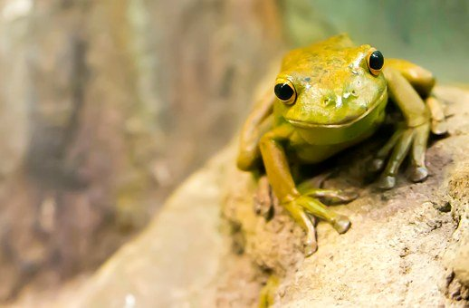
Make playdough. Colour it green or yellow and make frogs and ducks.
1 cups/200g of plain flour
1/2 cup/100g of salt
2 tsp cream of tartar
1 tbsp oil
1 cup/300ml water

Put all ingredients into a bowl suitable for the microwave. Cook at full power for one minute. Remove from oven and stir well. Put back in oven and cook for a further 1-1.5 minutes. Remove from oven and scrape out with a wooden spoon and leave to cool. Knead well, adding food colouring at this point.

Remember, this is a difficult time for your child to understand what is going on …. So most importantly Have Fun Together!

